Application Review –Assistant to the Dean/Appointing Officer, Search Chair and Search Chair Assistants
As one of the persons listed above, you can view/print the job and applicant details and assign interview pools.

The number of applications shown on the dashboard reflect how many applicants have started the application process. When you view applications, you will only see the completed applications so there may be a discrepancy.
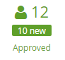
← Number of applicants that have begun an application.
← Number of completed applications.

Part A: Viewing Jobs
- Log into www.gvsu.edu/hiring using your GVSU Network account.
- Click the menu button in the top right corner of your screen.
- Click Manage jobs which is under the Jobs category.
- Click the title of the job to view and print the job information and any documents that have been uploaded.
  - Do not add notes to the job.

Part B: Reviewing Applications
Refer to Part E for instructions how to print all applications and documents at one time.
- Log into www.gvsu.edu/hiring using your GVSU Network account.
- Click the menu button in the top right corner of your screen.
- Click Manage jobs which is under the Jobs category.
- Click the applications icon to view and print the applications which is located to the right of the job title.
↓

- Click the applicant’s name to view their basic information.
  - To view the full application, including documents, click Form which is located next to the job title in the Applications section.

The Human Resources Office will no longer attach any documents for the applicants. All documents will have to be attached by the applicant at the time of submission.

Part C: Interview Pools
- Log into www.gvsu.edu/hiring using your GVSU Network account.
- Click the menu button in the top right corner of your screen.
- Click Manage jobs which is under the Jobs category.
- Click the applications icon to view the applications which is located to the right of the job title.
↓

- Click on the applicant’s name.
- Under the Applications section, click Actions to the right of the position you are reviewing.

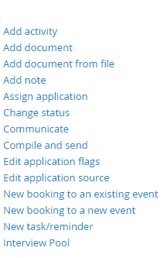
→

→

- Click Interview Pool.
- Select the Interview Pool form. Once you select the form, a preview will populate in the box below it. It is not required for you to choose a pool in the Form preview section.

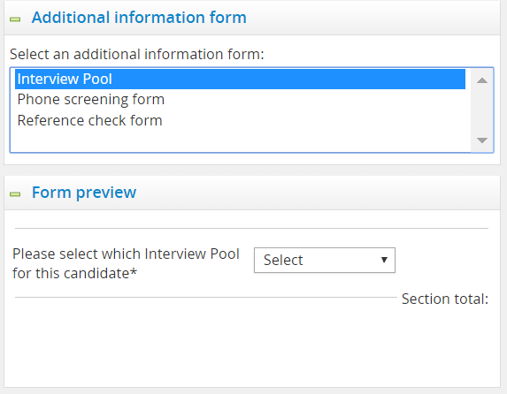

- Click Next>.
- Select the Interview Pool to assign the applicant – there are four pools. We do not use the scoring section, but it will assign a score when you select a pool. The score will equal the pool. Example: Interview Pool 1 = Total Score 1.
- Click Save.
- Repeat this process for each applicant that you choose to assign to a pool.

Part D: Initiating Interview Approval
Once the applicants have been chosen for an interview approval, move their status to begin the approval process.
- Log into www.gvsu.edu/hiring using your GVSU Network account.
- Click the menu button in the top right corner of your screen.
- Click Manage jobs which is under the Jobs category.
- Click the applications icon to view the applications which is located to the right of the job title.
↓

- Click the status of the applicant you have chosen for an interview.
- Choose the status depending on the type of position.
  - Faculty & AP: Interview Approval Pending – Dean/Appointing Officer.
  - Hourly: Interview Approval Pending - HR
- Click Next>.
- Click Move now. We are not using the system email function during this process.
- Email the next approver stating that applicant pool has been approved and is ready for the next step in the approval process using your GVSU email. This is the current process for interview approvals.

Faculty & AP Approval Chain | Hourly Approval Chain
Interview Approval Pending – Dean/Appointing Officer | Interview Approval Pending – HR
Interview Approved – Dean/Appointing Officer – Pending HR | Interview Approved HR – Pending Affirmative Action
Interview Approved HR – Pending Affirmative Action | Interview Approved Affirmative Action
Interview Approved Affirmative Action

Part E: Bulk Compile and Send
Optional: allows you to send the complete list of applicants in a PDF format via email and/or print all of the applications at once with attached documents.
- Log into www.gvsu.edu/hiring using your GVSU Network account.
- Click the menu button in the top right corner of your screen.
- Click Manage jobs which is under the Jobs category.
- Click the applications icon to view the applicants which is located to the right of the job title. ↓

- Click the green box to the left of all the applicants that you want to compile.

Before: ↓ After: ↓

- In the dropdown box at the top, select Bulk compile and send.

- Select the documents you would like to include in the document.
  - Check the boxes next to the description of each item. Here are the suggested items to click:

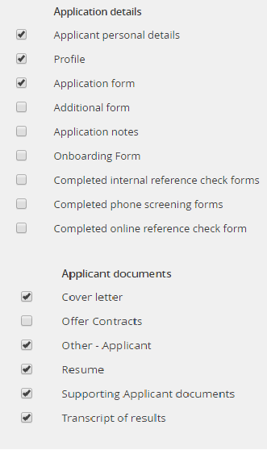

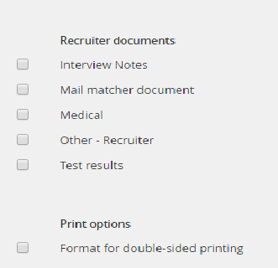

- Click Create PDF.
- Click Download document to view and print the applications.
- To send the applications, enter the recipient’s email in the Human Resources field. The Human Resources field does not have to be someone in Human Resources.
  - If you are sending to multiple people, enter their email in the Other email field. Separate each email with a semicolon.
  - You can also use the Human Resources field to look up unknown GVSU emails.
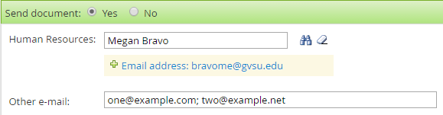

- Enter a subject into the Subject line, if it needs to be edited.
- Click Okay.

Part F: Not Selected for an Interview
Moving applicant into the status: Not Selected for an Interview.
- Log into www.gvsu.edu/hiring using your GVSU Network account.
- Click the menu button in the top right corner of your screen.
- Click Manage jobs which is under the Jobs category.
- Click the applications icon to view the applicants which is located to the right of the job title.
↓

- Click the Status of the applicant you have not chosen for an interview.
- Choose the status: Not Selected for an Interview.
- Click Next>.
- An email will not be sent to the applicant letting them know that they were not selected for an interview. However, if the applicant chooses to log into the system to check on the status of their application, they will see “Not selected for an interview.” **Once you are ready to send the email to the applicants, please refer to the document Bulk Communicate**
- Not selected for an interview reason– select the reason for this selection in the drop-down. For a list of the reasons, refer to the document Reasons for Non-selection.
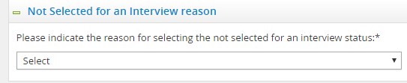

- Click Move now to confirm the status change.
- Repeat this process for each applicant that has not been selected for an interview.

