Creating a Job
Beginning the hiring approval/change for a new position, replacement position and position changes.
Part A: New/Replacement Positions
- Log into www.gvsu.edu/hiring using your GVSU Network account.
- Click the menu button in the top right corner of the screen.
- Click New Job which is under the Jobs category.
- Select your department – this will be pre-populated for you.
- Enter your position number.
  - If you enter a position number that is not recognized, the search screen will automatically pop-up and will allow you to search by title or number.
  - If you do not have a position number, leave it blank and continue. The Budget Office will add the position number during the approval process.
- Click Next>.
- Enter the information for the DEAN/APPOINTING OFFICER (Section 1).
  - Begin with Position Type
  - New or Replacement position
- For 1 position:
  - Leave the New and Replacement boxes empty. In the Type selection drop-down field, choose New or Replacement. If you know the position number, it will pre-populate in the Position no box.
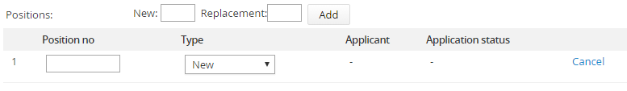

- For 2 or more positions:
  - Enter the number of additional positions in either the New or Replacement box and click Add.
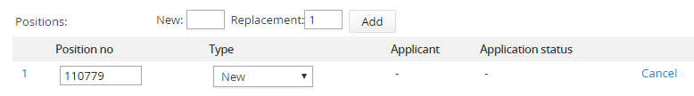

  - Complete the Type selection drop-down field for the additional position. Enter the position number, if known.

  - Working Title will populate if it is a known position in Banner. You may have to edit this title.
The Working Title is how the job will show on the career site.
On the job card:

On the job website:

  - Continue entering applicable information until you see:

- Scroll down to DEAN/APPOINTING OFFICER (Section 2)
  - USERS AND APPROVALS – Enter names into the following slots:
    - Dean/Appointing Officer/Vice President – this may often times be the Assistant to the Dean/Appointing Officer/Vice President. The person sitting in this field on the job card will receive the email notifications.
    - Search Chair/Search Chair Assistant
      - Search Chair Assistant is optional. If the Search Chair designates an Assistant, the Assistant will be able to make changes in the system in lieu of the Search Chair. If the Search Chair does not have an Assistant, enter the Search Chair’s name here.
    - Job Originator (will automatically populate – do not change)
  - Choose an Approval process depending on the type of position requested.
    - Academic Affairs (NOT visfac/12mo adj AP)
    - Academic Division (Changes only)
    - Academic Split Between 2 Deans/Appointing Officers
    - Interim HR Only Job Approval
    - Non-Academic Divisions
    - Non-Academic Divisions (Changes only)
    - Non-Academic Split Between Appointing Officers
    - Visiting Faculty or 12-month Adjunct AP*
  - Enter the appropriate person’s name into each step of the approval process. You can use the binoculars to search, if needed. Do not need to change the names that have been pre-populated for you.
    - If the Assistant to the Dean is creating the job, enter the Assistant’s name into the Dean/Appointing Officer slot.
    - In the Budget field, use the following names depending on the type of position:
Terri Suess | Davidpaul Lemmen
AP | 12-Month Adjunct AP
Tenure Track Faculty | Visiting Faculty
Affiliate Faculty

The following sections will be completed during the approval process:
- Hiring Manager/Search Chair
- Human Resources
- Budget

- Click Save and exit. This begins the approval process.
- Click Save a draft if you would like to save the job card and finish the process at a later time.
    - If saving a draft, click OK in the box when it asks if you want to save the following as a draft. Note: The approval process, if set, will be deleted.

*12-Month Adjunct AP and Visiting Faculty Positions – If you have a 12-Month Adjunct AP position or Visiting Faculty position, you will need to add the Position Announcement Form in the Hiring Manager/Search Chair section for the position to be approved. These positions do not require a search; however, it is possible. Once all the appropriate approvals are complete to fill the position, contact the Employment Manager in the Human Resources office to get the position posted on the job website. If not doing a search, contact the Employment Manager at 331-2213, once a candidate has been identified to fill the position.

- There are four tabs at the top of the position requisition: Position info, Notes, Sourcing and Documents. Sourcing is the advertisement page and will only be utilized by the Employment Manager. You will not use the Notes tab.
- The Next page button at the bottom of the screen will take you to the next tab.
- If you are missing any required fields, the system will mark them with a red asterisk.
Part B: Title/Position Changes
- Log into www.gvsu.edu/hiring using your GVSU Network account.
- Click the menu button in the top right corner of the screen.
- Click New Job which is under the Jobs category.
- Select your department – this will be pre-populated for you.
- Enter your position number.
  - If you enter a position number that is not recognized, the search screen will automatically pop-up and will allow you to search by title or number.
- Click Next>.
- Enter the position information for the DEAN/APPOINTING OFFICER (Section 1).
  - Begin with the Position Type.
  - Enter the Reason for Change
    - Title Change
    - Promotion (Must attach Promotion Justification form)
    - FTE Change
    - Reclassification
    - Funding Change
    - Other
  - Continue entering applicable information until you see:

- Scroll down to DEAN/APPOINTING OFFICER (Section 2)
  - USERS AND APPROVALS – Enter names into the following slots:
    - Dean/Appointing Officer/Vice President
    - Job Originator (will automatically populate – do not change)
  - Choose an Approval process depending on the type of position requested.
    - Academic Division (Changes only)
    - Non-Academic Divisions (Changes only)
  - Enter the appropriate person’s name into each step of the approval process. You can use the binoculars to search, if needed. Do not need to change the names that have been pre-populated for you.
    - If the Assistant to the Dean is creating the job, enter the Assistant’s name into the Dean/Appointing Officer slot.
- Click Save and exit. This begins the approval process.
- Click Save a draft if you would like to save the job card and finish the process at a later time.
    - If saving, click OK in the box when it asks if you want to save the following as a draft. Note: The approval process, if set, will be deleted.

