Bulk Move Applicants
Move multiple applicants at a time into a new status.

- Log into www.gvsu.edu/hiring using your GVSU Network account.
- Click the menu button in the top right corner of your screen.
- Click Manage jobs which is under the Jobs category.
- Click the applications icon to view the applications which is located to the right of the job title.
↓

- Click the green box to the left of all the applicants that you want to move.

Before: ↓ After: ↓

- In the dropdown box at the top, select Bulk move.

- Select the new application status from the dropdown. The number of applicants shown in the green bar will reflect the number of applicants that you are moving.
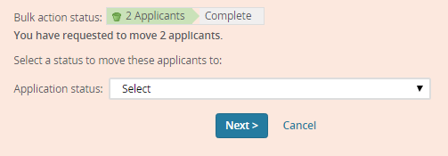
- Click Next>.
- Turn on/off the applicant/user emails as needed.
- If moving an applicant into a not selected status, enter a non-selection reason.
- Click Move now.

