Bulk Export
You can export the applicant list with their personal information into a csv file.
- Log into www.gvsu.edu/hiring using your GVSU Network account.
- Click the menu button in the top right corner of your screen.
- Click Manage jobs which is under the Jobs category.
- Click the applications icon to view the applicants which is located to the right of the job title. ↓

- Click the green box to the left of all the applicants that you want to export.

Before: ↓ After: ↓

- In the dropdown box at the top, select Bulk export.

- Select the documents you would like to include in the document.
  - Check the boxes next to the description of each item. Here are the suggested items to click:
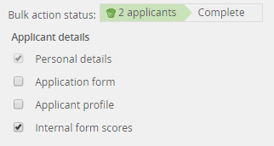

(Optional)

*Personal details gives you all of the columns that you see when you’re looking at the list of all of the applicants. (I.e. First name, Last name, Phone, Mobile)
*Internal form scores gives you the Interview Pool that an applicant has been assigned to, if you use Interview Pools.

