Application Statuses and Changes
There are different statuses for each step of the hiring process.
Part A: Application Statuses
Application Status List:
New
Prescreen Phone/Video Interview
Phone/Video Screen Accepted*
Phone/Video Screen Declined*
Not Selected for an Interview
Hiring Manager Review Unsuccessful – Do not use
Interview Approval Pending - Dean/Appointing Officer (Faculty & AP only)
Interview Approved – Dean/Appointing Officer – Pending HR (Faculty & AP only)
Interview Approval Pending – HR (Hourly only)
Interview Approved HR - Pending Affirmative Action
Interview Approved Affirmative Action
Interview 1
Interview 1 Accepted*
Interview 1 Declined*
Interview 2
Interview 2 Accepted*
Interview 2 Declined*
Interviewed - Not Hired
Preparing Offer Details
Offer to Candidate - Submitted Online
Offer Accepted*
Offer Declined*
Background Check(s) in Progress
Hired
Application Withdrawn (At any point in the process) **
Not Hired - Not Filling Position at this Time

- Not every applicant will move through each one of these statuses. For example, if you do not phone/video screen applicants, you will not use these statuses.
- When you move an applicant to a new status (depending on the status), emails are sent out to applicants and users. (Instructions how to send emails are in Part B).

*These statuses may be moved automatically through the system when the applicant accepts/declines an invitation through the careers webpage.
**Applicants withdraw their application themselves on the careers webpage.

Part B: Confirm Status Change & Emails
A confirm status change window appears each time you change an applicant’s status. This window includes 2 types of email that may be sent out when an applicant’s status is changed.

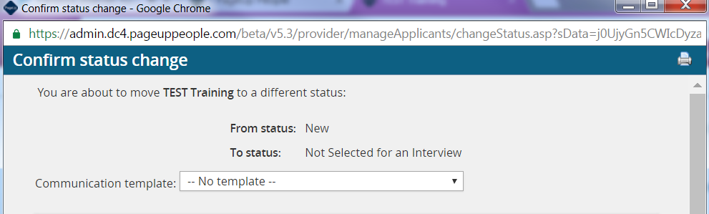

*You do not have to choose a communication template.

Email types:
- Applicant email – an example of an Applicant email:
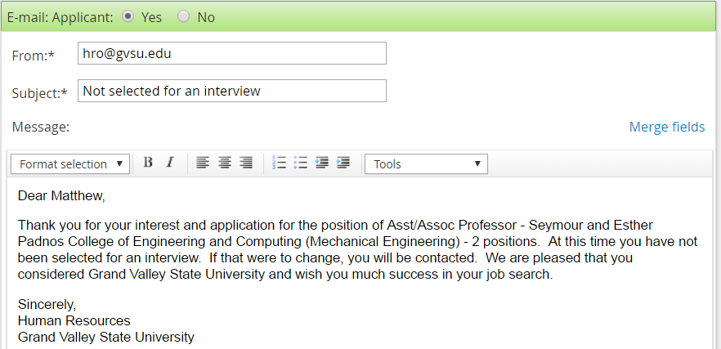

- User email – an example of a User email:
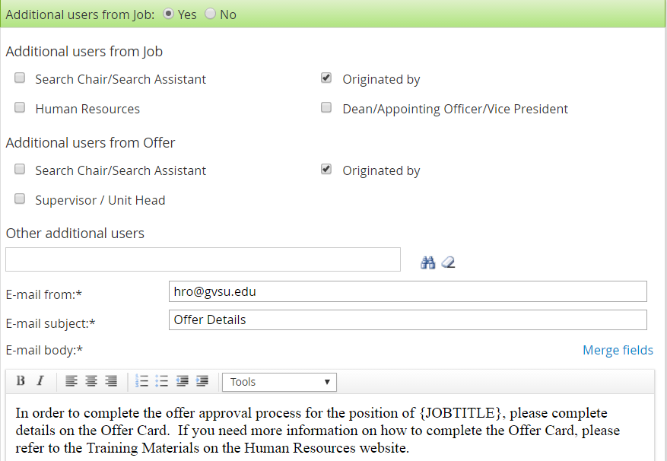

Example of a Merge Field

*Do not edit the capitalized merge fields in the User emails.

The User emails can be sent to additional users:
  - Additional users from the Job card
    - Search Chair/Search Assistant
    - Human Resources
    - Originated by
    - Dean/Appointing Officer/Vice President
  - Additional users from the Offer card
    - Search Chair/Search Assistant
    - Supervisor/Unit Head
    - Originated by
  - Other additional users
    - Use the binoculars to search for anyone in the GVSU network.
    - Once you find their name, click Select to add them.

- All of the emails can be edited – a base template has been provided.
- Some emails may require you to insert your contact information. If this is required, the template will instruct you do so.

Example:
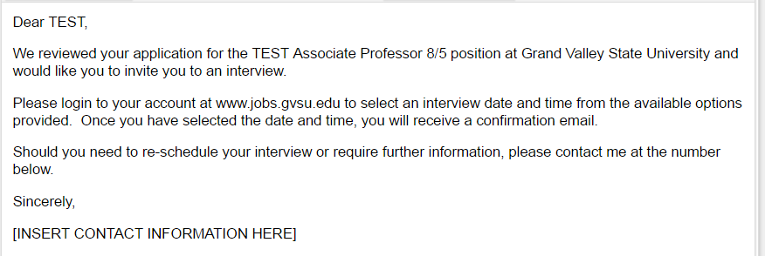

- Do not use the Note field.
- You can turn on and off the emails to either the applicant or the user. You will see the option in a green or white banner. If the banner is white, as shown below, the email is already turned off. You do not need to worry about the SMS – we do not use messaging.
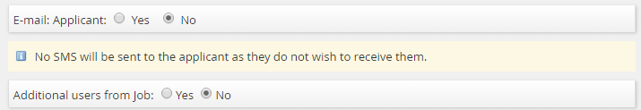

- If ‘No’ is selected, it means that the Human Resources Office does not believe you need to send out this email.

