03/26/2018

On Campus Interview Approvals

**PAGEUP APPLICANT TRACKING SYSTEM**

**Reminder: You must allow pop ups for this system to work properly.**

1. **Log into** [www.gvsu.edu/hiring](http://www.gvsu.edu/hiring) using your GVSU Network account.
2. Your home screen will look like below:

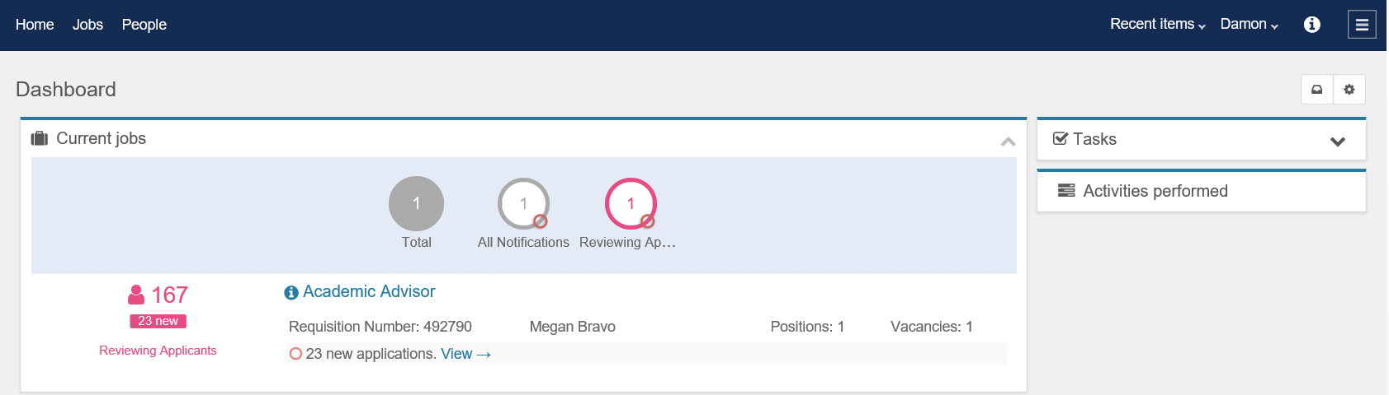

1. Please review your job listed.

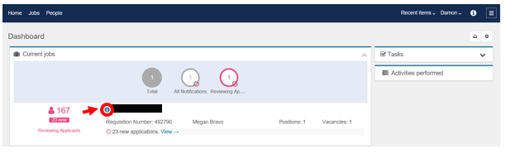

Job Title

1. Click on the blue icon next to your job.



Job Title

1. When you click on the blue icon the “Quick view” of the job will appear. This lists all of your applicants and their statuses.

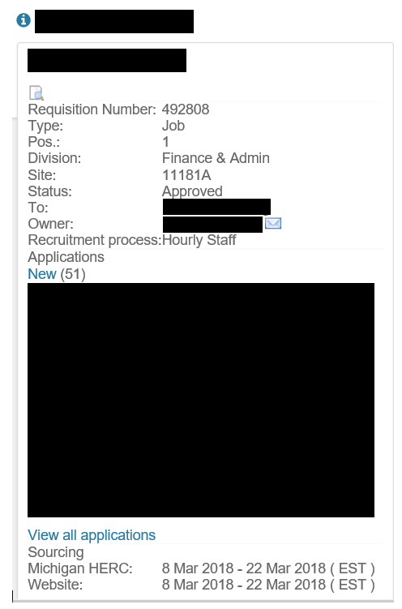

Job Title

Job Title

Applicants will be listed here

1. Search Chairs: refer to the status “New”



Dean/Appointing Officers or their Assistants: the status will be “Interview Approval – Pending Dean/Appointing Officer”

1. Search Chairs: All these applicants **must be** put into a “Not Selected” status or moved forward to an **interview approval** status.

* For *hourly* position applicants their status would be “Interview Approval- Pending HR.”
* For AP or Faculty position applicants their status would be “Interview Approval – Pending Dean/Appointing officer.

** There should not be candidates left in a “New” status. You can always go back to any applicant and change their status later, if needed. **

1. If you click on the status “New” or “Interview Approval,” then the list of those applicants will appear.

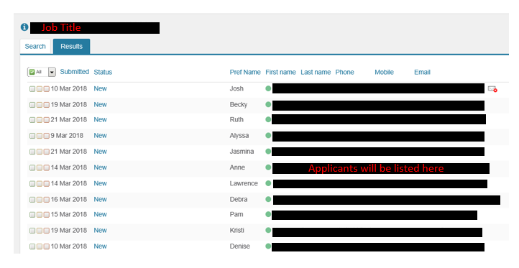

***If you do not need to indicate interview pools,*** ***hold down the CRTL button and click here.***

**Placing Applicants into Interview Pools**

**\*\***This step is only required if you have more than one pool of applicants. This is the only way Human Resources and Affirmative Action will know you have more than one pool.

1. To place your applicants into interview pools, first, click on the applicant’s first or last name.



1. Once you have clicked on their name, the applicant card will appear. It should look like this:

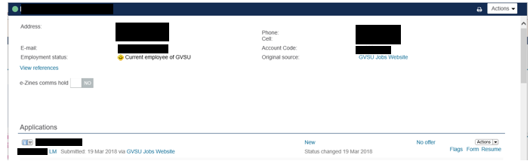

1. Refer to the “Applications” Section. 
2. On the right, you will find a small “Actions” drop down menu. Click on it. 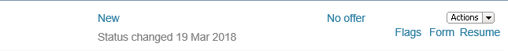
3. The below options will appear. Select “Interview Pool.”

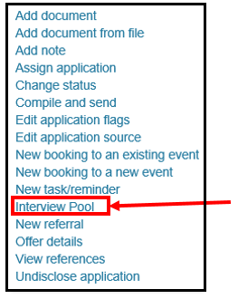

1. This screen will appear:

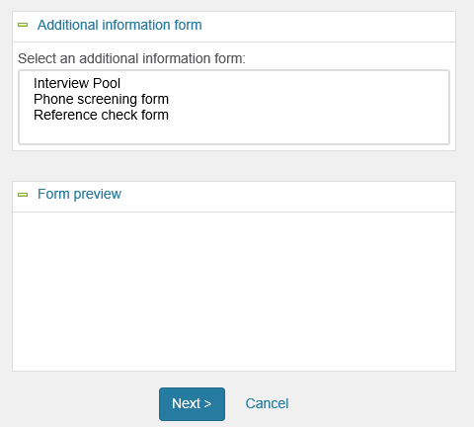

1. Select “Interview Pool” and then select which interview pool. Click “Next.”

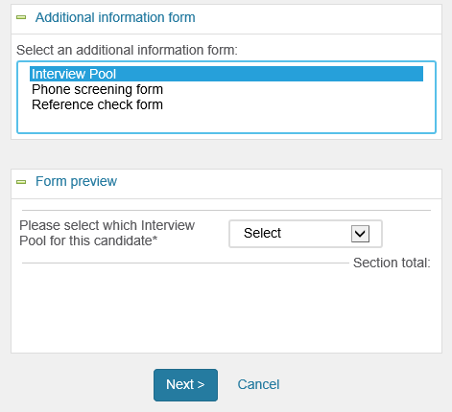

1. Select the interview pool once more and then click “Save.”

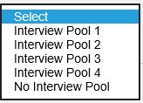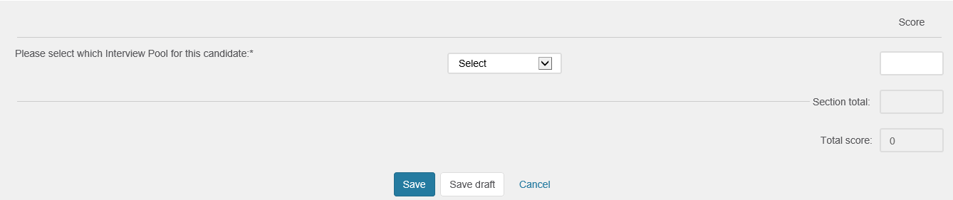

1. Once you click save, it will bring you back to the applicant card. You can close out of it.

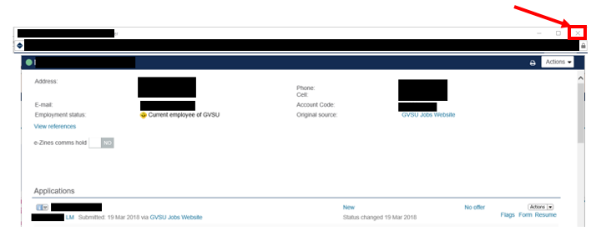

1. That applicant is now in the correct interview pool. You **must do this** **for each applicant** in your pools. It is very important the pools are documented! Please complete this, if you have interview pools.

**Moving Applicants forward in the Interview Approval Process**

1. Now you must select all of the applicants you would like to get approved for the interview. To do this, refer to the three boxes to the left of the applicant’s name.

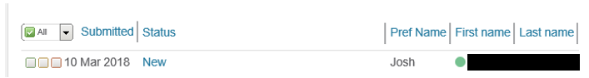

1. Select the leftmost box. The box should turn green with a white check mark in it.

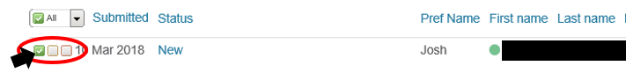

1. Do this for **all** of the applicants.

Search Chairs: If you cannot find all the applicants on your screen, you may need to go to the other pages.

**If selecting *all* the applicants *in that status*: Click on the “All” icon to select every applicant at once. You may have to use the drop down arrow to find it**



1. Once all of the applicants you want are selected, refer to the upper left side of your screen, above the job title.

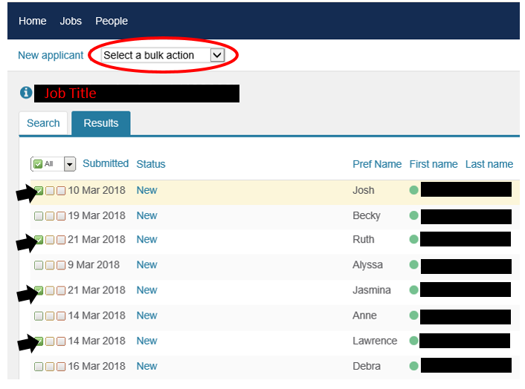

1. Click on the down arrow and a drop down menu will appear.

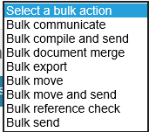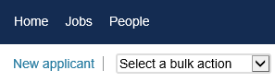

1. Select “Bulk Move”
2. The system may take a minute to think. Please wait until this screen appears.

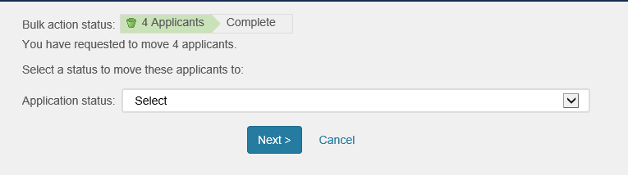

1. Click on the drop down arrow and all of the potential applicant statuses will appear.

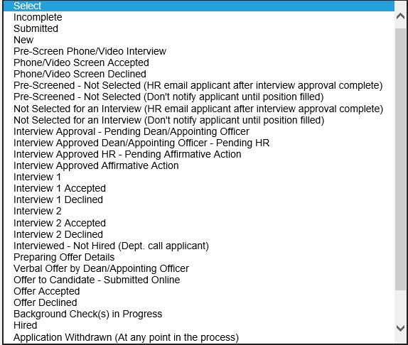

1. Below, in red, are the various roles for an interview approval. The arrow next to the role shows which status you must move the selected applicants to.

(AP or Faculty position approval process shown)



**Human Resources**

**Dean/Appointing Officer or their Assistant (AP and Faculty only)**

**Search Chair**

**Affirmative Action**

1. After you have selected the correct status, then press “next.”

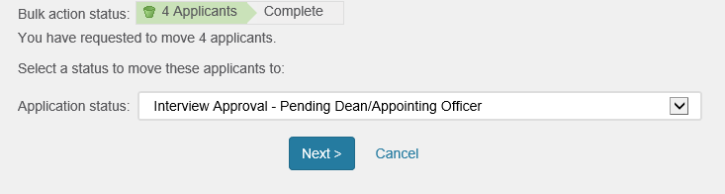

1. When the next screen appears, **scroll all the way down until you see:** 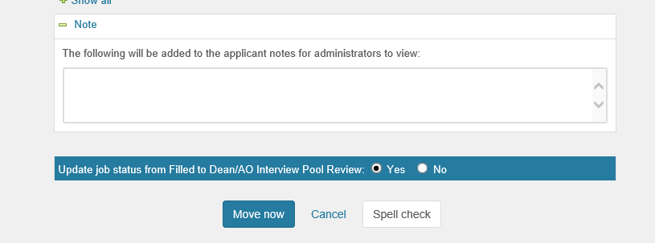
2. Click on Move now.



1. This will **move** the **applicants** into the **status** you chose and it will also **notify** the **next** **department** in the approval process **automatically**.

Listed below are the **automatic emails** that will get sent when moving the applicants. The **green** indicates who has **initiated the email** with the status change and **blue** are those who **will receive** the automatic notification.

The “{JOBNO}, {JOBTITLE}, and {SELECTEDAPPLICANTS}” will auto populate.

**Search Chair** to **Dean/Appointing Officer** and their **Assistant**

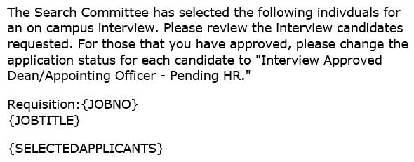

1. **Dean/Appointing Officer** or their **Assistant** to **Human Resources**

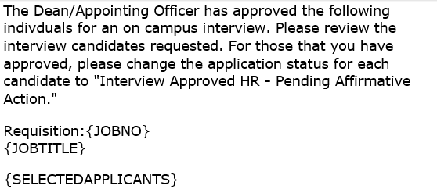

1. **Human Resources** to **Affirmative Action**

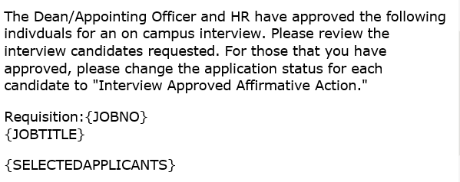

1. **Affirmative Action** to the **Search Chair** and **Dean/Appointing Officer’s Assistant**

