*Approving new/replacement positions or position changes.*

05/17/2018

Job Card Approval Process- Search Chair/Assistant

**PAGEUP APPLICANT TRACKING SYSTEM**

**Reminder: You must allow pop ups for this system to work properly.**

1. **Log into** [www.gvsu.edu/hiring](http://www.gvsu.edu/hiring) using your GVSU Network account.
2. Your home screen will look like below.

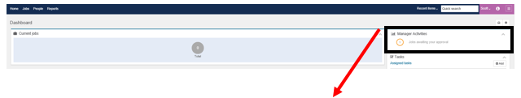

1. Please **refer** to the **right** of the screen.



1. **Click** on **Jobs awaiting your approval.**



1. **Click** **View** next to the job you are approving.

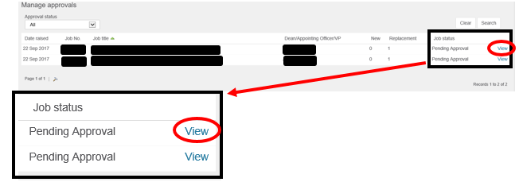

1. The **Job Card** will appear. 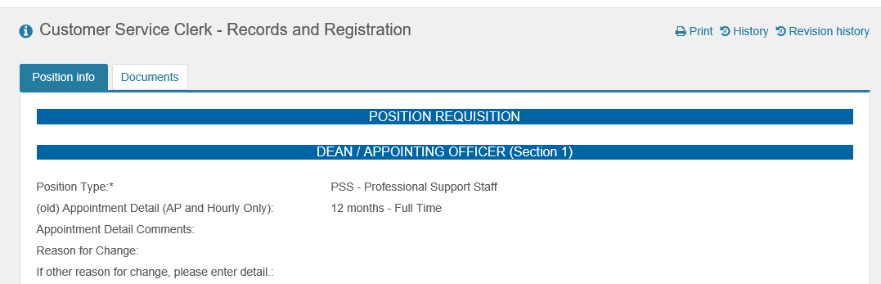
2. Scroll down to the Search Chair Section.
   1. 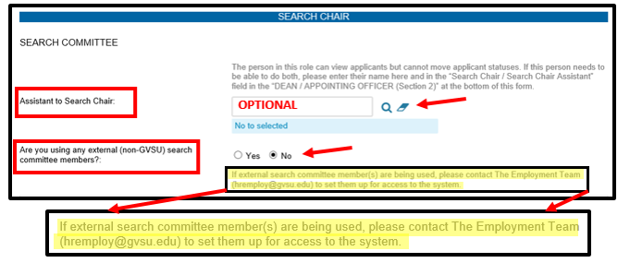Enter the Search Chair Assistant (if applicable) by entering the name or using the magnifying glass. *This is not the field for the Search Chair.*
   2. 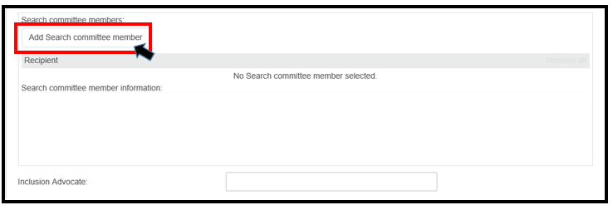Enter the Search Committee by clicking the **Add Search committee member** button.
   3. **Search** for each committee member by their name, and then click **Add**. When you have added everyone, *including the inclusion advocate*, press **Done**. You **do not** need to add the search chair here.

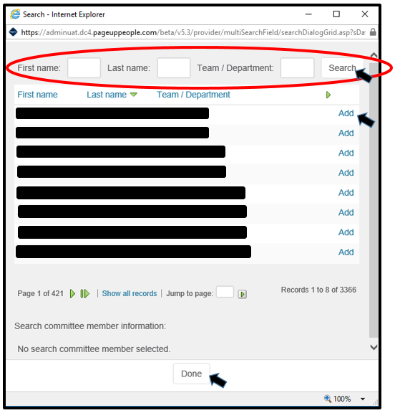

* 1. 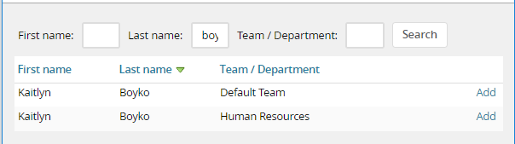**When searching for committee members, you may find that some individuals have two names that appear**.

In order to select the correct member, look at the Team/Department that is listed next to their name. Do not select the name that has “Default Team” under their Team/Department; the search committee member will not have the ability to access the applications.

* 1. 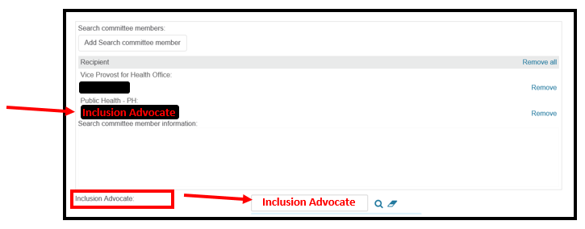 Enter the Inclusion Advocate into the box shown below: The inclusion advocate should be listed **both** in the search committee member’s area and the inclusion advocate box.

1. Enter the Position Details.
   1. Enter your advertising sources – list them in the box provided.
   2. Provide an Adverting Summary – this is a short paragraph that is displayed on the job website. To see an example, visit [jobs.gvsu.edu](http://www.jobs.gvsu.edu).
   3. 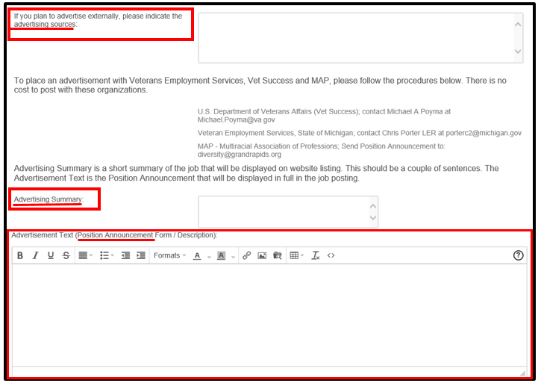 Copy and paste your position announcement – use the template that is found on the [Human](http://www.gvsu.edu/hro) Resources [website](http://www.gvsu.edu/hro/hiringforms). *It is easiest if you copy the announcement into WordPad and then copy and paste it from WordPad into the website.*
2. 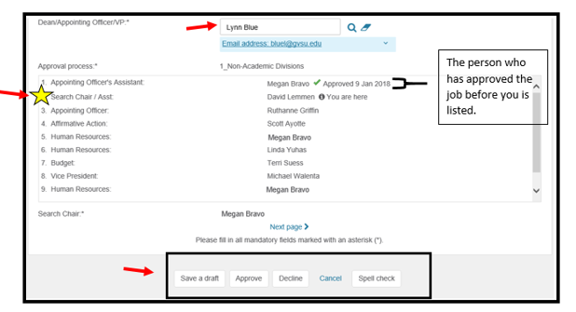Once you have input the correct information, **scroll to the bottom** of the **Job** **Card**. Listed here is the approval process, which will list everyone who has viewed and approved the job card before you as well as who will view and approve it after you.
3. 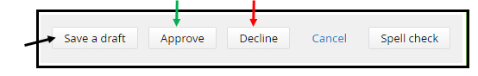You must **Approve/Decline** the **Job Card.**
   1. **Save a draft:** Click **Save a draft** if you would like to save the job card and finish the approval process at a later time.
      1. If saving a draft, click **OK** in the box when it asks if you want to save the following as a draft.
   2. **Approve**: Click **Approve**. This will save all changes that you have done and will automatically send an email to the next approver in the process.
   3. **Decline**: Click **Decline** at the bottom of the screen. **
      1. Select a reason for this selection.
      2. Click Save.

**\*\*Please note: If you have a question or concern that can be addressed with Human Resources before clicking decline, please contact us. When you click decline, the entire approval process must start over whereas Human Resources can edit the job card without restarting the process. Please contact us at 616-331-2215 or** [**hremploy@gvsu.edu**](mailto:hremploy@gvsu.edu)**. \*\***