Approving new/replacement positions or position changes.
05/17/2018
Job Card Approval Process- Executive Officer
PAGEUP APPLICANT TRACKING SYSTEM
Reminder: You must allow pop ups for this system to work properly.
- Log into www.gvsu.edu/hiring using your GVSU Network account.
  - Your home screen will look like below.
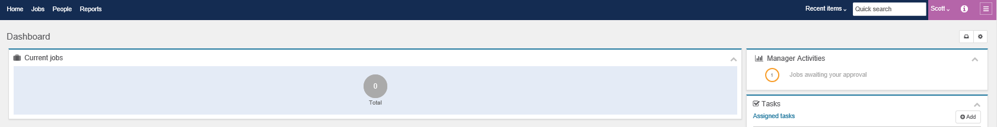

- Please refer to the right of the screen.
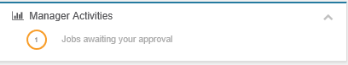

- Click on Jobs awaiting your approval.

- Click View next to the job you are approving.

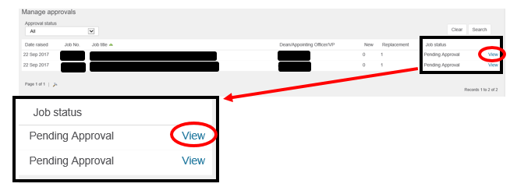

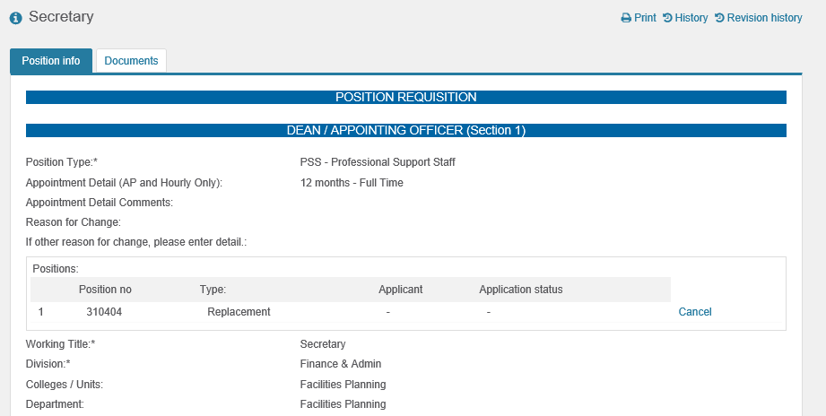
- The Job Card will appear. As the Executive Officer, please verify that all of the completed information on the job card is accurate.

- You may add comments in the HR / Vice Provost / Affirmative Action / Vice President Box.

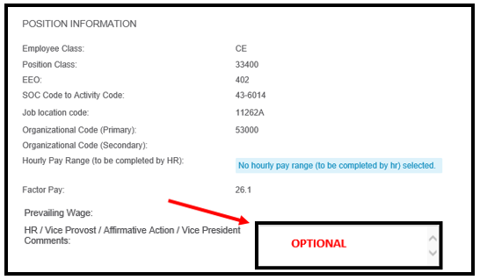

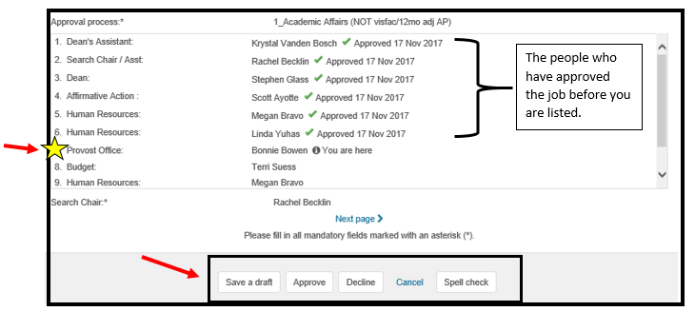
- Once you have verified the information is correct, scroll to the bottom of the Job Card. Listed here is the approval process, which will list everyone who has viewed and approved the job card before you as well as who will view and approve it after you.

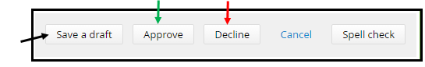
- You must Approve/Decline the Job Card.

  - Save a draft: Click Save a draft if you would like to save the job card and finish the approval process at a later time.
    - If saving a draft, click OK in the box when it asks if you want to save the following as a draft.
  - Approve: Click Approve. This will save all changes that you have done and will automatically send an email to the next approver in the process.
  - Decline: Click Decline at the bottom of the screen. **
    - Select a reason for this selection.
    - Click Save.
**Please note: If you have a question or concern that can be addressed with Human Resources before clicking decline, please contact us. When you click decline, the entire approval process must start over whereas Human Resources can edit the job card without restarting the process. Please contact us at 616-331-2215 or hremploy@gvsu.edu. **

