*Creating a HAF for a New or Replacement Position.*

05/17/2018

Job Card Approval Process- Creating the Job Card

**PAGEUP APPLICANT TRACKING SYSTEM**

**Reminder: You must allow pop ups for this system to work properly.**

1. **Log into** [www.gvsu.edu/hiring](http://www.gvsu.edu/hiring) using your GVSU Network account.
   1. Your home screen will look like below.
   2. Refer to the upper left corner of this screen and **click** on **Jobs.**

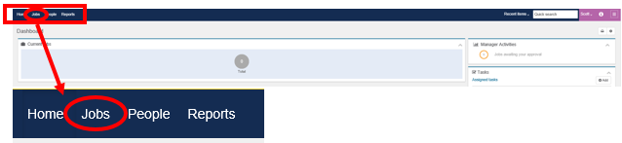

1. Once the system has moved to the next screen, continue to **refer to the upper left corner**. You will see this option. **Click** on **New job.**



1. This will appear on the next screen. **Select** the **department** using the drop down menu. Enter the **position** **number** (if known). If you do not have a position number, leave the field blank and click **Next**.

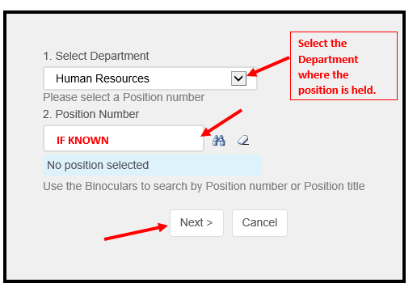

1. Complete the blank **Job Card** that appears. **The Dean/Appointing Officer Assistant is responsible for filling in all of the mandatory fields, which are indicated by an asterisk (*).**
   1. You must select the position type (PSS, EAP etc.) using the drop down menu. There is a comment box if you wish to include any comments on this position.
   2. If there is a change with a replacement position, select the reason for change, such as Title Change or FTE Change.
   3. 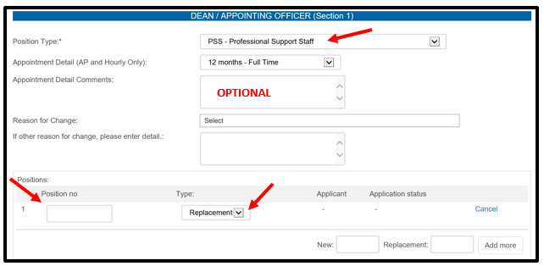Indicate whether this is a **new** or **replacement** position. To do this, click on the drop down menu and select either new or replacement. Also, if known, put in the position number.
   4. *If multiple positions*, enter the number of new or replacement positions and then click the Add more button. Repeat step C to finish this section.



1. Enter/edit the title of the position.
   1. If you have already entered the positon number from Step 1, your title will automatically populate. If the title is abbreviated, edit appropriately.
2. Select the Division, Colleges/Units and Department.
   1. If you have already entered the positon number from Step 1, your information will automatically populate. Verify that this is accurate and/or edit appropriately.

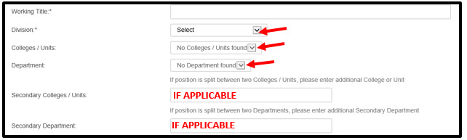

*If applicable, select the secondary college/ Units and Department.

1. Enter the correct information in the fields below. **Do not fill in the Requisition number**, as it will be automatically generate. This is not the same as the position number.

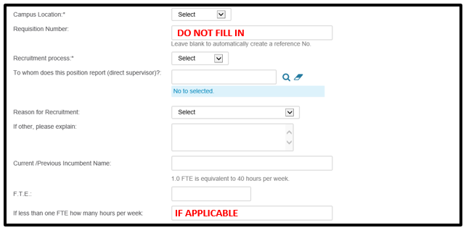

1. Enter the correct information in the fields below:

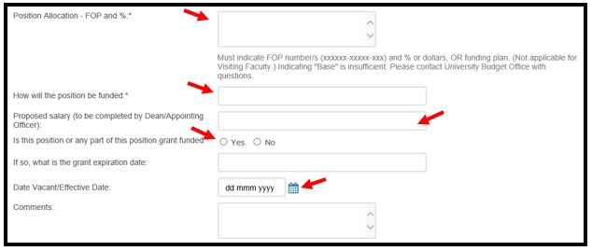

1. **Enter Search Chair section – This section varies by Department and/or College.** If you are not filling out this section, please click on Dean/Appointing Officer Section 2.
   1. 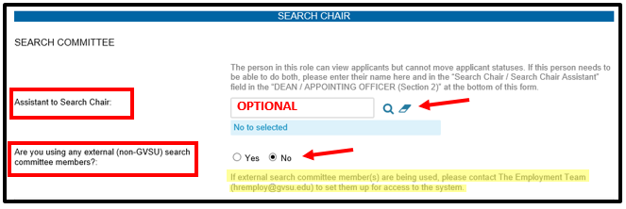Enter the Search Chair Assistant (if applicable) by entering the name or using the magnifying glass. *This is not the field for the Search Chair.*
   2. Enter the Search Committee by clicking the **Add Search committee member** button.

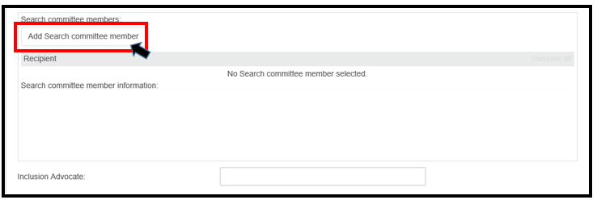

* 1. **Search** for each committee member by their name, and then click **Add**. When you have added everyone, *including the inclusion advocate*, press **Done**. You **do not** need to add the search chair here.

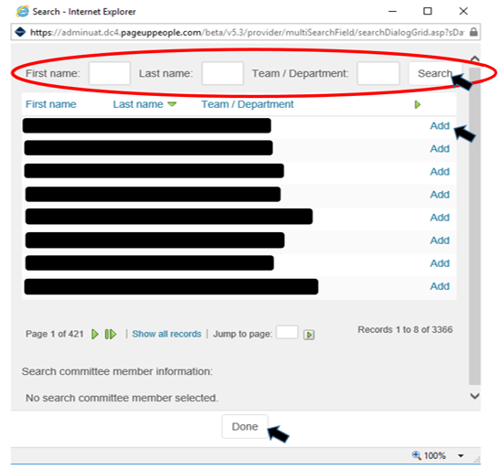

* 1. 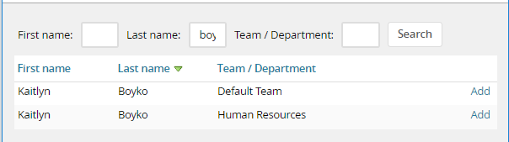When searching for committee members, you may find that some individuals have two names that appear.

In order to select the correct member, look at the Team/Department that is listed next to their name. Do not select the name that has “Default Team” under their Team/Department; the search committee member will not have the ability to access the applications.

* 1. 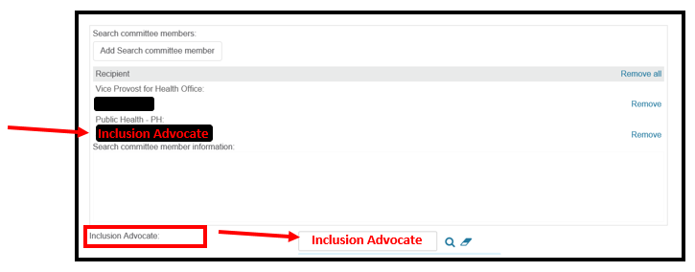Enter the Inclusion Advocate into the box shown below: The inclusion advocate should be listed **both** in the search committee member’s area and the inclusion advocate box.

1. Enter the Position Details.
   1. Enter your advertising sources – list them in the box provided.
   2. Provide an Adverting Summary – this is a short paragraph that is displayed on the job website. To see an example, visit [jobs.gvsu.edu](http://www.jobs.gvsu.edu).
   3. Copy and paste your position announcement – use the template that is found on the [Human](http://www.gvsu.edu/hro) Resources [website](http://www.gvsu.edu/hro/hiringforms). *It is easiest if you copy the announcement into WordPad and then copy and paste it from WordPad into the website.*

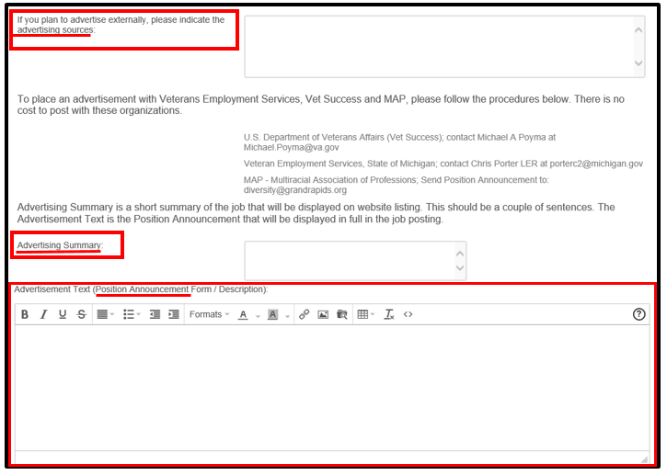

1. Scroll down to the Dean/Appointing Officer Section 2 and enter the APPROVERS AND APPROVAL PROCCESS.
   1. Enter Megan Bravo into the Human Resources field.
   2. Enter the Dean/Appointing Officer Assistant’s name into the Assistant to Dean/Appointing Officer/VP field.
   3. 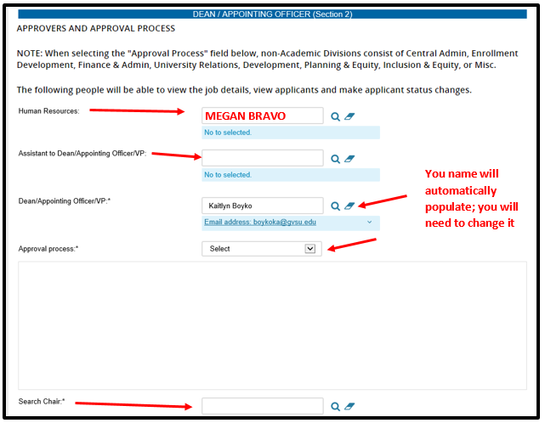Enter your Dean/Appointing Officer’s name into the Dean/Appointing Officer/VP field. **Your name will automatically populate; you will need to change it.**
   4. Choose the Approval process for your position. The chart below will assist you.

|  |  |
| --- | --- |
| **Academic Divisions** | **Non-Academic Divisions** |
| Academic – Salaried (AP, Tenure Track Faculty) | Non-Academic – Salaried (AP Only) |
| Academic Split Between 2 Deans | Non-Academic Split Between 2 Appointing Officers |
| Academic Hourly | Non-Academic Hourly |

* 1. Fill in the fields with the appropriate people. **Some of the fields will automatically populate; do not change these fields.**
  2. Enter the name of the Search Chair into the Search Chair field.

1. Saving a job card.
   1. **Save a draft:** Click **Save a draft** if you would like to save the job card and finish the approval process at a later time.
      1. If saving a draft, click **OK** in the box when it asks if you want to save the following as a draft. Note: The approval process, if set, will be deleted.
   2. **Save:** To move the job forward in the process: **Click** **Save**. This will save the job card and automatically send an email to the next approver in the process.

**\*\* Please note: If you have a question or concern that can be addressed with Human Resources, please contact us at 616-331-2215 or** [**hremploy@gvsu.edu**](mailto:hremploy@gvsu.edu)**.\*\***

