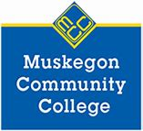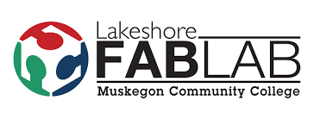
MCC’s 3rd Annual Talent Pipeline & STEM Events
Elementary School – 4/5 Graders
WHERE: Muskegon Community College’s Sturrus Technology Center and Lakeshore Fab Lab
388 W. Clay Avenue, Muskegon, MI
WHEN: Friday, June 5, 2020
Session One: 8:00am-11:00am Session Seven: 10:00am-1:00pm
Session Two: 8:20am-11:20am Session Eight: 10:20am-1:20pm
Session Three: 8:40-11:40am Session Nine: 10:40am-1:40pm
Session Four: 9:00am-12:00pm Session Ten: 11:00am-2:00pm
Session Five: 9:20am-12:20pm Session Eleven: 11:20am-2:20pm
Session Six: 9:40am-12:40pm Session Twelve: 11:40am-2:40pm
Session Thirteen: 12:00pm-3:00pm

- Due to limited availability, each school district is limited to one session/group. If all the sessions do not fill, then multiple groups from the same district/school will be allowed.
- Each session will consist of a 20 minute information session, 100 minute self-guided tours of the 5 applied technology labs where students will meet with representatives from local manufacturing companies and an MCC student, 20 minute snack time with additional information, and 40 minutes in the Lakeshore Fab Lab for STEM activities.
- Each session/group should have 30-40 students. (minimum of 25 students) A minimum of 2 adult chaperones are recommended with each group.
- Registration is “first come, first serve” including session preferences. List all sessions, in order of preference that your school/group can attend.
- Schools will be eligible for a $200 bus voucher for travel expenses.

School Name
Primary Contact
Phone Number
E-mail Address
Number of students
Number of busses
Session requested (list all in order of preference)
Make checks payable to
Address to mail check

designit.buildit.repairit.
To register, email this form to Cyndi Langlois at cyndi.langlois@muskegoncc.edu

