Name:________________________

User ID: _________________________

UltraTime Vacation Reporting Supervisor User Guide

This guide will explain how to use UltraTime to approve the vacation time of your AP Staff members.

Questions or Temporary Approver Changes?

If you have any questions regarding the reporting of vacation usage or approval, please contact the Payroll Office.

If you are going to be gone during the approval period and need to temporarily allow someone else to approve vacation on your behalf, please contact the Payroll Office.

Phone: (616) 331-2237
Email: payroll@gvsu.edu
How to Log In

Access UltraTime at www.gvsu.edu/payroll Select “UltraTime” tab.
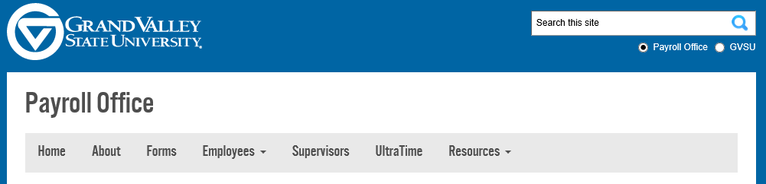

Clicking on the link will bring you to the following screen:

Select “Login to Ultratime”

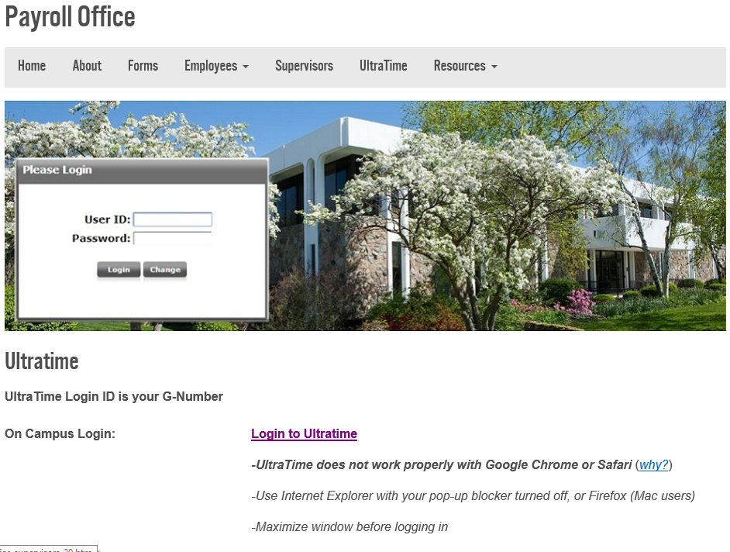

Log In Screen
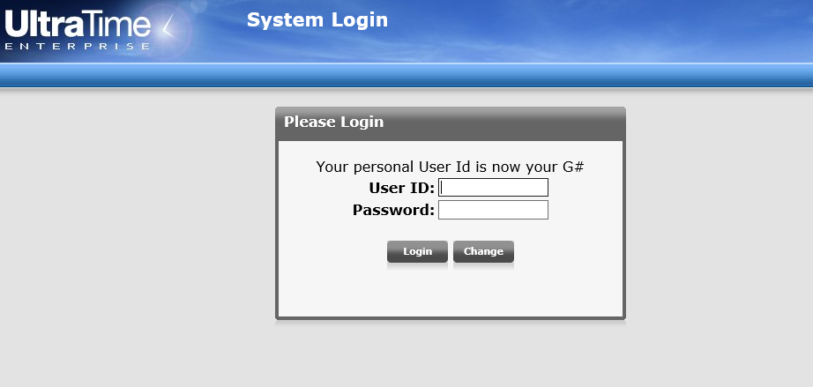
****BEFORE LOGGING IN, ULTRATIME WINDOW MUST BE MAXIMIZED!!****
If the window is not maximized, you may not be able to view all information on the screen.

User ID: Your email address without @gvsu.edu.

Password: Default password is ‘super’. You will be prompted to change your password the first time you log in. If you are already an UltraTime supervisor, your password will be whatever you set it to be.

To create a shortcut on your desktop:
- Right Click on the Desktop
- Go to New > Shortcut
- For Location, use: https://timeclock.gvsu.edu/UltraTime
Once logged in, you will be brought to your Main Menu screen:
- Select AP Supervisor Calendar to view the Vacation Calendars of your AP Staff to approve their time off.
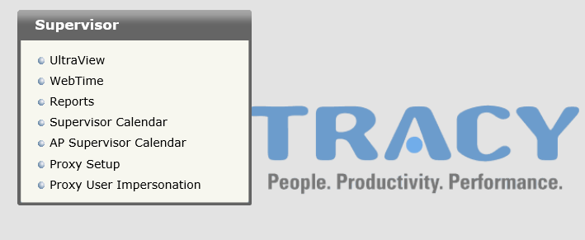

The AP Supervisor Calendar will populate with the current quarter of the year, similar to the screen shot below:

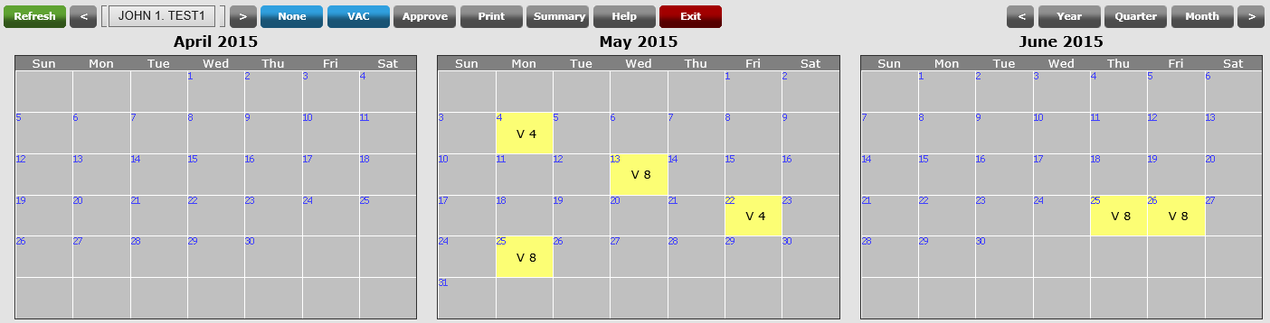

Explanation of Toolbar:
1
6
3
4
5
8
2
7

- Refresh: Refreshes the screen you are viewing.
- JOHN1. TEST1: Shows the name of the staff member you are viewing.
- None: Used to note that no vacation was taken in the quarter.
- VAC: Allows you to set up a macro to record vacation time.
- Approve: Approves vacation time.
- Print: Prints a Yearly Attendance Calendar for the staff member.
- Exit: Takes you out of the Calendar view of UltraTime.
- Year, Quarter, Month: Changes the time frame you are viewing to a year, quarter, or month view.

Selecting an Employee:
The names off all of your AP staff members, will appear when entering in the AP Supervisor Calendar mode. To select a specific staff member, follow the directions below:

- Click on the Employee’s name that is showing.
- A box will appear with the name of your staff members.
- Type the last name of the staff member you would like to view. The list will sort to bring their name to the top of the list.
- Click on the staff member’s name. Their calendar will appear.
- To scroll through staff members, use the arrow buttons at the bottom of the box or the up and down arrow keys on the keyboard.

NOTE: All employees need to indicate each quarter their vacation used or “none” if they did not use any vacation that quarter.

Approving Vacation Time:

At the end of the quarter, you will review your staff member’s vacation time and approve their vacation time taken. Approval of vacation time or none time should always be done in retrospect.

Vacation time can be approved for the entire quarter all at once. However, if there is a day that should not be approved, it should be marked as unapproved before approving the rest of the quarter.

When entering the calendar mode, the screen will default to the current quarter. When reviewing vacation time, be sure that the screen is set to the appropriate quarter.

Approved Vacation Days

- Review the vacation days and make any corrections if needed.
- Click on ‘Approve’.
- The following notification box will appear, and notify you of how many pending request are unapproved. Select the ‘Approved’ radio button and then click ‘OK’. The day will be colored in green to signify that the day was approved for vacation.
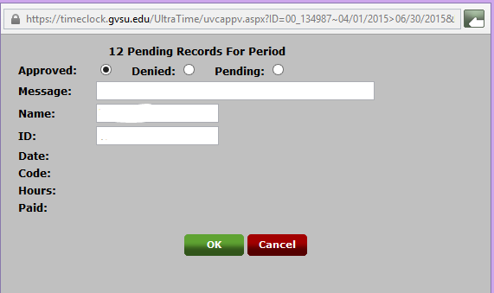

Undo the Approve

- Right click on the approved day you want to change to unapproved.
- Click on ‘Approve/UnApprove’.
- In the box that appears, click on the ‘Denied’ option. Click on ‘OK’. This will change the day from Approved to Unapproved (Green to Red).
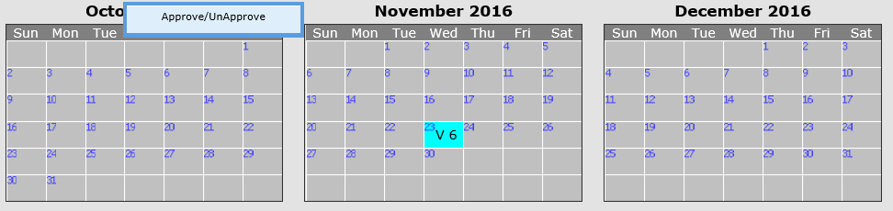

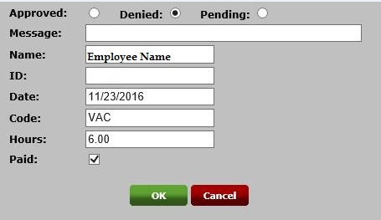

Entering ‘No Vacation Taken’

If no vacation was taken within the quarter, this must be noted on your staff member’s vacation report.

- Click on the ‘None’ button. 
- A conformation will pop up to conform NONE for the last day of the quarter. Select ‘OK’.
- Once confirmed a ‘N’ will appear on the last day of the quarter, and it is considered submitted.


