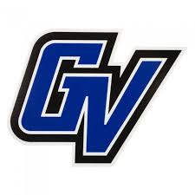 **Laker Junior Golf Program**

Train like a college golfer! This program offers weekly instruction and practice session in a college practice style setting. Participants will receive instruction from Head Men’s Golf Coach Gary Bissell and Assistant Coach Steve Milewski, as well as an OFFICIAL GVSU golf team hat!

This program is designed to allow junior golfers to prepare and learn in the same setting as college players. Participants will work on an individual basis with the coaches on improving their unique skill sets. Week 1 will begin with fundamental analysis from full swing down to putting. Over the course of the 5 weeks our coaches will improve participant’s fundamentals, enhance skill, and help create more efficient practice habits.

* All students will receive video analysis showing improvement
* Program cost: $250
* This program is **limited to 8 participants** per age group!

*Sign up fast before program is full!*

**Bachelor’s Program: Ages 12-14 Master’s Program: Ages 15-17**

**Monday**: 8:45-11:00 A.M **Wednesday**: 8:45-11:00 A.M

June 18 June 20

June 25 June 27

July 9 July 11

July 16 July 18

July 23 July 25

Stop by The Meadows Pro Shop, call at 616-331-1004, or email at [meadows@gvsu.edu](mailto:meadows@gvsu.edu) to Register.