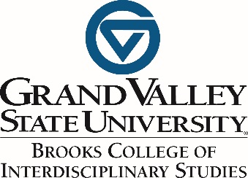

Honorarium for Foundations of Online/Hybrid Course Training
for Part-Time and One-year Visiting Faculty

Part-time and one-year visiting faculty teaching in the Brooks College of Interdisciplinary Studies are eligible to receive a $300 stipend for completing the GVSU certification training to teach online/hybrid
courses. This form must be complete and signed by appropriate unit head.

Name of Instructor: ___________________________________________________

Course Number : ___________________________________________________

Course Title: ___________________________________________________

Number of credits: ___________________________________________________

Semester offered: ___________________________________________________

Class format
(hybrid or online): ___________________________________________________
Training Completion
Date: ___________________________________________________

Signature of Instructor: ___________________________________________________

Signature of Instructor’s Unit Head: ___________________________________________________

Please return this completed form and a copy of the certificate of completion to Noreen Savage in the Brooks College Dean’s Office.

