Applied Behavior Analysis Graduate Certificate

Many schools and mental health agencies are seeking professionals who can incorporate behavior analytic principles and practices into their services and supports for individuals with learning and behavior challenges.

The GVSU Psychology department is offering an online graduate level certificate in Applied Behavior Analysis (ABA) that will allow students to pursue certification as a Board Certified Behavior Analyst (BCBA). Students complete seven courses (315 hours and 21 credits) that meet the 5th Edition Task List coursework requirements of the Behavior Analyst Certification Board (BACB). A master’s degree is required for admission to the program.

The program emphasizes the integration of behavior analytic principles and practices in school settings, and working collaboratively with clinical professionals providing ABA services. Program faculty members have strong connections to the educational and mental health community and provide real-world examples of working at both an individual and system level.

To become a BCBA, students must meet the BACB course requirements, meet supervised experience requirements, and pass the BCBA exam. For more information about becoming a Board Certified Behavior Analyst, go to http://bacb.com.

GVSU ABA Graduate Certificate Courses
PSY 522 | ABA I: Foundational Principles (first course) | 3 credits | 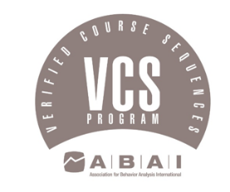
PSY 523 | ABA II: Application to Behavior Change | 3 credits
PSY 550 | Research in Applied Settings | 3 credits
PSY 624 | Behavioral Assessment and Intervention | 3 credits
PSY 527 | Ethics and Diversity in Professional Practice | 3 credits
PSY 525 | Behavior Analysis Applied to Autism Spectrum Disorders and Developmental Disorders | 3 credits
PSY 658 | Advanced ABA | 3 credits
TOTAL |  | 21 credits
Courses offered online
First course in the sequence starts in the fall

Visit our website at www.gvsu.edu/grad/aba
Contact Amy Matthews at matthewa@gvsu.edu or karsteam@gvsu.edu for more information

