Vending Machine Self-Management System Date:______________
Morning Break – Vending Machine Selection
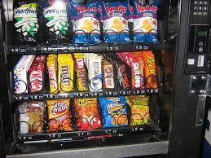 | 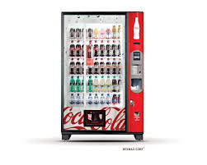
Food Selection | Drink Selection

Lunch – Vending Machine Selection
Food Selection | Drink Selection

Afternoon Break – Vending Machine Selection
Food Selection | Drink Selection

