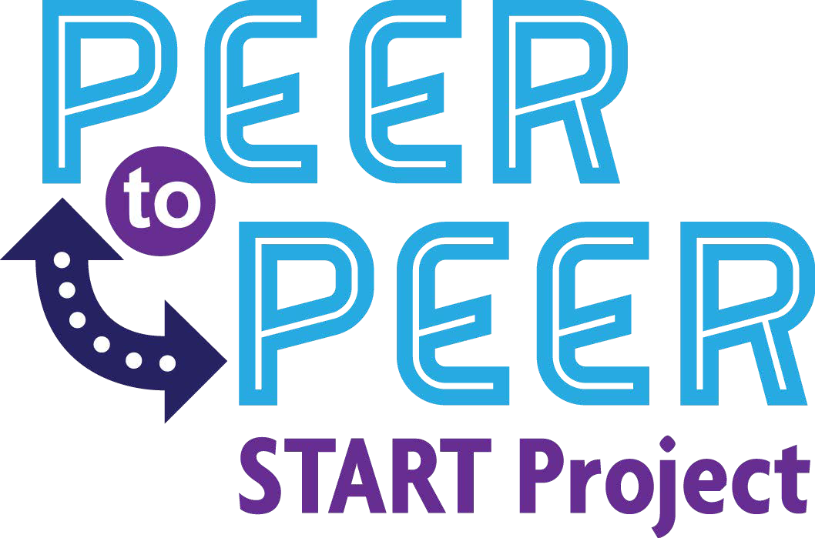

DATE

Dear Parents and/or Guardians,

TEACHER'S classroom is beginning a new program called Peer to Peer. This is a program where students from SCHOOL NAME will be “Linked” up with students in TEACHER'S NAME classroom. The purpose of the program is to increase socialization and independence skills within the classroom setting. With this program, the middle school students may ask questions about student’s abilities, disabilities, likes, dislikes, strengths, weaknesses, etc. We are asking your permission to discuss this information with students. We will not disclose personal family information - only information and pictures will be shared that will help create a bond amongst students.

If you have questions please feel free to contact TEACHER'S NAME AND CONTACT INFORMATION. You may also contact
ADMINISTRATOR OR SUPERVISOR NAME AND CONTACT INFORMATION.

This will be a rewarding experience for all individuals involved.

My son/daughter has permission to participate in the Peer to Peer Program.

Parent/Guardian Signature Date

