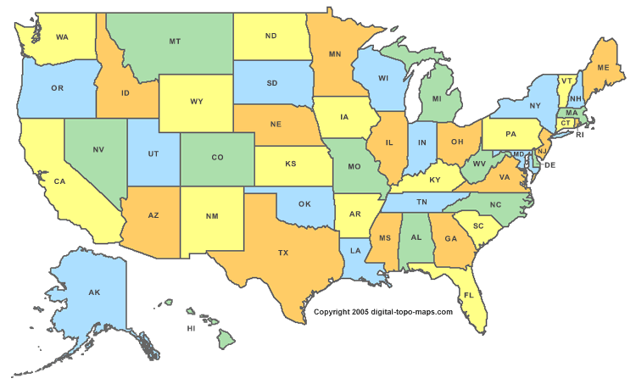

**6** = Colorado True False

**7** = Connecticut True False

**8** = Delaware True False

**9** = Florida True False

**10** = Georgia True False

**1** =Alabama True False

**2** = Alaska True False

**3** = Arizona True False

**4** = Arkansas True False

**5** = California True False

9

7

4

6

5

10

3

88

2

**1**

**True**

**False**