

Looking Towards the Future:

Using Person‐Centered Planning Tools Pre‐K Through Adulthood

Teresa Cogar, M.Ed. VCU‐ACE Training Staff

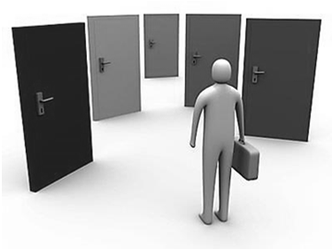

Currently………

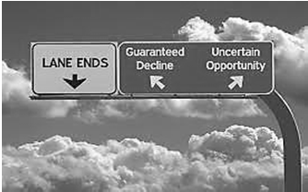

Make Decisions for Them

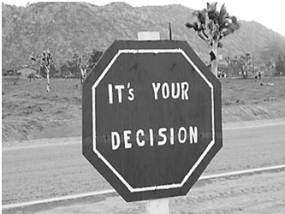

Not With Them

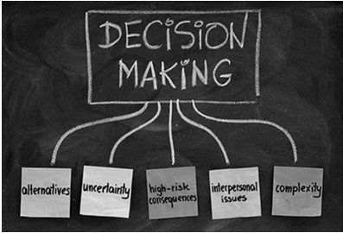

What if we could………

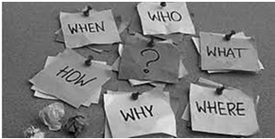

Make Decisions with Them



Not for Them

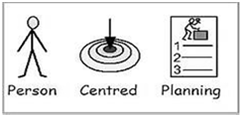

What is Person‐Centered Planning

* A decision making process to plan for the future.
* Increase the individual’s quality of life by developing a plan to support hopes, dreams and passions.
* Brings together a support network of people to help support individual to reach desired outcomes.

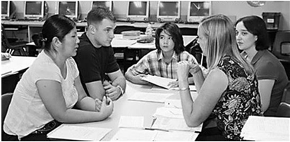

Involves a Dedicated Team

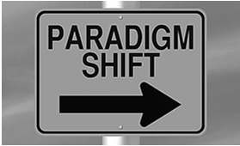

What are you currently doing?

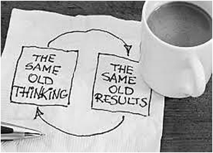

Changing Mindsets

The only true failure is when we walk away and assume *incompetence*.



Invest in standardized testing

and assessments.

* Generate written reports.

Adapted from: *Person –Centered Planning: Finding directions for change using personal futures planning.* By Dr. Beth Mount

* See individuals in the context of their environment/community

•

Depend on people, families and people who work directly with them to build good descriptions.

•

* Depend on professionals to make judgements.
* Spend time getting to know person.
* Emphasis on deficits and needs.
* Search for capabilities, gifts.
* Focus on labels.
* See people first.

**System‐Centered**

**Person‐Centered**

Person Centered vs. System Centered



Importance of Person –Centered Planning

* Helps to focus on person to see the total person.
* To recognize the person has desires and interests and goals, hopes and dreams!
* To discover different ways to think about the individual’s future (education, quality of life).



Person‐Centered Outcomes

* Know themselves
* What the want/like/don’t like
* Better quality of life
* Employment
* Relationships
* Living Arrangements

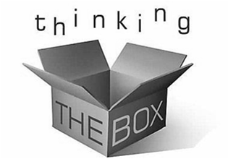

What Our Students Need

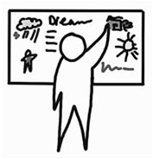

Things like….

* How do they learn?
* How do they communicate?
* How do they respond?
* What are their strengths, preferences, needs, etc.?
* Who are the important people in their life?

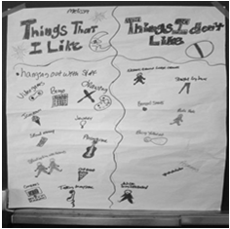

Tools To Use

* Good Day Plan
* One Pager
* Goal Setting
* MAPS
* PATHS



Good Day Plan

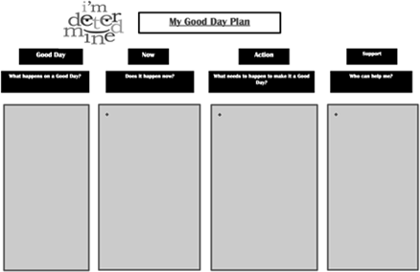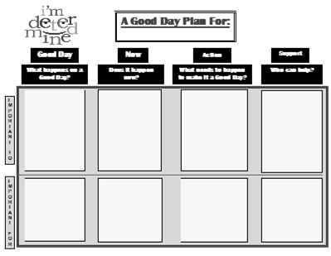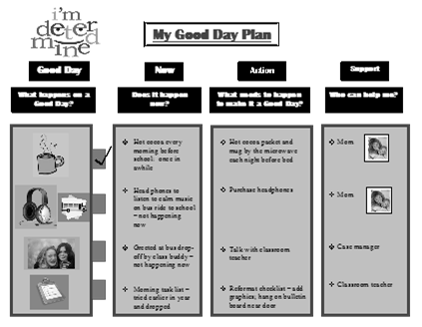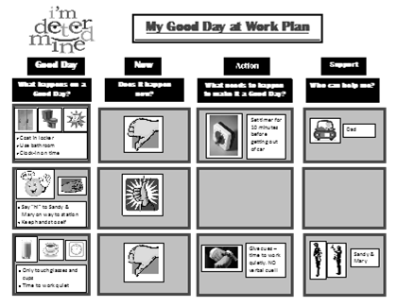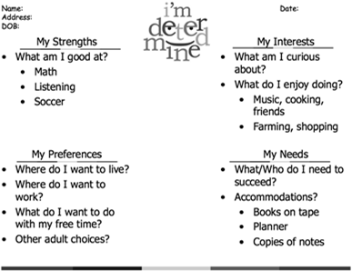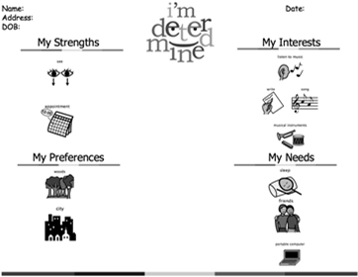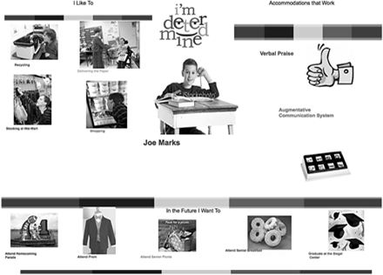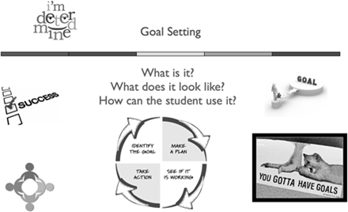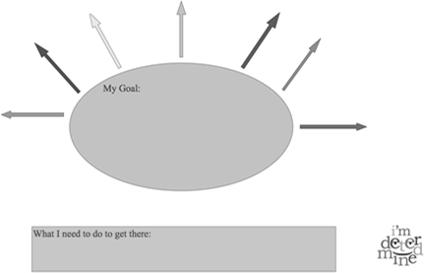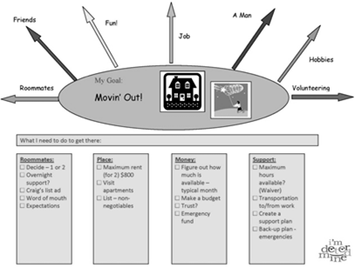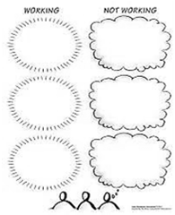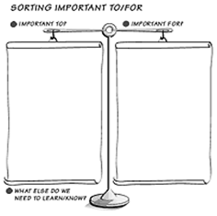

MAPS ‐ Making Action Plans

Created by Marsha Forest & Jack Pearpoint, Inclusion Press

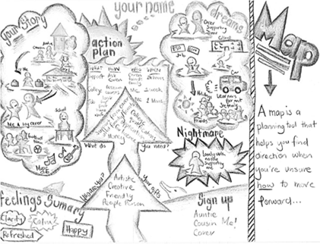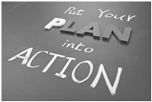

PATH ‐ Planning Alternative Tomorrows with Hope

Created by Marsha Forest & Jack Pearpoint, Inclusion Press

* Uses graphic facilitation to map out a vision of a desirable future for an individual .
* Is highly effective when used to develop a vision or plan for a positive future for an individual with a disability and planning personalized supports and services.
* Goals are set, as part of the journey, then actions to achieve these goals are recorded.

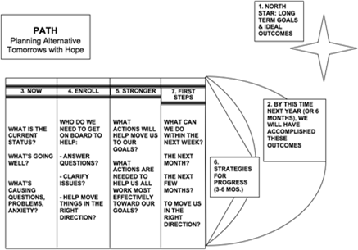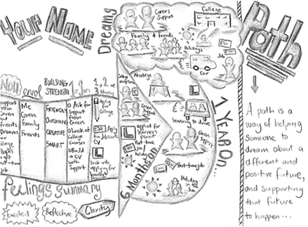

Person‐Centered Meeting

* What assistive technology may the need during the meeting?
* What type of prompts may they need during the meeting?
* Is there a visual agenda?
* Have they practiced ahead of time?

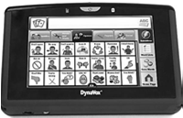

Assistive Technology

* Augmentative Communication Devices
* Tablets and IPADS

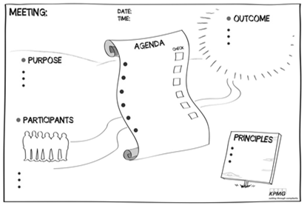

Visual Agenda

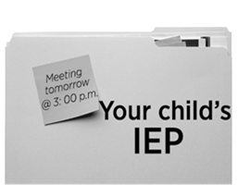

How do we incorporate the tools in a system centered world?

* IEP Planning
* FBA/BIP Meetings
* Transition Planning
* Parent Conference
* Parent Nights

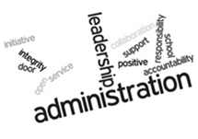

Benefits for Administrators

* Better understanding/relationship with student.
* Better understanding/relationship with parent/guardian.
* Staff have instructional time back.
* Students have instructional time back.
* Students have improved behavioral outcomes.



Benefits for Staff

* Better understanding/relationship with student.
* Better understanding/relationship with parent/guardian.
* Individualized instructional interventions.
* Individualized behavioral interventions to meet needs of students.



Benefits for Students

* Improved relationship with peers, school staff, admin and parent/guardian.
* Increased time on task.
* Improved behavioral outcomes.
* Setting goals for the future:
  + short‐term
  + long‐term
* Overall Better Quality of Life.

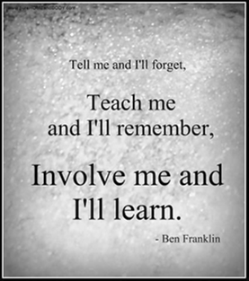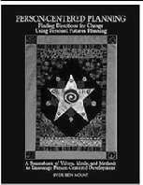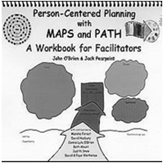

PATH: A Workbook for Planning Positive

Possible Futures, Jack Pearpoint, John O’Brien & Marsha Forest, Inclusion Press, 24 Thome Cres., Toronto, Ontario, Canada M6H 2S5.

Person‐Centered Planning: Finding Directions

for Change Using Personal Futures Planning, Beth Mount, Graphic Futures, Inc., 25 W. 81st St. #16‐B, New York, NY 10024

More Information

* [www.Imdetermined.org](http://www.Imdetermined.org/) & [www.inclusion.com/maps.html](http://www.inclusion.com/maps.html)



Contact Information

Teresa Cogar M.Ed. [tlcogar@vcu.edu](mailto:tlcogar@vcu.edu)