Peer to Peer Support
1st Grade Example

Student with ASD Name: Michael
Grade: 1st Grade
General Education Teacher Name: Mrs. Bell
Special Education Teacher Name: Mrs. Smith
Physical Education Teacher Name: Ms. Johnson
Art Teacher Name: Mr. Thompson
Music Teacher Name: Ms. Vaughn

Michael is a student with ASD integrated full day into Mrs. Bell’s 1st Grade Class. Michael attends all specials with his 1st grade class. A paraprofessional is assigned to the three first grades in the building but because of the high needs of the two students placed in the other 1st grade classrooms; she spends very little time in Mrs. Bell’s Room.
Mrs. Bell stated that Michael does not seem to need direct adult support, but he does require additional support during arrival and departure, class meeting, calendar, share time (carpet area) group work, lunch and math. Ms. Johnson (Physical Education) and Mr. Thompson (Art) also stated having additional support during the time Michael was in their class would be beneficial. Mr. Vaughn (music) explained she did not need an additional support during Music. The team supporting Michael decided to develop a creative peer to peer support program to address Michael’s needs during these times.
Because of how young Michael’s same aged supports are, 1st Grade, Michael’s team decided to use a combination of same age and cross age supports. The cross age supports will include students from 4th and 5th grade classes who attend school in the same building. Because of the location of the school, there is no option of cross age peers from the middle or high school. One alternative high school student is scheduled as a cross age peer for Michael.
Since the team will be using students from a variety of settings, the team had to examine Michael’s schedule to determine where the support is needed.

Michael’s Daily Schedule
Activity | Location | Support
Arrival | Coat Room/Desk | P2P Support Required
Class Meeting | Carpet | P2P Support Required
Calendar | Carpet | P2P Support Required
Math | Desk | P2P Support Required
Recess | Playground | P2P Support Required
ELA | Desk | N/A
Lunch | Lunchroom | P2P Support Required
Recess | Playground | P2P Support Required
Social Studies | Desk | N/A
Share Time | Carpet | P2P Support Required
Science | Desk | N/A
Departure | Coat Room/Desk | P2P Support Required

Mrs. Bell’s 1st Grade Class Specials Schedule
Day of the Week | Special | Time
Monday | Art | 1:25 - 1:55pm
Tuesday | Physical Education | 10:00 - 10:30am
Wednesday | Art | 1:25 - 1:55pm
Thursday | Physical Education | 10:00 - 10:30am
Friday | Music | 2:35 - 3:05pm

Same Age Peer to Peer Supports – Recess

15 of the 27 students in Mrs. Bell’s first grade class have signed parental permission to be a peer to peer support for Michael during Recess. Post schedule in Mrs. Bells Classroom. Highlight schedule and put color on desk of peer to peer support student’s desk so the student knows what day they are a peer to peer support.

Michael’s Peer to Peer Support Recess Schedule
Day of the Week | Student Name | Student Name | Alternate
Monday | Daniel | Katie | Stephen
Tuesday | Caleb | Parker | Connor
Wednesday | Hannah | David | Amy
Thursday | Cole | Marcus | Kelly
Friday | Kayla | Emma | Allison

Cross Age Peer to Peer Supports – Arrival/Departure - Mr. Williams 4th Grade
10 of the 32 Students in Mr. Williams 4th Grade Class have signed parental permission to be a peer to peer support for Michael during arrival to school and departure from school. On the day the peer to peer support student is assigned to Michael, he/she will report to Mrs. Bell’s 1st grade class immediately upon arrival. That same student will leave Mr. Williams 4th Grade Class 5 Minutes prior to end of the day and report to Mrs. Bell’s Room to assist Michael with departure. Post Arrival and Departure Schedule in Mr. Williams 4th Grade Class

Day of the Week | Student’s Name | Alternate
Monday | Dave | Kevin
Tuesday | Michelle | Eric
Wednesday | Melissa | Monica
Thursday | Karen | Jennifer
Friday | James | Amanda

Cross Age Peer to Peer Supports – Lunch – Mrs. Linder’s 5th Grade
24 of the 34 Student’s in Mrs. Linder’s 5th Grade Class have signed parental permission to be a peer to peer support for Michael. 10 of those students will support Michael during Lunch. In this building the Upper Elementary Students (3rd, 4th and 5th Grade) are at recess while the Lower Elementary Students (Kindergarten, 1st and 2nd Grade) are at Lunch. Two Peer to Peer Support Students will be assigned to Michael each day at Lunch. Peer to Peer Support Students will be missing on recess period per week. Post the Lunch Schedule in Mrs. Linder’s 5th Grade Class

Day of the Week | Student’s Name | Student’s Name
Monday | Rebecca | Greg
Tuesday | Ryan | Natalie
Wednesday | Robert | Dan
Thursday | Michelle | Russell
Friday | Emily | Jamie

Cross Age Peer to Peer – Physical Education – Mrs. Linder’s 5th Grade
24 of the 34 Student’s in Mrs. Linder’s 5th Grade Class have signed parental permission to be a peer to peer support for Michael. 14 of those students will support Michael during Physical Education. Mrs. Linder’s 5th Grade Class has Art scheduled on Tuesday and Thursday at 10:00-10:30. The team met with Ms. Johnson (Physical Education) and Mr. Thompson (Art) to develop a Peer to Peer Support plan for Michael during Physical Education. The team asked Mr. Thompson if it was possible for these 14 peer to peer support students to miss one Art class per month. Parents were informed and gave consent. Mr. Thompson agreed that was acceptable. The physical education peer to peer support schedule was developed to ensure that none of the student’s from Mrs. Linder’s Class would miss more than one Art Class per month. Post the Peer to Peer Support Physical Education Schedule in Mrs. Linder’s 5th Grade Class.
Week # | Tuesday | Thursday | Alternate
1st Week | Tim | Bruce | Rachael
2nd Week | Jeff | Keith | Carrie
3rd Week | Amanda | Margie | Jessica
4th Week | Laurie | Kathy | Chris
Changes Needed

Cross Age Support – Carpet Time and Math – Alternative High School
Bryce is a cross age peer to peer support who attends the Alternative High School. Bryce is scheduled as a peer to peer support during 2nd hour which is a 1 ½ hour block from 8:45-10:15. Bryce is assigned to Mrs. Bell’s Class every day 2nd Hour. Mrs. Smith, the special education teacher in collaboration with Mrs. Bell will develop and post a daily schedule for Bryce so he understands the expectations of a peer to peer support in Mrs. Bell’s Class

Additional Peer to Peer Support Needs for Michael
The team will need to continue to develop peer to peer support in Art and in the afternoon carpet time. Until that time, the paraprofessional assigned to the 1st grade classes will support Michael during Art (Monday and Wednesday 1:25-1:55) and during the afternoon carpet time.

Peer to Peer Support Students Supporting Michael
Currently there are 50 peer to peer support students supporting Michael throughout the month. Because there are same age and cross age students involved in the peer to peer support in many different capacities, the team will have to determine how the peers are trained. In the beginning, the team may want to train the peer to peer supports students around the activities they are supporting Michael. Once each group has initial training, the team will determine how to provide ongoing support through case conferences. Just as there is in any newly developed program, adjustments will need to be made to assure the peer to peer support system is working.

Training of the Peers Supporting Michael
The team supporting Michael will need to develop systems to allow Michael to be as independent as possible. The systems will be used as the primary training component for the peer to peer supports students assigned to Michael.

System supports include:
Arrival System (Visual and Self-Management)
Basket to put all of Michael’s belongings in. This will be especially helpful during the winter months; coat, snow pants, lunch bag, hat, mittens, and boots.

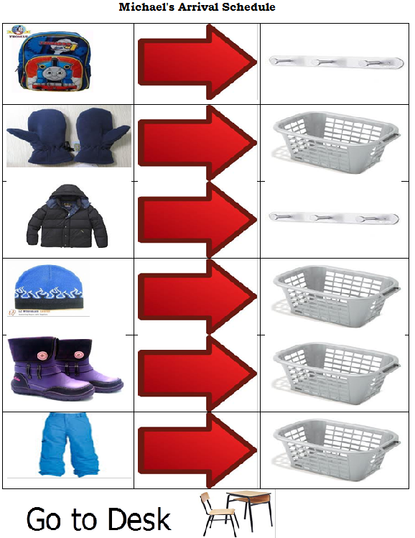
Classroom Meeting and Calendar (Carpet square to define space) (Mini Calendar for Michael)
During share time, Michael will sit on a carpet square. The peer assigned to Michael will direct him back to sitting on the carpet square. The peer will also provide Michael with the card below. One side of the card states Michael’s Turn. When Michael is sharing, he will hold the yellow side of the card face up. When another student is sharing the peer supporting Michael will turn the card over which is green and will show Michael it is another student’s turn.
Michael’s Turn

Friend’s Turn

Math (Differentiation to daily assignment, assessments and projects)
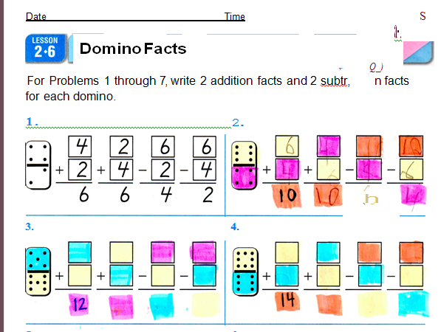

Lunch (Documentation Sheet completed by 5th Grade Students)

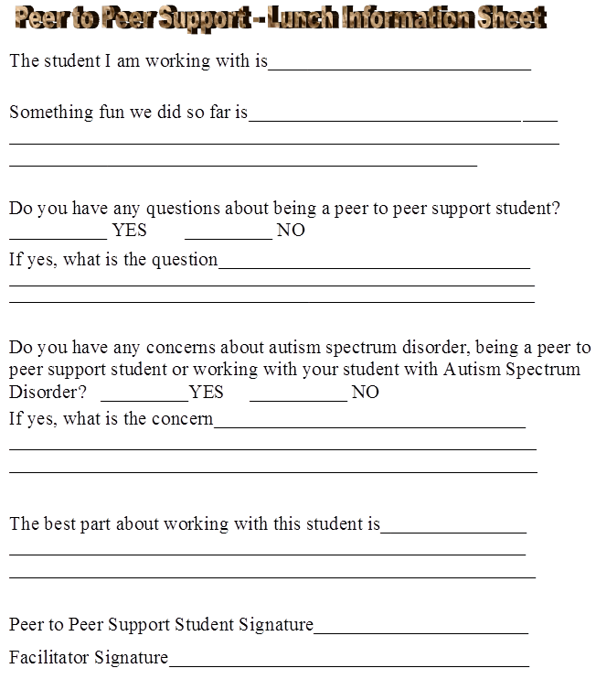

Recess (Daily Recess Schedule)

Today is
Wednesday
At Recess, I will:

Share Time (Carpet square)
During share time, Michael will sit on a carpet square. The peer assigned to Michael will direct him back to sitting on the carpet square. The peer will also provide Michael with the card below. One side of the card states Michael’s Turn. When Michael is sharing, he will hold the yellow side of the card face up. When another student is sharing the peer supporting Michael will turn the card over which is green and will show Michael it is another student’s turn.

Michael’s Turn
Friend’s Turn

Physical Education System
Michael is assigned to the BLUE SQUAD in Physical Education. The peer assigned to support Michael during Physical Education will also be assigned to the BLUE SQUAD and will sit directly in front of Michael. The Peer assigned to Michael will complete the warm up, activities and clean-up in the Physical Education Class as a participant. The role of the peer is to model for Michael the expectations of the class. Since the Peer is older that the other students in the class there will be a natural gravitation toward Michael because of the peer. The peer presence will increase the engagement of other students with Michael.
Art System
Michael is assigned to the RED Table in Art. The peer assigned to support Michael during Art will also be assigned to the RED Table and will sit directly next to Michael. The Peer assigned to Michael will complete the activities and clean-up in the Art Class as a participant. The role of the peer is to model for Michael the expectations of the class. Since the Peer is older that the other students in the class there will be a natural gravitation toward Michael because of the peer. The peer presence will increase the engagement of other students with Michael.

Departure Schedule (Visual and Self-Management)

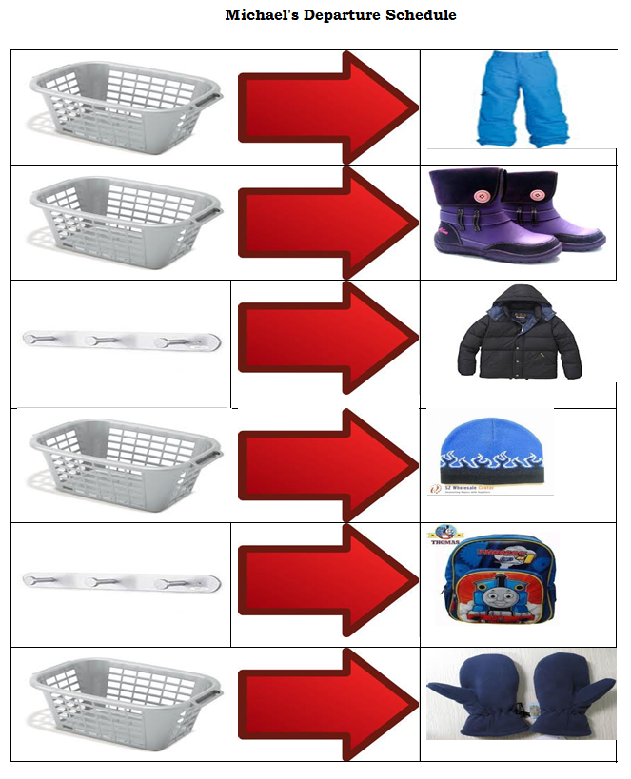

Activity | Location | Support
Arrival | Coat Room/Desk | Mr. Williams – 4th Grade
Class Meeting | Carpet | Alternative High School
Calendar | Carpet | Alternative High School
Math | Desk | Alternative High School
Recess | Playground | Mrs. Bells – 1st Grade
ELA | Desk | N/A
Lunch | Lunchroom | Mrs. Linders – 5th Grade
Recess | Playground | Mrs. Bells – 1st Grade
Social Studies | Desk | N/A
Share Time | Carpet | Paraprofessional
Science | Desk | N/A
Departure | Coat Room/Desk | Mr. Williams – 4th Grade

