TO DO |  |  | DONE
1. WASH ALL TABLE & DESK TOPS
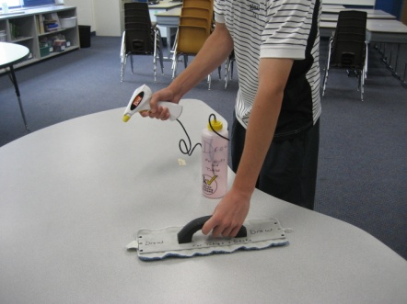 | 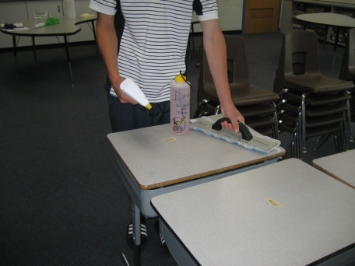
2. DUST ALL TABLE LEGS
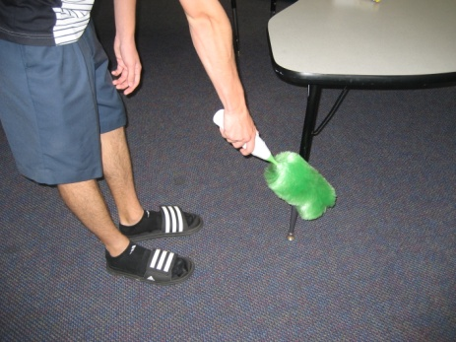
3. MOVE ALL TABLES TO SIDE OF ROOM
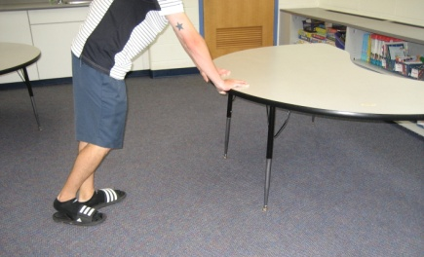
4. VACUUM
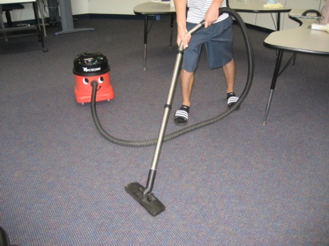
5. Hang “Cleaned by Drew” sign on the door knob  CLEANED BY:  DREW |  | 