Cell Growth and Division

Assignment #1

Step #1 - Go to classzone.com
Step #2 - Select the 2008 Biology book

Step #3 - Go to “Interactive Review”
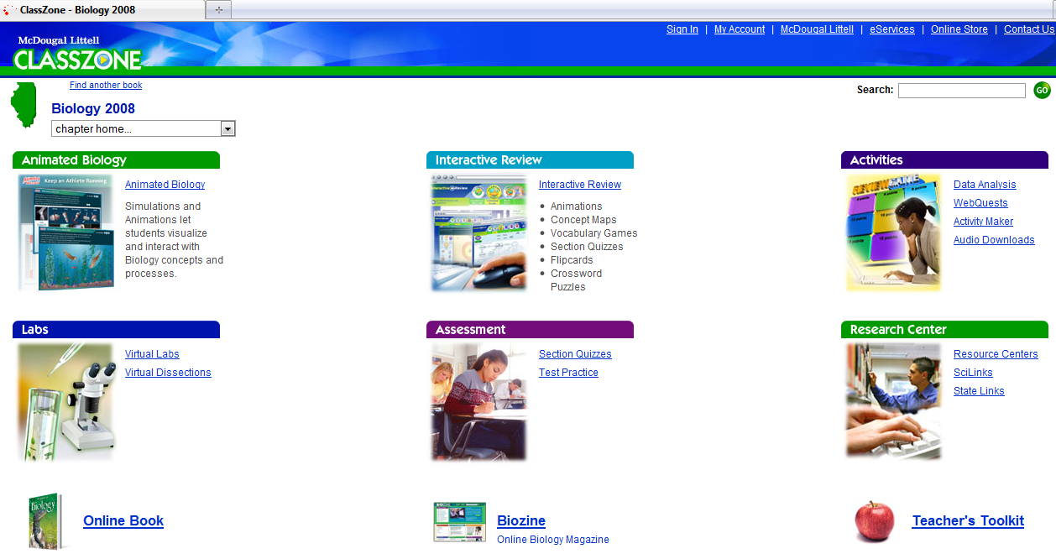

Step #4 - Go to left hand side, under Biology 2008, select Chapter 5
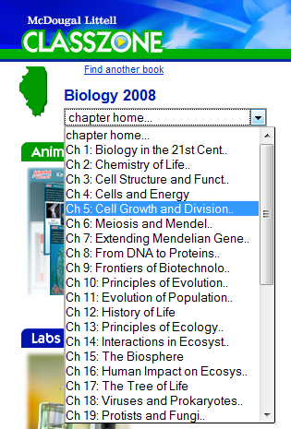

Step #5 – Pick “Animated Biology”

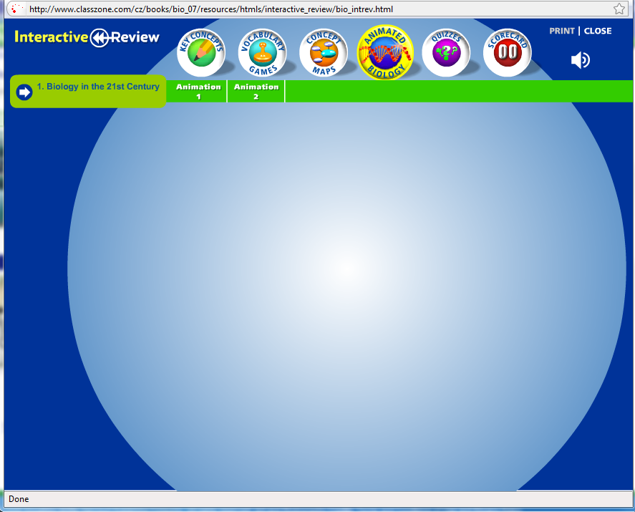
Step #6 – Select “Animation 2”

Step #7 - Complete the activity.

Cell Growth and Division

Assignment #2

Step #1 - Go to classzone.com
Step #2 - Select the 2008 Biology book

Step # 3 - Go to “Activities”
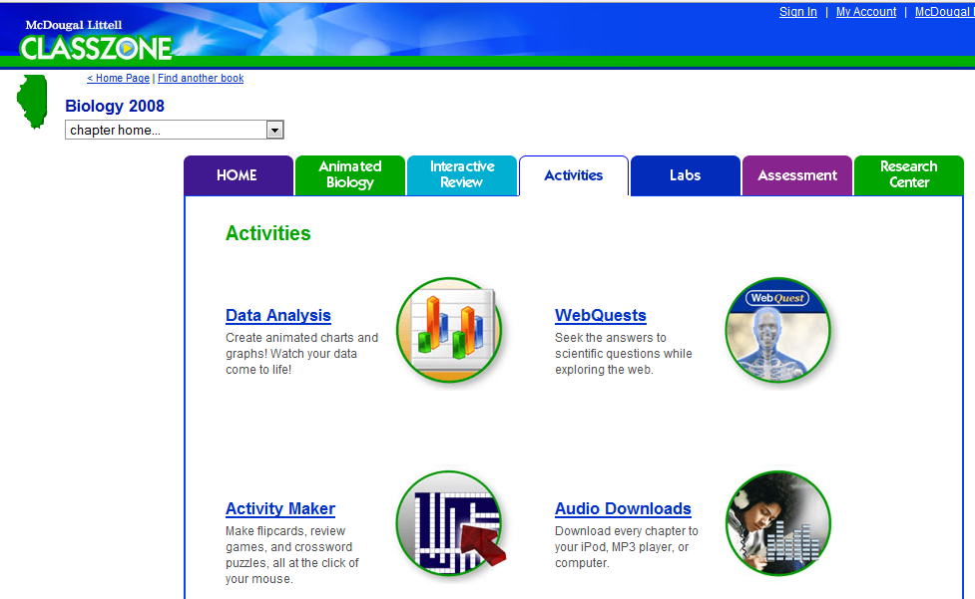

Step #4 - Pick “WebQuests”

Step #5 - Select “Unit 2” on the left hand side
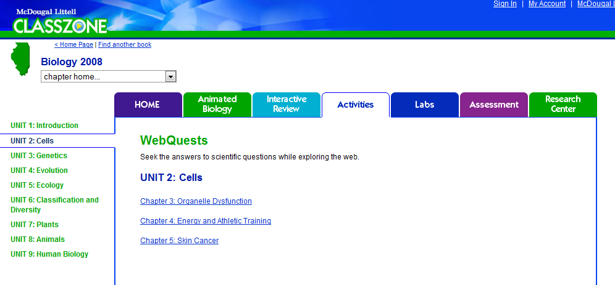

Step #6 – Pick the “Chapter 5: Skin Cancer” section

Step #7 - Complete the activity
