Autism Spectrum Disorder (ASD)  - 1 in 68 children are diagnosed with ASD in the U.S. (CDC, 2014). In 2016, the Michigan Department of Education, 19,632 children were receiving services under the ASD eligibility.  What is Peer to Peer (P2P)?  - P2P support involves general education peers modeling typical academic and social behavior in educational environments throughout the school day. Peers provide support for students with ASD to promote independence and socialization.  - Teaching peers to interact with, and support, their peers with ASD by increasing social and learning opportunities within natural environments leads to new skills, and a sense of belonging that only comes from being in class with peers and participating in typical school activities. | If you have questions, please contact:  Name:  Phone:  Email:  School Website:  Name:  Phone:  Email:  School Website:  Name:  Phone:  Email:  School Website:  P2p PROGRAM NAME School name Address | YOUR PEER TO PEER  LOGO HERE  P2p PROGRAM NAME  - Peer to Peer Support Program
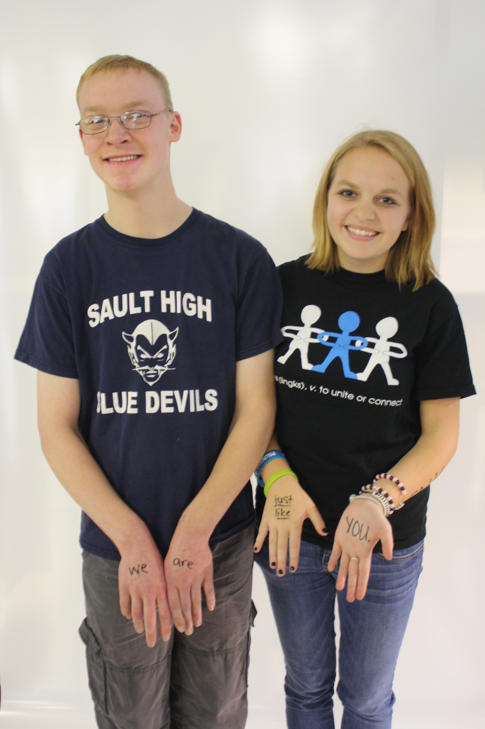  Change photo to fit your needs  Program Purpose: | What to expect:  “This is a great spot for a testimonial or a relevant quote”  How does LINKS work? | 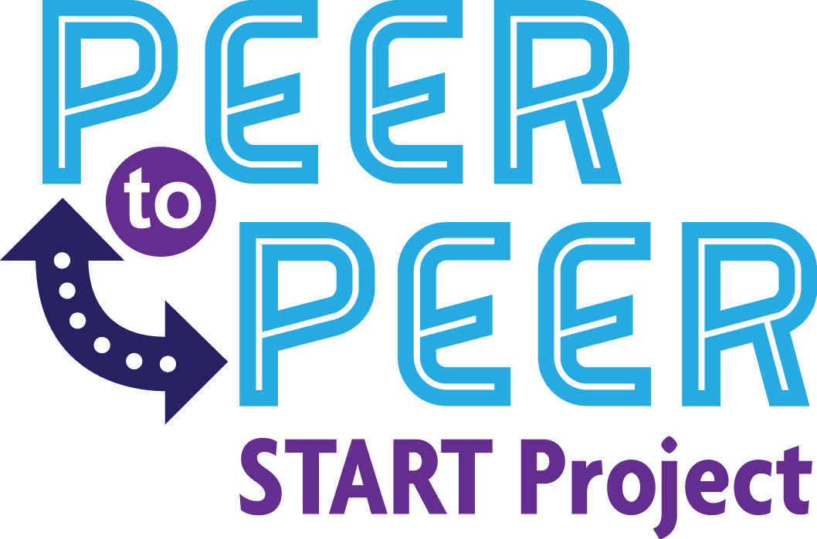  How do I participate?

