[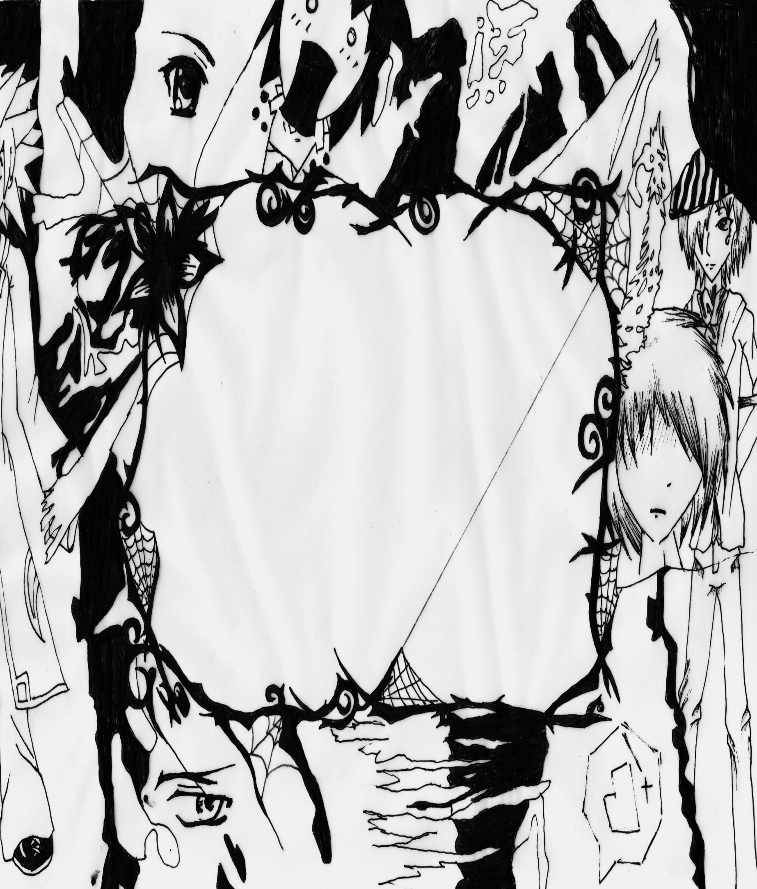](http://www.deviantart.com/download/124148721/Anime_Border_by_CandyxCorex.jpg)

|  |  |  |  |  |
| --- | --- | --- | --- | --- |
| Sub | | Class | Swearing | Homework |
|  | **1st Hour**  Comm Art Room E 108  Hanthorne | | Y N | Y N |
|  | **2nd Hour**  Biology  Erikson | | Y N | Y N |
|  | **3rd Hour**  World History | | Y N | Y N |
|  | **4th Hour**  Algebra | | Y N | Y N |
|
|
|
|
|  | **5th Hour**  English | | Y N | Y N |
|
|
|
|
|  | **6th Hour**  Media Assistant | | Y N |  |
|
|
|
|