
Applications | Connections | Extensions
A C E

Applications

1. a. Miki tosses a coin 50 times, and the coin shows heads 28 times.
What fraction of the 50 tosses is heads? 14/25
Yes

No

What percent is this? 65%

Yes

No

b. Suppose the coin is fair, and Miki tosses it 500 times.
500 / 2 =

About how many times can she expect it to show heads? 50 times.

Yes

No

2. Suppose Kalvin tosses a coin to determine his breakfast cereal
every day. He starts on his twelfth birthday and continues until his
eighteenth birthday.

About how many times would you expect him to eat Cocoa Blast cereal? 1095

Yes

No

3. Kalvin tosses a coin five days in a row and gets tails every time.

Do you think there is something wrong with the coin?

Yes

No

4. Len tosses a coin three times. The coin shows heads every time.
What are the chances the coin shows tails on the next toss?

The chances are 70%.
Yes

No

5. Is it possible to toss a coin 20 times and have it land heads-up
20 times?
Yes

No

Is this likely to happen? Yes (or) No

Yes

No

6. Kalvin tosses a paper cup once each day for a year to determine his
breakfast cereal. In 50 tosses 20 landed on the ends.
a. How many times do you expect the cup to land on its side? 219 times

Yes

No

How many times do you expect the cup to land on one of its ends? 200 times

Yes

No

b. How many times do you expect Kalvin to eat Cocoa Blast in a
month? 12 times

Yes

No

How many times do you expect Kalvin to eat Cocoa Blast in a in a year? 59 times

Yes

No

7. Dawn tosses a pawn from her chess set five times. It lands on its base
four times and on its side only once.
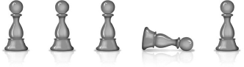

Andre tosses the same pawn 100 times. It lands on its base 28 times
and on its side 72 times. Based on their data, if you toss the pawn one
more time, is it more likely to land on its base or its side? Base

Yes

No

8. Kalvin flips a small paper cup 50 times and a large paper cup
30 times. The table below displays the results of his experiments.
Based on these data, should he use the small cup or the large cup
to determine his breakfast each morning? small cup
Yes

No

Cup-Toss Results

Where Cup Lands | Small Paper Cup | Large Paper Cup
Side | 39 times | 22 times
One of Its Ends | 11 times | 8 times
9. Kalvin’s sister Kate finds yet another way for him to pick his
breakfast. She places one blue marble and one red marble in each
of two bags. She says that each morning he can choose one marble
from each bag. If the marbles are the same color, he eats Cocoa Blast.
If not, he eats Health Nut Flakes.
Explain how selecting one marble from each of the two bags and tossing two coins are similar.
Red and blue are like heads and tails. Each bag is like a coin. Red and blue are equally likely in each bag, just as heads and tails are on each coin.
Yes

No

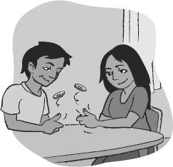
10. Adsila and Adahy have to decide who will take out the garbage.
Adahy suggests they toss two coins. He says that if at least one head
comes up, Adsila takes out the garbage. If no heads come up, Adahy
takes out the garbage.

Should Adsila agree to Adahy’s proposal?

Yes

No

For Exercises 11–15…

Are the possible results are equally likely?

Exercise # | Action | Possible Results | Equally Likely?
11 | Your phone rings at 9:00 p.m. | The caller is your best friend, the caller is a relative, or the caller is someone else. | YES  NO
12 | You check the temperature at your home tomorrow morning. | The temperature is 30°F or above, or the temperature is below 30°F. | YES  NO
13 | 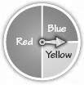  You spin the pointer once. | The pointer lands on yellow, the pointer lands on red, or the pointer lands on blue. | YES  NO
14 | You find out how many car accidents occurred in your city or town yesterday. | There were fewer than five accidents, there were exactly five accidents, or there were more than five accidents. | YES  NO
15 | You choose a card from a standard deck of playing cards (with no jokers). | The card is a spade, the card is a heart, the card is a diamond, or the card is a club. | YES  NO

For Exercises 16–17, first list all the possible results for each action.
Then decide whether the results are equally likely.

Exercise # | Action | List possible results. | Are the results likely?
16 | You choose a block from a bag containing one red block, three blue blocks, and one green block. | 1. a red block  2. a blue block  3. a green block | YES  NO
17 | You try to steal second base during a baseball game. | 1. steal 2nd base successfully  2. you’re out | YES  NO

18. For parts (a)–(f ), give an example of a result that would have a
probability near the percent given.

 | Percent | Give an example of a result that would be near the percent given. | Is this accurate?
a. | 0% | It will be 80 degrees Fahrenheit on February 1st in Michigan. | YES  NO
b. | 25% | You guess the right answer on a multiple choice question with four options. | YES  NO
c. | 50% | It will snow during a week of winter in New Hampshire. | YES  NO
d. | 75% | A quarter will land heads up when it is tossed. | YES  NO
e. | 80% | When you choose a letter at random from the letters A, B, C, D and F you choose a consonant. | YES  NO
f. | 100% | The sun will set tonight. | YES  NO

Choice Bank:

Connections

19. Colby rolls a number cube 50 times. She records the result of each
roll and organizes her data in the table below.

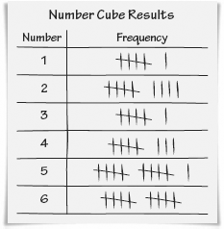

- What fraction of the rolls are 2’s? 9/50
Yes

No

What percent is this? 20%
Yes

No

- What fraction of the rolls are odd numbers? 23/50
Yes

No

What percent is this? 46%
Yes

No

- What percent of the rolls is greater than 3? 58%
Yes

No

- Suppose Colby rolls the number cube 100 times. About how many
times can she expect to roll a 2? 18 times
Yes

No

- If Colby rolls the number cube 1,000 times, about how many
times can she expect to roll an odd number? 10 times

Yes

No

20. Find a fraction between each pair of fractions.

a. and 9/50 b. and 13/40

Yes

No
Yes

No

For Exercises 21–23, use the bar graph below.
Reasons People Moved
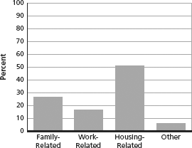

21. Multiple Choice Suppose 41,642 people moved. About how many
of those people moved for family-related reasons?
11,000
Yes

No

22. Multiple Choice What fraction of the people represented in the
graph moved for reasons other than work-related, housing-related,
or family-related?
Yes

No

23. Multiple Choice Suppose 41,642 people moved. About how many
moved for housing-related reasons?
11,000
Yes

No

24. Write all the factors of 42 on pieces of paper and put them in a bag.
Shake the bag.
Then, choose one piece of paper from the bag.
Did you choose an even number?
Yes

No

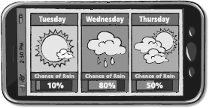

25. Weather forecasters often use percents to give probabilities in
their forecasts. For example, a forecaster might say that there is a
50% chance of rain tomorrow. For the forecasts below, change the
fractional probabilities to percents.
a. The probability that it will rain tomorrow is . 2 ÷ 5 = 40%
Yes

No

b. The probability that it will snow Monday is . 3 ÷ 10 = 33%
Yes

No

c. The probability that it will be cloudy this weekend is . 3 ÷ 5 = 60%
Yes

No

For Exercises 26–29, use the graph below.
Average Number of Tornadoes Per Year
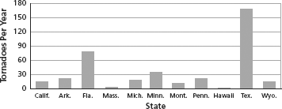

26. Is a tornado equally likely to occur in California and in Florida?
Yes

No

27. Is a tornado equally likely to occur in Arkansas and in Pennsylvania?

Yes

No

28. Is a tornado equally likely to occur in Massachusetts and in Texas?

Yes

No

29. Based on these data, is a person living in Montana more likely to
experience a tornado than a person living in Massachusetts?

Yes

No

