
Applications | Connections | Extensions
A C E

Applications

1. a. Miki tosses a coin 50 times, and the coin shows heads 28 times.
What fraction of the 50 tosses is heads?

What percent is this?

b. Suppose the coin is fair, and Miki tosses it 500 times.

About how many times can she expect it to show heads?

Explain your reasoning.

2. Suppose Kalvin tosses a coin to determine his breakfast cereal
every day. He starts on his twelfth birthday and continues until his
eighteenth birthday.

About how many times would you expect him to eat Cocoa Blast cereal?

3. Kalvin tosses a coin five days in a row and gets tails every time.

Do you think there is something wrong with the coin?

How can you find out?

4. Len tosses a coin three times. The coin shows heads every time.
What are the chances the coin shows tails on the next toss?

Explain.

5. Is it possible to toss a coin 20 times and have it land heads-up
20 times?

Is this likely to happen?

Explain.

6. Kalvin tosses a paper cup once each day for a year to determine his
breakfast cereal. Use your results from Problem 1.2 to answer the following.
a. How many times do you expect the cup to land on its side?
How many times do you expect the cup to land on one of its ends?

b. How many times do you expect Kalvin to eat Cocoa Blast in a
month?

How many times do you expect Kalvin to eat Cocoa Blast in a in a year?

Explain.

7. Dawn tosses a pawn from her chess set five times. It lands on its base
four times and on its side only once.
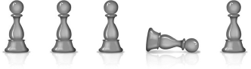

Andre tosses the same pawn 100 times. It lands on its base 28 times
and on its side 72 times. Based on their data, if you toss the pawn one
more time, is it more likely to land on its base or its side?

Explain.

1

Copyright © Pearson Education, Inc., or its affiliates. All Rights Reserved.
What Do You Expect? Investigation 1

8. Kalvin flips a small paper cup 50 times and a large paper cup
30 times. The table below displays the results of his experiments.
Based on these data, should he use the small cup or the large cup
to determine his breakfast each morning?

Explain.
Cup-Toss Results

Where Cup Lands | Small Paper Cup | Large Paper Cup
Side | 39 times | 22 times
One of Its Ends | 11 times | 8 times
9. Kalvin’s sister Kate finds yet another way for him to pick his
breakfast. She places one blue marble and one red marble in each
of two bags. She says that each morning he can choose one marble
from each bag. If the marbles are the same color, he eats Cocoa Blast.
If not, he eats Health Nut Flakes.
Explain how selecting one marble from each of the two bags and tossing two coins are similar.

10. Adsila and Adahy have to decide who will take out the garbage.
Adahy suggests they toss two coins. He says that if at least one head
comes up, Adsila takes out the garbage. If no heads come up, Adahy
takes out the garbage.

Should Adsila agree to Adahy’s proposal?
Explain why or why not.

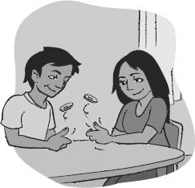

For Exercises 11–15…

Are the possible results are equally likely? Explain.

Exercise # | Action | Possible Results | Equally Likely? | Explain
11 | Your phone rings at 9:00 p.m. | The caller is your best friend, the caller is a relative, or the caller is someone else.
12 | You check the temperature at your home tomorrow morning. | The temperature is 30°F or above, or the temperature is below 30°F.
13 | 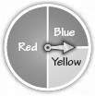  You spin the pointer once. | The pointer lands on yellow, the pointer lands on red, or the pointer lands on blue.
14 | You find out how many car accidents occurred in your city or town yesterday. | There were fewer than five accidents, there were exactly five accidents, or there were more than five accidents.
15 | You choose a card from a standard deck of playing cards (with no jokers). | The card is a spade, the card is a heart, the card is a diamond, or the card is a club.

For Exercises 16–17, first list all the possible results for each action.
Then decide whether the results are equally likely.

Exercise # | Action | List possible results. | Are the results likely?
16 | You choose a block from a bag containing one red block, three blue blocks, and one green block.
17 | You try to steal second base during a baseball game.

18. For parts (a)–(f ), give an example of a result that would have a
probability near the percent given.

 | Percent | Give an example of a result that would be near the percent given
a. | 0%
b. | 25%
c. | 50%
d. | 75%
e. | 80%
f. | 100%

3
Copyright © Pearson Education, Inc., or its affiliates. All Rights Reserved.
What Do You Expect? Investigation 1

Connections

19. Colby rolls a number cube 50 times. She records the result of each
roll and organizes her data in the table below.

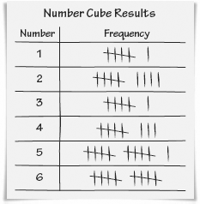

- What fraction of the rolls are 2’s?
What percent is this?
- What fraction of the rolls are odd numbers?
What percent is this?
c. What percent of the rolls is greater than 3?
d. Suppose Colby rolls the number cube 100 times. About how many
times can she expect to roll a 2?
Explain.
e. If Colby rolls the number cube 1,000 times, about how many
times can she expect to roll an odd number?
Explain.

20. Find a fraction between each pair of fractions.
a. and b. and

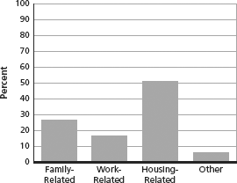

For Exercises 21–23, use the bar graph below.
Reasons People Moved

21. Multiple Choice Suppose 41,642 people moved. About how many
of those people moved for family-related reasons?
A. 28 B. 11,000 C. 21,000 D. 31,000

22. Multiple Choice What fraction of the people represented in the
graph moved for reasons other than work-related, housing-related,
or family-related?
F. G. H. J.

23. Multiple Choice Suppose 41,642 people moved. About how many
moved for housing-related reasons?
A. 52 B. 11,000 C. 21,000 D. 31,000

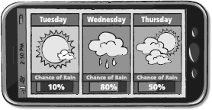
24. Write all the factors of 42 on pieces of paper and put them in a bag.
Shake the bag.
Then, choose one piece of paper from the bag.
a. What is the experimental probability of choosing an even number? _________
b. What is the experimental probability of choosing a prime number? _________

25. Weather forecasters often use percents to give probabilities in
their forecasts. For example, a forecaster might say that there is a
50% chance of rain tomorrow. For the forecasts below, change the
fractional probabilities to percents.
a. The probability that it will rain tomorrow is . ______ %
b. The probability that it will snow Monday is . ______ %
c. The probability that it will be cloudy this weekend is . ______ %

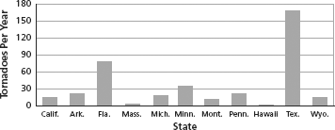
For Exercises 26–29, use the graph below.
Average Number of Tornadoes Per Year

26. Is a tornado equally likely to occur in California and in Florida?
Explain your reasoning.

27. Is a tornado equally likely to occur in Arkansas and in Pennsylvania?

28. Is a tornado equally likely to occur in Massachusetts and in Texas?

29. Based on these data, is a person living in Montana more likely to
experience a tornado than a person living in Massachusetts?

Explain.

Extensions

30. Monday is the first day Kalvin tosses a coin to determine his cereal.
During the first five days, he has Cocoa Blast only twice. One possible
pattern of Kalvin’s coin tosses is shown.

Coin-Toss Results

Monday | Tuesday | Wednesday | Thursday | Friday
H | H | T | T | T
Find every way Kalvin can toss the coin during the week and have
Cocoa Blast cereal twice. Use the space provided to figure out your answer.

Explain how you know that you found every
possible way.

31. Yolanda watches a carnival game in which a paper cup is tossed.
It costs $1 to play the game. If the cup lands upright, the player
receives $5. Otherwise, the player receives nothing. The cup is tossed
50 times. It lands on its side 32 times, upside-down 13 times, and
upright 5 times.
a. If Yolanda plays the game ten times, about how many times can
she expect to win?

How many times can she expect to lose?

- Do you expect her to have more or less money at the end of ten
games?
Explain.

