Investigating the Secrets of a Cycloid
- Recall: What is the definition of $π$?

- So if $R$ is the length of the radius of a circle, what is the length of the circumference - - i.e., the distance around the circle?

- Suppose an ant on a sidewalk gets caught in the tread of a bicycle wheel of radius. Draw the path the ant would make until the ant hits the pavement again (and presumable jumps off). This path is called a cycloid. It has many interesting properties and has an interesting history as well.

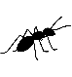
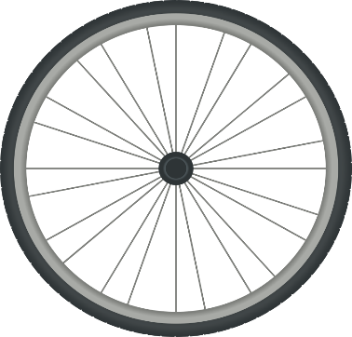

- Let’s try to find the length, $L$, of the cycloid - - that is, the total distance traveled by the ant.
- First find upper and lower bounds for $L$. That is, find numbers (which will depend on $R$) that you are certain will be able to fill in the blanks below. Even though you must be certain that the inequality is satisfied, you still want bounds that are as close as possible to the actual length. $________≤L≤____________.$
- Now use a tape measure or string to try to get an approximation for $L.$
- Given what you’ve learned from above fill in your best guess: How many times longer is $L$
than ? That is: $L=____∙R$.
- Search cycloid online to see if you can find the answer. It can be found using calculus using the fact that the coordinates of the cycloid are $x\left(t\right)=R\left(t-\sin\left(t\right)\right), y\left(t\right)=R(t-\cos\left(t\right))$.

- Now we come to the most interesting property of the cycloid. Suppose you wanted to build a slide which got you from point $A$ to point $B$ as quickly as possible (assume no friction and constant gravity). Draw your best guess:

- It turns out that even though a straight line from point $A$ to point $B$ is the shortest distance, the path from a cycloid will give you the shortest time. This is called the brachistochrone problem. (brachi means “short” and chrone means “time”.) Equally interesting, if you start anywhere along the cycloid, it will always take exactly the same amount of time to reach the bottom. Christian Huygens used this fact to build a pendulum clock with a pendulum (on an adjustable arm) that ran along a cycloid. Then no matter how high or low the pendulum swung, it’s period (time for an complete back-and-forth) always stayed the same.

- I promised you the interesting history. Have you heard of the Bernoulli brothers – Jacob and Johann? They lived in the 17th century and were both great mathematicians and physicists. And like all brothers, they were very competitive. It turned out the Johann solved the brachistochrone problem and when he did, he wanted the whole scientific world to know that he was smarter than his brother. So he posed the problem as a challenge to the mathematical community – hoping that his brother wouldn’t be able to solve it. Among the replies, Jacob got one anonymous solution which was by far the most elegant of all of them. The mathematical technique used was clever and quick and elegant. Perhaps it was anonymous to make Johann think that his brother had beat him. But when Johann saw the solution, he immediately announced, “This solution is from Sir Isaac!” (meaning Isaac Newton). When asked how he could be so sure, he replied, “You can tell the lion from the size of the paw.” In other words, Johann know that only Isaac Newton had the genius to give such a beautiful solution. He was right.

