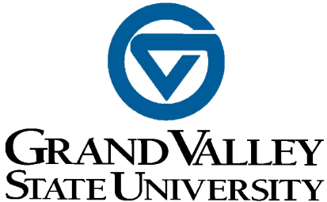

To: CLAS Unit Heads and Academic Coordinators

From: Donovan Anderson
Associate Dean for Personnel, Hiring, and Planning
CLAS Faculty Development Committee

Re: Deadline for submission of award nominations

Date: August 31, 2021

With the semester starting, it is time to think about nominating your faculty for awards. Please encourage the faculty members in your unit to begin the nomination process soon. To nominate a colleague for an award, complete the nomination form, collect the appropriate materials, and submit these items to the CLAS Dean's Office (B-4-232 MAK) by October 1, 2021. The CLAS selection committees will then review nominations and submit chosen candidates to the Dean for final submission to FTLC and CSCE by Nov. 1, 2021.
Please follow the directions below to submit nomination materials electronically.
Electronic: While award materials may be submitted to your office in various formats (Microsoft Word, Excel, .pdf, etc.), all materials must be merged into a single .pdf document, organized in the order listed on the award nomination form. If you are unfamiliar with creating or merging .pdf documents, please contact Kristin Winfrey (x12266) or Mona Silva (x13041) in the CLAS Dean’s Office for assistance. It is best to avoid scanned images as components of the .pdf file but you may include them if necessary. Email the .pdf file to Kristin Winfrey at winfreyk@gvsu.edu.

Glenn A. Niemeyer Faculty Award

Submit all materials using the above instructions to the CLAS Dean’s Office by October 1, 2021. More information on this award is available at the Provost Office website: http://www.gvsu.edu/provost/glenn-a-niemeyer-awards-5.htm

Outstanding Teacher Award

Submit all materials using the above instructions to the CLAS Dean’s Office by October 1, 2021. More information on the University Outstanding Teaching Award: https://www.gvsu.edu/ftlc/university-outstanding-teaching-award-333.htm

Pew Awards for Excellence

These awards include:
Pew Teaching Excellence Award
Pew Teaching with Technology Award
Pew Excellence Award for Teaching and Learning Enrichment
Pew Teaching Excellence Award for Adjunct Faculty
The Burch, Jacobs & Moore Diversity Teaching Excellence Award
Submit all materials using the above instructions to the CLAS Dean’s Office by October 1, 2021. For information on the Pew Awards for Excellence:
https://www.gvsu.edu/ftlc/teaching-awards-31.htm

Awards for Scholarly and Creative Excellence

These awards include:
Distinguished Early Career Scholar Award
Distinguished Undergraduate Mentoring Award
Distinguished Graduate Mentoring Award

Submit all materials using the above instructions to the CLAS Dean’s Office by October 1, 2021. More information on the Awards for Scholarly and Creative Excellence awards: https://www.gvsu.edu/csce/faculty-awards-40.htm

Distinguished Contribution to a Discipline Award

Materials are to be submitted directly to CSCE by November 1, 2021. Please remember that the Dean does need to sign before submitting to CSCE. More information can be found here: https://www.gvsu.edu/csce/distinguished-contribution-in-a-discipline-42.htm

