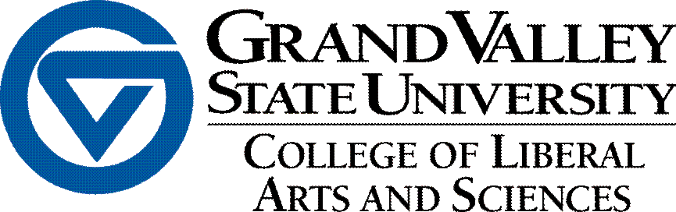

**Recognition of Award-winning CLAS Faculty & Staff**

The following is a list of recent CLAS award recipients. For a description of the requirements surrounding each award, please click on its title.

[CLAS Teaching Excellence Award for Affiliate Faculty](http://www.gvsu.edu/advising/professional-opportunities-46.htm)

2020 Award Recipients: Jill Morris (Chemistry)

Suzanne Zack (Visual and Media Arts)

[CLAS Lifetime Service Award](https://www.gvsu.edu/clas/awards-faculty-and-staff-507.htm)

2020 Award Recipient: Ginny Peterson (Geology)

[CLAS Faculty Service Award](https://www.gvsu.edu/clas/awards-faculty-and-staff-507.htm)

2020 Award Recipient: Randy Winchester (Chemistry)

[CLAS AP Service Award](https://www.gvsu.edu/clas/awards-faculty-and-staff-507.htm)

2020 Award Recipient: Jodi DenUyl (Cell and Molecular Biology