
SAFETY. SERVICE . SUPPORT

www.gvsu.edu/emergency



Emergency Notification System

 | STAY INFORMED WHEN THERE’S A CAMPUS EMERGENCY
GVSUAlert! is a secure emergency
notification system that alerts students, faculty, and staff of imminently
dangerous situations via email, text and voice messages to cell phone and
land lines.
C | UPDATE YOUR INFORMATION  Your “PRIMARY MOBILE NUMBER” in Workday is the number used for the GVSUAlert! system.  You may add emails and other numbers by visiting www.gvsu.edu /gvsualert  Need help? Email William O’Donnell odonnewi@gvsu.edu



IN AN EMERGENCY, DIAL 911
All Grand Valley State University phones, on any campus, are equipped to dial the local 911 center by dialing 911 or 9-911. Either will work.

Do NOT contact GVPD directly in the event of an emergency, ALWAYS dial 911.
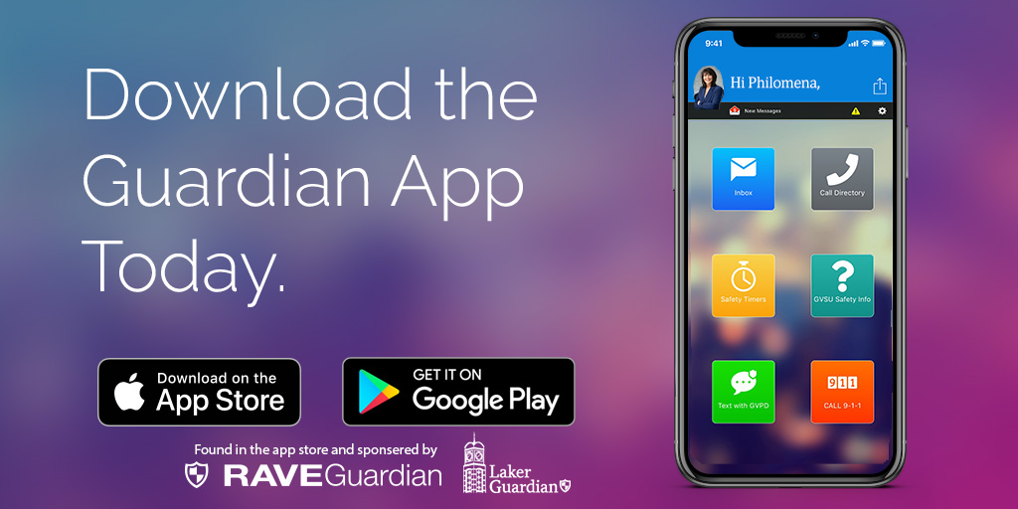
For the most accurate and up-to-date information during an emergency and campus alerts visit:
www.gvsu.edu/emergency

The Grand Valley Department of Public Safety is a multi-disciplined department. We strive to provide a safe and secure environment in which to work, live, and learn.

