ELECTRONIC LEARNING CONTRACT INSTRUCTIONS – STUDENT VIEW

You will use your Grand Valley username and password to log in to the site after clicking on the learning contract link ([https://www.gvsu.edu/ssw/felc/login.htm](https://wwwtest.gvsu.edu/ssw/felc/login.htm)) from the School of Social Work Field Education webpage. Please begin the learning contract within two weeks of the start of the semester so your field education supervisor can be assigned to view it as well. You do not need to completely finish it in that time, just need to log in and start. Choose the correct learning contract for you; if BSW student you will click on that link. For MSW, you will do the foundational learning contract for your first semester if you are regular status, and then do advanced practice for the second and third semester. Advanced Standing MSW students will use the advanced practice learning contract for both semesters. Once you log in, you will see a screen that looks like this:

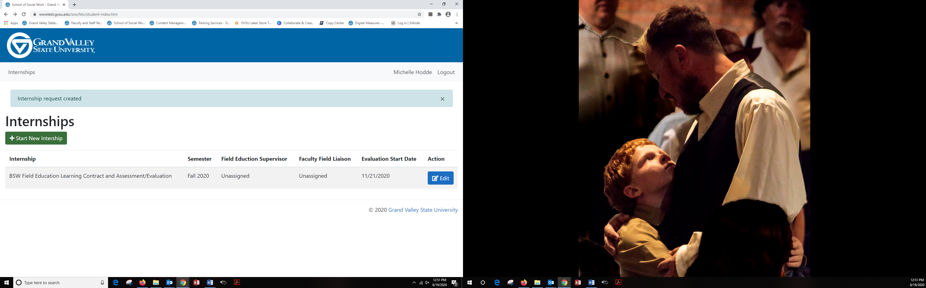

Click on the green button that says start new internship. Scroll down on the page that says edit internship until you get to the learning activities for Competency One:

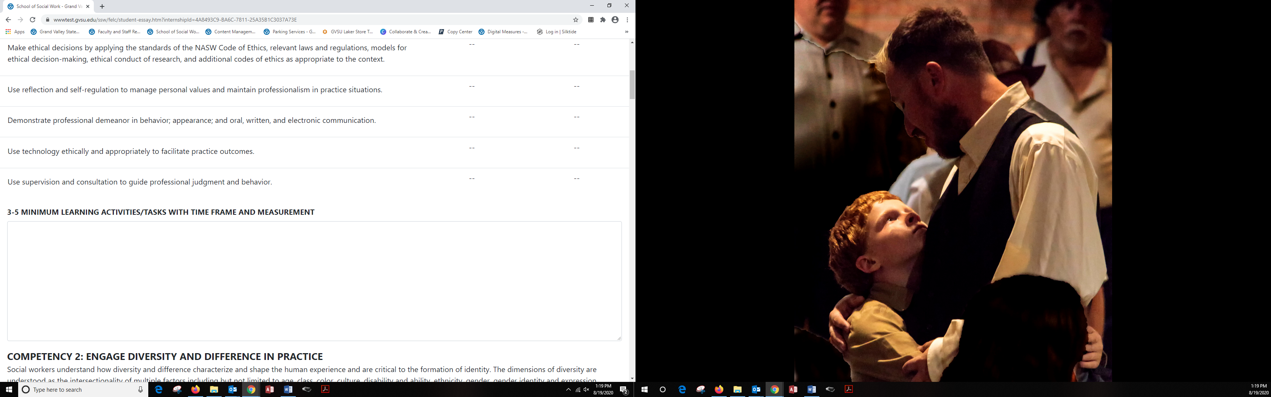

You’ll find a text box to type in the learning activities that you plan to complete. Type in learning activities for all nine competencies. You may stop and start working in this document; you don’t have to type in all learning activities in one sitting.

When finished working, click save:

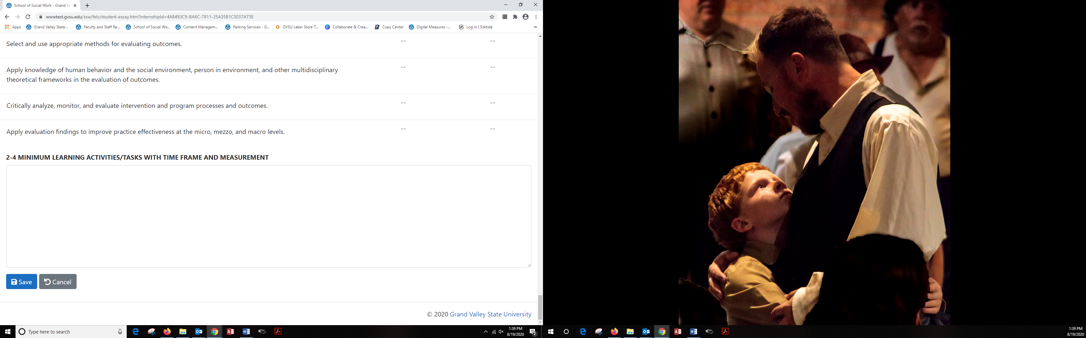

Review the learning contract with your field supervisor, and make any edits/changes that they recommend if needed. Your field liaison will also have access to view your learning contract and may suggest changes. You are able to make changes to your learning contract throughout the semester.

Evaluation Portion – End of Semester

At the end of the semester, you will rate your progress on each of the competencies using the dropdown menu. Your field supervisor will rate your progress as well. This is the evaluation scale you and your supervisor will use:

|  |  |
| --- | --- |
| Score | Definition |
| 1 | **Unacceptable Competence:** Student has not developed in relation to this behavior/competency. The student was unable to demonstrate a basic level of understanding and proficiency. Performance Improvement Plan required in collaboration with student’s Faculty Field Liaison. |
| 2 | **Minimal Competence:** Student is aware but is having difficulties, demonstrates minimal evidence of competence, growth, and change; unable to demonstrate an adequate level of understanding and proficiency. Performance Improvement Plan required in collaboration with student’s Faculty Field Liaison. |
| 3 | **Emerging competence:** Student meets baseline expectations and is working on progressing. The student has demonstrated an adequate level of understanding and proficiency. |
| 4 | **Competence:** Student demonstrates consistent growth and development, increased levels of understanding and proficiency. Able to function with independence. |
| 5 | **Advanced competence:** Student demonstrates a high degree of competence, understanding, and proficiency. Able to initiate and add significant value. |
| D | **Deferred:** Student has little or no opportunity to engage in activities that would develop this behavior. More than 2 scores of “D” in an evaluation results in a Performance Improvement Plan. No “deferred” allowed in the final semester of field education. |

Please note that the student rating and field supervisor rating dropdown menus will not be accessible until November 1. Here’s what it will look like on the screen:

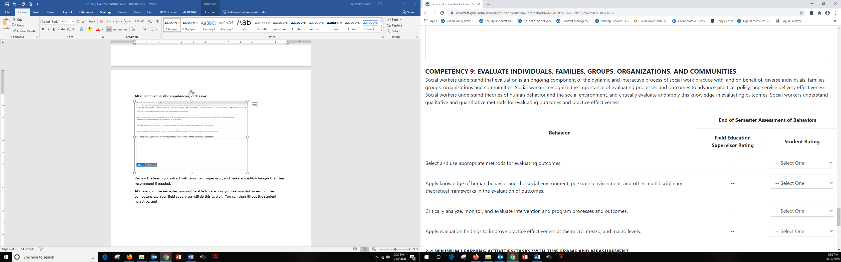

Finally, please provide comments on your professional development and then click save. Once you are finished and ready to submit your learning contract, click submit. This will let your faculty field liaison know that you have completed all components of the learning contract.

