PROTOCOL FOR SAMPLING Oxyria digyna FOR DNA EXTRACTION AND SEQUENCING

Christine D. Bacon, Anne Bjorkman, Jonathan Henn, María Fernanda Torres Jiménez
(In alphabetic order)

We are two senior lecturers and two postdocs based at the University of Gothenburg and we are developing a research project to study ecological adaptation to warming climates in arctic plants. Our research involves sampling populations of Oxyria digyna along a latitudinal gradient covering most of North America and Europe. We are inviting you to help us achieve our sampling and be part of this research project. We can offer you co-authorship in exchange for the collection of samples from populations near your current location (see the Aims section), as well as can help acquiring the materials you will need if you don’t have them.

- DESCRIPTION

Oxyria digyna (alpine/mountain sorrel; Polygonaceae) is an herbaceous, perennial plant that grows in the Arctic and mountain regions of the northern hemisphere, from the sea level to 4500 masl (Hulten and Fries 1986). In North America, it can be found 83ºN to the Arizona Mountains (Below, Figure 2 in Mooney and Billings, 1961). In Europe, the species can be found from north Norway to France and the Alps (Fig. 1a in Wang et al., 2016). In general, O. digyna can be found at lower elevations towards the poles and at higher elevations towards lower latitudes, in tundra-like environments (Moony and Billings, 1961). Oxyria can be found in rock crevice areas, cliffs, gravel, sometimes road fills and ditches, or areas with poor vegetation cover and soil pockets.

Left: Map of locations at which Oxyria digyna samples were collected by Moony and Billings, 1961. Right: Map of locations sampled by Wang et al., 2016.

Oxyria digyna is a short plant with no secondary branching and it can grow solitary or in clumps. It has small leaves shaped like kidneys connected to the base of the stem by somewhat long petioles. Petioles and leaves can be reddish or green.
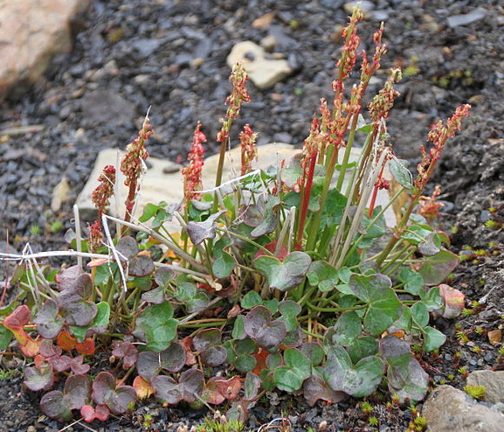
Oxyria digyna plant with flowers. Photo by Bjoertvedt, Wikicommons.

- AIMS

We aim to sample populations of O. digyna along a latitudinal gradient in North America and Europe to test for adaptation (or lack thereof) to photoperiod and other factors correlated with latitude.

We aim to generate whole genome sequences from 10-20 individuals in at least 10 populations along the gradient. We define a population as a group of individuals growing within a radius of one kilometer and sharing a similar habit, e.g. all individuals growing in a meadow nearby. However, defining a population is tricky. If you find an area in which O. digyna individuals grow in a bog and also in a rock crevice, both groups could potentially be different populations and it would be ideal to sample at least 10 individuals from each growing habitat.

We will identify single nucleotide polymorphisms (SNPs) that correlate with latitude. We will test for structure within the species, and while controlling for it, use latent mixed models to test for correlations between genetic variance (as SNPs) and the environmental factors that vary with latitude such as photoperiod, temperature extremes, periods of snow cover. Finally, we will compare our results from two latitudinal gradients across the species distribution: one in North America and another across Europe. If environmental factors that vary with latitude, e.g. photoperiod, select for individuals adapted to their local conditions, we expect genetic differences to accumulate and to be explained at least partially by the variation in environment.

We have prepared a list of materials and a protocol for collecting the plants to make everything as simple as possible. Briefly, we would like you to collect samples from 20 (minimum 10) individuals of O. digyna that are not connected by a rhizome and that appear to be different individuals. If the plant has fruits, please collect their fruits as well, we would like to use them in a future common garden experiment. Finally, because we want to test for genetic differences along the geographical gradient, we will also need latitude/longitude coordinate information. Then you’ll just need to send us the sample and that will be it! We encourage you to use this as an excuse to go out to the nice weather, and enjoy the fresh air and your favourite music playlist or podcast. We also encourage you to follow COVID guidelines to protect yourself and others during sampling.

We are happy to offer co-authorship on the resulting manuscript for those interested. In order to be a co-author, in addition to collecting samples we ask that you also be involved in reading and commenting on an advanced-stage manuscript and approve the final submission.

- MATERIALS

Function | Consumable | Image
Storing leaf material and seeds when available | 1a. Empty tea bags, easy to close. These bags are preferable to envelops because the silica gel can dry the samples better through their pores and without coming into direct contact with the leaf | 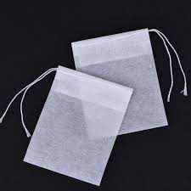
Storing leaf material and seeds when available | 1b. Or paper envelops, small, easy to close | 
Drying leaf material | 2a. Loose silica gel, any color | 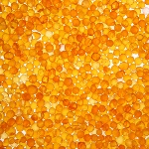
Drying leaf material | 2b. Or packed silica gel | 
Labelling envelops | 3a. Sharpie or any permanent, medium-size marker | 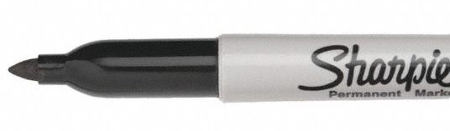
Storing envelops inside the bag with silica gel | 4a. Ziploc plastic bags or similar bags with a good closing system. Better if these are recycled | 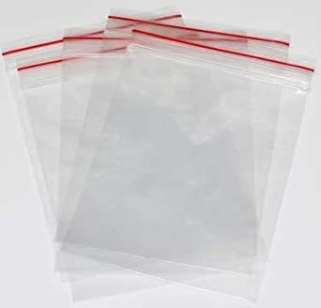
Sending samples to Sweden | 5a. Large, padded envelop for delicate material | 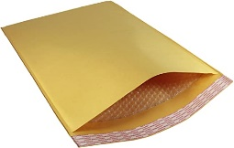
Recording coordinates | 6a. Mobil phone with geolocation capacity and a reliable app to record coordinates
Recording coordinates | 6b. GPS geodetic datum WGS 84
Recording data | 7a. Notebook and pencil. You can use a pen too but regular carbon pencils are waterproof
Taking photos | 8a. A camera or a phone with a reasonable camera

- SAMPLING PROTOCOL

Note: We would greatly appreciate some photos from representative plant individuals at the collecting site. We will not be collecting vouchers and therefore having visual references is valuable. However, you could skip taking the plant photographs if it makes the protocol significantly easier for you.

- Identify an area where you are likely to find multiple individuals, sparsely distributed if possible. Locate yourself at one edge of the area to facilitate collecting the samples in a systematic way, avoiding collecting the same individual twice. Take a photo of the general landscape of the place.

- Prepare a Ziploc bag (4a) with approximately one third of the bag full of unsaturated silica gel to dry the samples you are about to collect. Place a piece of paper with the name of the location (in pencil) inside the bag. You can use this bag to collect all the samples that belong to this particular location. You can use multiple bags per location if they are of a smaller size but make sure to label them all. Remove as much air as possible from inside the bag when closing it.

- Label a tea bag or envelop with the following format: your initials, a one-word descriptor of the location, and the consecutive number for that individual, separated by a hyphen. E.g. MFT-barrow-1 for a first individual collected at Barrow. Please make sure to differentiate clearly between number characters that can be similar, like seven, one and four, or five and six, etc.

- Select the first plant and from it, select six to eight leaves that have no evidence of herbivory or disease, and that are neither the youngest nor the oldest leaves. Take a couple of photos from the individual if it has flowers or fruits and place the labelled tea bag on the side so it is visible in the photo. If no individual has flowers or fruits, select a representative individual per location and take photos of that one. Photographs of at least two individuals per location are enough. If the individual has flowers or fruits, try to capture as much detail of the reproductive structures as possible. They just need to be clear and on focus.

- Cut the six leaves (without petioles) and place them inside an empty tea bag (1a) or small envelop (1b) as flat as possible, since we want to take photos of them at our lab. The leaves don’t need to include the petioles.

- If the plant has fruits and seeds, collect as many fruits as possible inside a tea bag or small envelop and place the sample in the Ziploc bag with silica gel, just like you did with the leaves. Make sure to label the tea bag or envelop with the same code you use for the leaves of the same individual.

- If you are using tea bags, close the tea bag securely and place it inside the Ziploc bag with silica gel. You can place other tea bags inside the plastic bag with silica, as long as there is enough silica to deal with the moisture of all the samples. Keep the plastic bag tightly closed as much as possible.

- If you are using small envelops, place a few silica gel pellets inside the envelope and close it very tightly. Envelops are less porous than tea bags and it is important to dry the leaf tissue as much as possible. However, be careful not to mechanically break the leaf tissue with the silica pellets. Then, place the envelope inside the Ziploc plastic bag with more silica gel.

- In your notebook, log the same code you used for labelling the tea bag or envelop, the complete location name and the coordinates associated to each sample. If the samples are within the radius of accuracy of your GPS (3-5 meters) or phone (up to 15 meters), take the coordinates at the centroid of the area covered by the samples you are collecting.

- Repeat until you have collected 20 individuals.

- Once you are back at home, get your beverage of choice and prepare the samples and data for delivery. Transcribe your notes to a spreadsheet in Excel or Google and share it with us via email or shared link. You can send us the photos via email, WeTransfer, or a shared link.

- Place the Ziploc bag(s) with the tea bags or envelops inside a padded envelop (5a). You can add the notebook pages with the coordinate information into the envelope if you prefer. Get the padded envelope(s) delivered to:

Christine Bacon
University of Gothenburg
Dept of Biological and Environmental Sciences
Carl Skottsbergs gata 22B
SE-413 19 Gothenburg
SWEDEN

- REFERENCES

Hultén E, Fries M. 1986. Atlas of North European vascular plants. Königstein, Germany: Koeltz Scientific Books.
Mooney, H.A. and Billings, W.D. 1961. Comparative physiological ecology of arctic and alpine populations of Oxyria digyna. Ecological Monographs, 31(1), pp.1-29.
Wang, Q., Liu, J., Allen, G.A., Ma, Y., Yue, W., Marr, K.L. and Abbott, R.J. 2016. Arctic plant origins and early formation of circumarctic distributions: a case study of the mountain sorrel, Oxyria digyna. New Phytologist, 209(1), pp.343-353.

