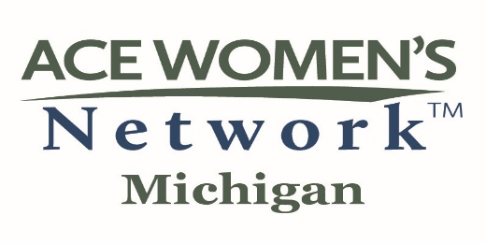

BENEFITS OF INSTITUTIONAL MEMBERSHIP

- Join with Michigan’s two-year, four-year, public, and private colleges and universities to identify, develop, encourage, advance, link, and support women in higher education. The award-winning Michigan ACE Network, founded in 1978, was one of the first 12 “pioneering” networks formed in the nation.

- Reinforce your commitment to the American Council on Education, the umbrella organization of higher education in this country.

- Strengthen your accreditation portfolio by highlighting an institutional commitment to employee satisfaction and the professional development of staff and faculty in support of regional and program accreditation standards.

- Appoint up to two women leaders from your institution to the statewide council of Institutional Representatives (IRs). Your representative(s) receive extensive information regarding state and national ACE initiatives to help guide your campus programs and connect with women leaders.

- Ensure that women on your campus are aware of opportunities for professional development at the state and national levels, job shadowing, professional advancement, grant/research funding, and opportunities to present at the Annual MI-ACE Network Conference.

- Nominate a candidate for the prestigious Distinguished Woman in Higher Education Leadership Award. Previous recipients have showcased the achievements of Alpena Community College, Central Michigan University, Davenport University, Grand Rapids Community College, Grand Valley State University, Hope College, Michigan State University, Northwood University, the University of Michigan – Flint, Wayne County Community College, Wayne State University, and Western Michigan University.

- Provide opportunities for leadership training and networking through participation in a statewide conference that annually attracts hundreds of Michigan’s leaders in higher education.

- Ensure awareness of state and national issues facing higher education and have access to current research.

- Assist the Network’s Public Policy Advocacy Committee in framing an agenda that supports university, state, regional, and federal policies enabling women to pursue higher education, start a career in higher education, and succeed within the academy.

- Demonstrate the strength of your support for women’s initiatives on your campus by your institution’s membership in the Michigan ACE Network for Women Leaders in Higher Education.

