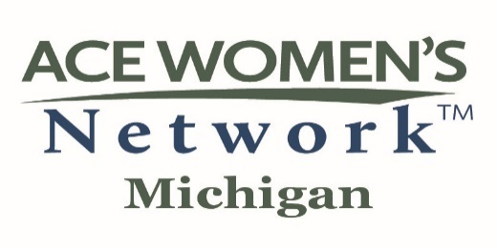
Dear (Insert Supervisor name),

I am excited to share a unique leadership development program for women in higher education offered in the State of Michigan. I would like to apply to be a mentee in the program for the 2025-2026 academic year and seek your support.

The MI ACE Senior-Level Leadership Development Job Shadow program in 2025-2026 will be in its 10th year. Direct outcomes of the program are to further develop leadership skills for women in their current higher education positions and to prepare them to enter senior-level positions in Michigan higher education institutions.

The MI ACE program provides participants from an MI institution with an opportunity to shadow and be mentored by one or more senior-level administrators from a Host institution in the State. Mentees will fulfill program expectations throughout the academic year, which includes about 150 hours with the host institution. Home institutions are not expected to provide any financial support for participants.

The shadow experience is to be co-designed by the Host senior mentor and participating mentee around the mentee’s interests and goals. In addition, Mentees are encouraged to discuss how the program experiences could also be a benefit to the home institution.

Applicants are selected to be mentees through a competitive process coordinated by the MI ACE Executive Board. A host institution has the opportunity to review a potential mentee’s application materials and to interview the applicant before agreeing to serve as that individual’s host institution.

Attached for your review is specific information about the program for Mentees (home institutions) and Mentors (host institutions).
I look forward to discussing this opportunity with you and would value a Letter of Support from you as my immediate Supervisor.

Respectfully,

(Applicant name)
2024-2025 Executive Board
Connie Tingson Gatuz, Ph.D., State Chair
University of Michigan
Linda Logan, Ph.D., Immediate Past State Chair
Olivet College
Reva Curry, Ph.D., State Chair-Elect
Delta College

Christine Benson, Ph.D
Madonna University
Lennetta Coney, M.A.
Mott Community College Foundation
Betty Dennis, PhD.
Western Michigan University
Michelle Hunt Bruner, M.A.
University of Michigan
CharMaine Hines, Ed.D.
Wayne County Community College
Dawn Hinton, Ph.D.
Saginaw Valley State University
Kimberly Hurns, D.M.
Oakland Community College
Shai James-Boyd, Ed.D.
Henry Ford College
Marlanna Landeros, M.S.W.
University of Michigan
Stephanie Lee, Ed.D.
Oakland University
Amy Radford-Popp, Ph.D.
Michigan State University
Mamiko Reeves, Ed.D.
Northwood University
Rachel Render
Davenport University
Seleana Samuel, Ed.D.
Lansing Community College
Kathleen Smith, M.A.
Michigan State University
Erin Van Egmond, M.A.
Grand Rapids Community College

Active Emerita
Nancy L. Barker
Northwood University, Retired
Deborah Z. Bloom, M.S.W.
Davenport University, Retired
MaryLee Davis, Ph.D.
Michigan State University, Emerita
Lynette Findley, Ph.D.
Eastern Michigan University, Emerita
Superior Township Clerk
Nancy Giardina, Ed.D.
Grand Valley State University
Martha Grier, Emerita
Wayne County Community College District
Marlene Kowalski-Braun, Ph.D.
Grand Valley State University

Honorary Emerita
Diane Anderson, Ph.D.
Western Michigan University
Claudia Douglass, Ph.D.
Central Michigan University, Emerita
Christine Hammond, Ph.D.
Mid Michigan College, Retired
Jacqueline D. Taylor, Ph.D.
Davenport University, Retired

