ISOLATING ON CAMPUS
People who have symptoms of COVID-19 (fever, cough etc.), have been told by a health care provider that they have symptoms consistent with COVID-19 or have had a positive test for COVID-19 need to self-isolate away from others to help reduce the spread of the virus. Many people will have symptoms that are mild and will be able to recover at home. The following information may be helpful if your provider has instructed you to self-isolate:

HOW TO SELF-ISOLATE:
- Stay in your apartment/room, DO NOT LEAVE except to get medical care.
- Do not go to any public areas or use public facilities including great rooms, laundry areas, or TV rooms
- Do not have any visitors in your apartment or room.
- Some items will be set in your Quarantine space on campus, or will be dropped off to you if staying in your current space. Please see the attached list for full details as well as a list of recommended items to bring to the space.

MONITOR YOUR SYMPTOMS
- Complete page three of this form daily.
- Call 911 if you develop emergency warning signs for COVID-19; tell the operator that you are in isolation for COVID.
  - Emergency warning signs include:
    - Trouble breathing / Persistent pain or pressure in the chest / New confusion or inability to arouse / Bluish lips or face
    - Any other symptoms that seem severe or cause you concern
- Call your medical provider if your illness is worsening (for example, if you have a change in your breathing that doesn’t seem to be an emergency). Tell them you have or may have COVID-19.
- If you have to leave to receive medical care, wear a facemask when you leave your apartment/room, and before you enter the healthcare building. If you can’t put on a facemask, try to keep a safe distance from other people (at least 6 feet away). This will help protect the people in the office or waiting room.
- Follow all care instructions from your healthcare provider

CLEAN & DISINFECT
- Clean all “high-touch” surfaces every day in your isolation area and bathroom, if you can.
- High-touch surfaces include phones, remote controls, counters, tabletops, doorknobs, bathroom fixtures, toilets, keyboards, tablets, and bedside tables.

FOOD SERVICE & DELIVERY
The quarantine space you have been provided will include some food items for 3-7 days based on your initial intake information. If you need food additional assistance, GVSU is able to assist you. The Housing COVID Coordinator will work with you to identify your needs, and if appropriate, set up delivery. You should not have face-to-face contact with delivery drivers from local restaurants. If someone delivers something, ask them to knock, and leave the item outside the door. Do not open the door until they are at least 6 feet away.

TRASH
DO NOT USE THE PUBLIC TRASH AREAS ON CAMPUS. Use the trash liners provided in your kit to double line your trash container. Once your trash is full, tie the bag off as tightly as possible. Wash hands afterwards. Notify your Living Center Director to arrange a time when the trash can be set outside your door for pick-up

LAUNDRY
If you have small items, you can do by hand in your room/apartment sink.
- DO NOT USE THE PUBLIC LAUNDRY AREAS ON CAMPUS.
- Wash, rinse well, and hang to dry.
- Wash hands with soap and water after touching your laundry
- Do not shake dirty laundry.
- If you have a larger amount that cannot be done by hand, GVSU can arrange to have a service do your laundry at a facility. Please inform the Housing COVID Coordinator if you need assistance with laundry.
WHEN TO DISCONTINUE SELF- ISOLATION

People with COVID-19 who have stayed home (self- isolated) may discontinue isolation under the following conditions:

IF YOU WILL NOT HAVE A TEST
If you will not have a test to determine if you are still contagious, you can discontinue self-isolation after these three things have happened:
- At least 7 days have passed since your symptoms first appeared
AND
- Your symptom sheet reflects no fever for at least 72 hours (that is three full days of no fever without the use medicine that reduces fevers)
AND
- Your other symptoms have improved (for example, when your cough or shortness of breath have improved)
IF YOU WILL BE TESTED
If you will be tested to determine if you are still contagious, you can leave home after these three things have happened:
- You no longer have a fever (without the use medicine that reduces fevers)
AND
- Your other symptoms have improved (for example, when your cough or shortness of breath have improved)
AND
- You received two negative tests in a row, 24 hours apart. Your doctor will follow CDC guidelines.

In all cases, follow the guidance of your healthcare provider and/or the local health department. The decision to stop home isolation should be made in consultation with your healthcare provider and state and local health departments. Local decisions depend on local circumstances.

RESOURCES
- Please see the DUTY Contact information if you need any assistance while in quarantine/isolation enclosed in this packet
- If you have a facilities emergency during quarantine/isolation please see the enclosed information to report the concern or repair needed
- If you need any additional food, supplies or assistance please contact the Housing office or Covid Coordinator by calling 616-331-2120 or emailing Housing@gvsu.edu

14-DAY ISOLATION OBSERVATIONS
Take your temperature twice a day, in the morning and in the evening, and write it down. Mark if you have any of the symptoms: circle ‘Y’ for Yes and ‘N’ for No. Don’t leave any spaces blank.
DATE | TIME | Temperature | Cough | Fatigue or aches | Shortness  of Breath | Diarrhea | Chills
1 | AM |  | Y N | Y N | Y N | Y N | Y N
 | PM |  | Y N | Y N | Y N | Y N | Y N
2 | AM |  | Y N | Y N | Y N | Y N | Y N
 | PM |  | Y N | Y N | Y N | Y N | Y N
3 | AM |  | Y N | Y N | Y N | Y N | Y N
 | PM |  | Y N | Y N | Y N | Y N | Y N
4 | AM |  | Y N | Y N | Y N | Y N | Y N
 | PM |  | Y N | Y N | Y N | Y N | Y N
5 | AM |  | Y N | Y N | Y N | Y N | Y N
 | PM |  | Y N | Y N | Y N | Y N | Y N
6 | AM |  | Y N | Y N | Y N | Y N | Y N
 | PM |  | Y N | Y N | Y N | Y N | Y N
7 | AM |  | Y N | Y N | Y N | Y N | Y N
 | PM |  | Y N | Y N | Y N | Y N | Y N
8 | AM |  | Y N | Y N | Y N | Y N | Y N
 | PM |  | Y N | Y N | Y N | Y N | Y N
9 | AM |  | Y N | Y N | Y N | Y N | Y N
 | PM |  | Y N | Y N | Y N | Y N | Y N
10 | AM |  | Y N | Y N | Y N | Y N | Y N
 | PM |  | Y N | Y N | Y N | Y N | Y N
11 | AM |  | Y N | Y N | Y N | Y N | Y N
 | PM |  | Y N | Y N | Y N | Y N | Y N
12 | AM |  | Y N | Y N | Y N | Y N | Y N
 | PM |  | Y N | Y N | Y N | Y N | Y N
13 | AM |  | Y N | Y N | Y N | Y N | Y N
 | PM |  | Y N | Y N | Y N | Y N | Y N
14 | AM |  | Y N | Y N | Y N | Y N | Y N
 | PM |  | Y N | Y N | Y N | Y N | Y N
A GVSU representative will contact you at various times to help track your progress.

* The attached forms are provided by the Centers for Disease Control and Prevention for patients who are under public health monitoring. They are being provided to you to use to protect yourself while at home.

If you have fever, cough, or shortness of breath, call your healthcare provider. They may tell you to manage your care from home. Follow these tips:

- Stay home from work, school, and away from other public places. If you must go out, avoid using any kind of
public transportation, ridesharing, or taxis.

- Monitor your symptoms carefully. If your symptoms get worse, call your healthcare provider immediately.

Get rest and stay hydrated.

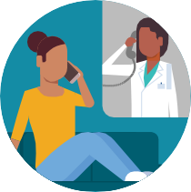
- If you have a medical appointment, call the healthcare provider ahead of time and tell them that you have or
may have COVID-19.

- For medical emergencies, call 911 and notify the dispatch personnel that you have or may have COVID-19.

Cover your cough and sneezes.

- Wash your hands often with soap and water for at least 20 seconds or clean your hands with an alcohol-based
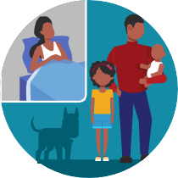
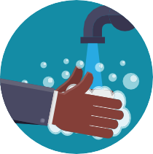
hand sanitizer that contains at least 60% alcohol.

- As much as possible, stay in a specific room and away from other people in your home. Also, you should use a separate bathroom, if available. If you
need to be around other people in or outside of the home, wear a facemask.

- Avoid sharing personal items with other people in
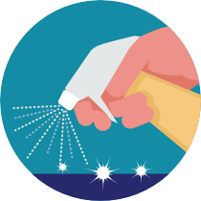
your household, like dishes, towels, and bedding.

- Clean all surfaces that are touched often, like counters, tabletops, and doorknobs. Use household cleaning sprays or wipes according to the label instructions.

10 ways to manage
respiratory symptoms at home

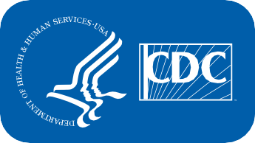
CS 315822-A 03/12/2020

DISINFECTING YOUR ROOM / APARTMENT

As part of your everyday prevention actions clean and disinfect frequently touched surfaces and objects. For example: tables, countertops, light switches, doorknobs, and cabinet handles. Wear disposable gloves to clean and disinfect.

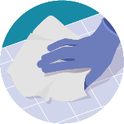
CLEAN
Clean surfaces using soap and water. Practice routine cleaning of frequently touched surfaces. High touch surfaces include: Tables, doorknobs, light switches, countertops, handles, desks, phones, keyboards, toilets, faucets, sinks, etc.

DISINFECT
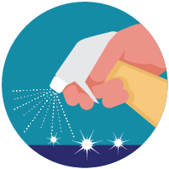
- Use diluted household bleach solutions if appropriate for the surface. Check to ensure the product is not past its expiration date. Unexpired household bleach will be effective against coronaviruses when properly diluted.
- Follow manufacturer’s instructions for application and proper ventilation. Never mix household bleach with ammonia or any other cleanser.
- To make a bleach solution, mix:
  - 5 tablespoons (1/3rd cup) bleach per gallon of water
  - OR
  - 4 teaspoons bleach per quart of water
- Alcohol solutions with at least 70% alcohol.
- Household cleaners and disinfectants: Clean the area or item with soap and water or another detergent if it is dirty. Then, use a household disinfectant.
- Follow the instructions on the label to ensure safe and effective use of the product.
- Many products recommend:
  - Keeping the surface wet for several minutes to ensure germs are killed.
  - Precautions such as wearing gloves and making sure you have good ventilation during use of the product.

SOFT SURFACES
For soft surfaces such as carpeted floor, rugs, and drapes
    - Clean the surface using soap and water or with cleaners appropriate for use on these surfaces.
    - Launder items (if possible) according to the manufacturer’s instructions. Use the warmest appropriate water setting and dry items completely.

SOURCE: https://www.cdc.gov/coronavirus/2019-ncov/prepare/disinfecting-your-home.html

