Anderson and Krathwohl – Bloom’s Taxonomy Revised

Understanding the New Version of Bloom’s Taxonomy

©Leslie Owen Wilson (2016, 2013, 2005, 2001) Contact Leslie

A succinct discussion of the revisions to Bloom’s classic cognitive taxonomy by Anderson and Krathwohl and how to use them effectively

Background:
Who are Anderson and Krathwohl? These gentlemen are the primary authors of the revisions to what had become known asBloom’s Taxonomy — an ordering of cognitive skills. (A taxonomy is really just a word for a form of classification.) This taxonomy had permeated teaching and instructional planning for almost 50 years before it was revised in 2001. And although these crucial revisions were published in 2001, surprisingly there are still educators who have never heard of Anderson and Krathwohl or their important work in relation to Bloom’s Cognitive Taxonomy. Both of these primary authors were in a perfect position to orchestrate looking at the classic taxonomy critically. They called together a group of educational psychologists and educators to help them with the revisions. Lorin Anderson was once a student of the famed Benjamin Bloom, and David Krathwohl was one of Bloom’s partners as he devised his classic cognitive taxonomy.
Here in the United States, from the late 1950s into the early 1970s, there were attempts to dissect and classify the varied domains of human learning – cognitive (knowing, or head), affective (emotions, feelings, or heart) and psychomotor (doing, or kinesthetic, tactile, haptic or hand/body). The resulting efforts yielded a series of taxonomies for each area. The aforementioned taxonomies deal with the varied aspects of human learning and were arranged hierarchically, proceeding from the simplest functions to those that are more complex. Bloom’s Cognitive Taxonomy had been a staple in teacher training and professional preparation for almost 40 years before Anderson and Krathwohl instituted an updated version. An overview of those changes appear below.
While all of the taxonomies above have been defined and used for many years, there came about at the beginning of the 21st century in a new version of the cognitive taxonomy, known commonly before as Bloom’s Taxonomy. You can also search the Web for varied references on the other two taxonomies — affective or psychomotor. There are many valuable discussions on the development of all the of the hierarchies, as well as examples of their usefulness and applications in teaching. However, it is important to note that in a number of these discussions, some web authors have mislabeled the affective and psychomotor domains is extensions of Bloom’s work. These authors are in grave error. The original cognitive domain was described and published in 1956. While David Krathwohl was one of the original authors on this taxonomy the work was named after the senior or first author Benjamin Bloom. The affective domain was not categorized until 1964 and as David Krathwohl was the lead author on this endeavor, it should bear his name, not Bloom’s. Bloo had nothing to do with the psychomotor domain and it was not described or named until the first part of the 1970s. There are 3 versions of this taxonomy by 3 different authors — Harrow (1972); Simpson (1972); and Dave (1970) See full citations below.

The Cognitive Domain:
The following chart includes the two primary existing taxonomies of cognition. Please note in the table below, the one on the left, entitled Bloom’s, is based on the original work of Benjamin Bloom and others as they attempted in 1956 to define the functions of thought, coming to know, or cognition. This taxonomy is almost 60 years old. The taxonomy on the right is the more recent adaptation and is the redefined work of Bloom in 2000-01. That one is labeled Anderson and Krathwohl. The group redefining Bloom’s original concepts, worked from 1995-2000. As indicated above, this group was assembled by Lorin Anderson and David Krathwohl and included people with expertise in the areas of cognitive psychology, curriculum and instruction, and educational testing, measurement, and assessment. The new adaptation also took into consideration many of Bloom’s own concerns and criticisms of his original taxonomy.
As you will see the primary differences are not in the listings or rewordings from nouns to verbs, or in the renaming of some of the components, or even in the re-positioning of the last two categories. The major differences lie in the more useful and comprehensive additions of how the taxonomy intersects and acts upon different types and levels of knowledge — factual, conceptual, procedural and metacognitive. This melding can be charted to see how one is teaching at both knowledge and cognitive process levels. Please remember the chart goes from simple to more complex and challenging types of thinking.

Taxonomies of the Cognitive Domain
Bloom’s Taxonomy 1956 | Anderson and Krathwohl’s Taxonomy 2001
1. Knowledge: Remembering or retrieving previously learned material. Examples of verbs that relate to this function are:  know identify relate list define recall memorize repeat record name recognize acquire | 1. Remembering:  Recognizing or recalling knowledge from memory. Remembering is when memory is used to produce or retrieve definitions, facts, or lists, or to recite previously learned information.
2. Comprehension: The ability to grasp or construct meaning from material. Examples of verbs that relate to this function are:  restate locate report recognize explain express identify discuss describe discuss review infer illustrate interpret draw represent differentiate conclude | 2. Understanding:  Constructing meaning from different types of functions be they written or graphic messages or activities like interpreting, exemplifying, classifying, summarizing, inferring, comparing, or explaining.
3. Application: The ability to use learned material, or to implement material in new and concrete situations. Examples of verbs that relate to this function are:  apply relate develop translate use operate organize employ restructure interpret demonstrate illustrate practice calculate show exhibit dramatize | 3. Applying:  Carrying out or using a procedure through executing, or implementing. Applying relates to or refers to situations where learned material is used through products like models, presentations, interviews or simulations.
4. Analysis: The ability to break down or distinguish the parts of material into its components so that its organizational structure may be better understood. Examples of verbs that relate to this function are:  analyze compare probe inquire examine contrast categorize differentiate contrast investigate detect survey classify deduce experiment scrutinize discover inspect dissect discriminate separate | 4. Analyzing:  Breaking materials or concepts into parts, determining how the parts relate to one another or how they interrelate, or how the parts relate to an overall structure or purpose. Mental actions included in this function aredifferentiating, organizing, and attributing, as well as being able to distinguish between the components or parts. When one is analyzing, he/she can illustrate this mental function by creating spreadsheets, surveys, charts, or diagrams, or graphic representations.
5. Synthesis: The ability to put parts together to form a coherent or unique new whole. Examples of verbs that relate to this function are:  compose produce design assemble create prepare predict modify tell plan invent formulate collect set up generalize document combine relate propose develop arrange construct organize originate derive write propose | 5. Evaluating:  Making judgments based on criteria and standards through checking and critiquing. Critiques, recommendations, and reports are some of the products that can be created to demonstrate the processes of evaluation. In the newer taxonomy, evaluating comes before creating as it is often a necessary part of the precursory behavior before one creates something.
6. Evaluation: The ability to judge, check, and even critique the value of material for a given purpose. Examples of verbs that relate to this function are:  judge assess compare evaluate conclude measure deduce argue decide choose rate select estimate validate consider appraise value criticize infer | 6. Creating:  Putting elements together to form a coherent or functional whole; reorganizing elements into a new pattern or structure through generating, planning, or producing. Creating requires users to put parts together in a new way, or synthesize parts into something new and different creating a new form or product. This process is the most difficult mental function in the new taxonomy.
Table 1.1 – Bloom vs. Anderson/Krathwohl
______________________________________________________________________________
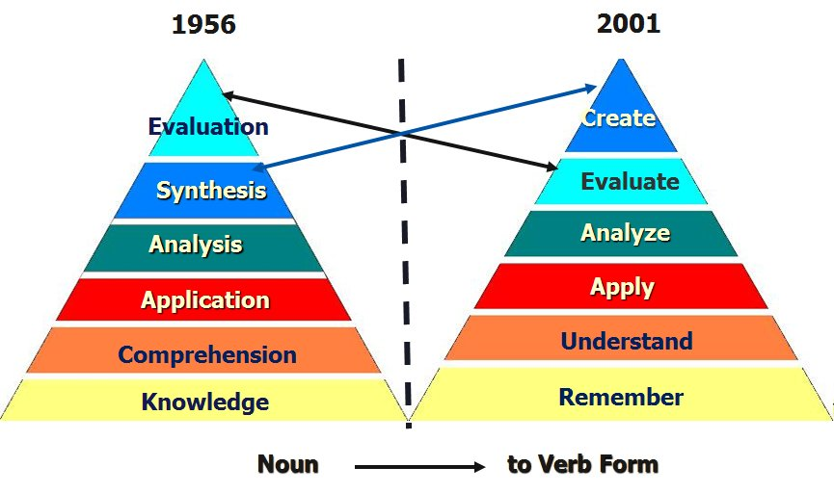(Diagram 1.1, Wilson, Leslie O. 2001)
Note: Bloom’s taxonomy revised – the author critically examines his own work – After creating the cognitive taxonomy one of the weaknesses noted by Bloom himself was that there is was a fundamental difference between his “knowledge” category and the other 5 levels of his model as those levels dealt with intellectual abilities and skills in relation to interactions with types of knowledge. Bloom was very aware that there was an acute difference between knowledge and the mental and intellectual operations performed on, or with, that knowledge. He identified specific types of knowledge as:
- Terminology
- Specific facts
- Conventions
- Trends and sequences
- Classifications and categories
- Criteria
- Methodology
- Principles and generalizations
- Theories and structures
Levels of Knowledge – The first three of these levels were identified in the original work, but rarely discussed or introduced when initially discussing uses for the taxonomy. Metacognition was added in the revised version.
- Factual Knowledge – The basic elements students must know to be acquainted with a discipline or solve problems.
- Conceptual Knowledge – The interrelationships among the basic elements within a larger structure that enable them to function together.
- Procedural Knowledge – How to do something, methods of inquiry, and criteria for using skills, algorithms, techniques, and methods.
- Metacognitive Knowledge – Knowledge of cognition in general, as well as awareness and knowledge of one’s own cognition. (29)
(Summarized from: Anderson, L. W. & Krathwohl, D.R., et al (2001) A taxonomy for learning, teaching and assessing: A revision of Bloom’s taxonomy of educational objectives. New York: Longman.)
One of the things that clearly differentiates the new model from that of the 1956 original is that it lays out components nicely so they can be considered and used. Cognitive processes, as related to chosen instructional tasks, can be easily documented and tracked. This feature has the potential to make teacher assessment, teacher self-assessment, and student assessment easier or clearer as usage patterns emerge. (See PDF link below for a sample.)
As stated before, perhaps surprisingly, these levels of knowledge were indicated in Bloom’s original work – factual, conceptual, and procedural – but these were never fully understood or used by teachers because most of what educators were given in training consisted of a simple chart with the listing of levels and related accompanying verbs. The full breadth of Handbook I, and its recommendations on types of knowledge, were rarely discussed in any instructive or useful way. Another rather gross lapse in common teacher training over the past 50+ years is teachers-in-training are rarely made aware of any of the criticisms leveled against Bloom’s original model.
Please note that in the updated version the term “metacognitive” has been added to the array of knowledge types. For readers not familiar with this term, it means thinking about ones thinking in a purposeful way so that one knows about cognition and also knows how to regulate one’s cognition.
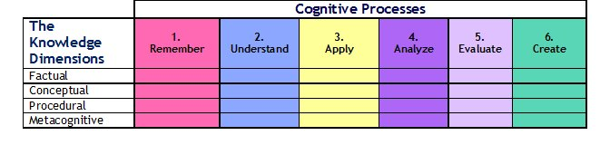Knowledge Dimensions Defined:
Factual Knowledge is knowledge that is basic to specific disciplines. This dimension refers to essential facts, terminology, details or elements students must know or be familiar with in order to understand a discipline or solve a problem in it.
Conceptual Knowledge is knowledge of classifications, principles, generalizations, theories, models, or structures pertinent to a particular disciplinary area.
Procedural Knowledge refers to information or knowledge that helps students to do something specific to a discipline, subject, or area of study. It also refers to methods of inquiry, very specific or finite skills, algorithms, techniques, and particular methodologies.
Metacognitive Knowledge is the awareness of one’s own cognition and particular cognitive processes. It is strategic or reflective knowledge about how to go about solving problems, cognitive tasks, to include contextual and conditional knowledge and knowledge of self.
*A comprehensive example from the book is provided with publisher permission athttp://www.scribd.com/doc/933640/Bloom-Revised

Sources:
Anderson, L. W. and Krathwohl, D. R., et al (Eds..) (2001) A Taxonomy for Learning, Teaching, and Assessing: A Revision of Bloom’s Taxonomy of Educational Objectives. Allyn & Bacon. Boston, MA (Pearson Education Group)
Bloom, B.S. and Krathwohl, D. R. (1956) Taxonomy of Educational Objectives: The Classification of Educational Goals, by a committee of college and university examiners. Handbook I: Cognitive Domain. NY, NY: Longmans, Green
Krathwohl, D. R. (2002) A Revision of Bloom’s Taxonomy. (PDF) in Theory into Practice. V 41. #4. Autumn, 2002. Ohio State University. Retrieved @ http://www.unco.edu/cetl/sir/stating_outcome/documents/Krathwohl.pdf

