Drop-In Readings and Discussion

Dr. Martin Luther King Jr. Commemoration Week
“Activate Your Activism”
January 18, 2016, 2:30-4:00PM
Russel H. Kirkhof Center - Room 2270

Drop in to Listen and Discuss
Excerpts from Dr. Martin Luther King Jr.’s book:

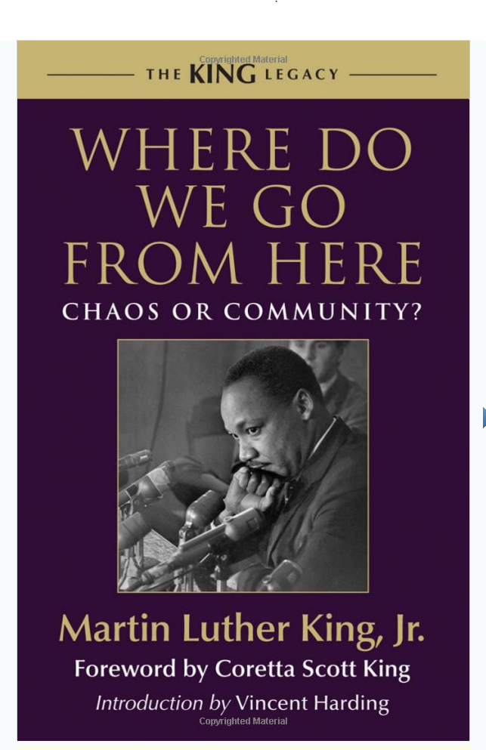
Readers: Dr. Chasity Bailey-Fakhoury, Casey Thelenwood, Dr. John Shinsky

