University of Versailles (France)
Environmental and Sustainability Studies, Geography and Sustainable Planning, Natural Resources Management, open to all majors
UVSQ offers excellent world-class curriculum in sustainability, climate change studies, Arctic Studies, geography, environmental science, environmental economics, ecoinnovation, urban planning and other fields.

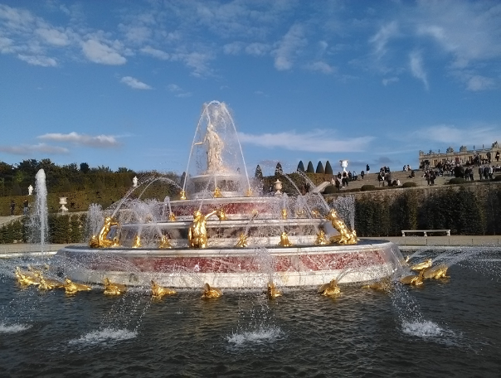 | 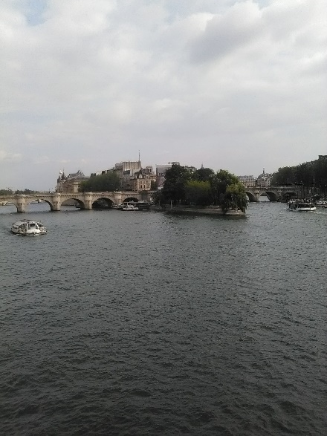 | 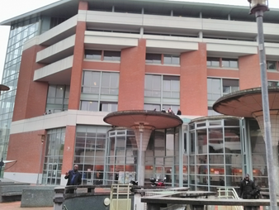

University of Versailles (UVSQ) – Recommended course curriculum for GVSU students seeking study abroad in Geography and Sustainable planning and closely related areas of study:
Fall 2017 semester courses offered in English*:
UVSQ course, | Course level, UVSQ unit, format | Suggested GVSU course equivalency for geography majors attending UVSQ
Climate Change | M1 CEMOTEV, face to face, | GPY412 Global Environmental Change or GPY380 (3)
Transition to sustainability: Human and technological systems | M2 OVSQ, hybrid (1 or 2 class meetings, the rest is online) | GPY481 or GPY499 or GPY380 (3)
Arctic Societies | M2 OVSQ, face to face | GPY481 or GPY399 or GPY380 (3)
Environmental Science for the Arctic | M2 OVSQ, face-to-face | GPY481 or GPY399 or GPY380 (5)
Arctic Climate and Meteorology | M2 OVSQ, face –to-face | GPY481 or GPY399 or GPY380 (4)
Arctic Geopolitics | M2 OVSQ, face-to-face | GPY481 or GPY399 or GPY380 (3)
Risk management | M2 OVSQ, face-to-face | GPY481 or GPY499 or GPY380 (3)
Governance and Sustainability | M2 OVSQ, face-to-face | GPY481 or GPY499 or GPY380 (3)

Winter 2018 semester courses offered in English*:
UVSQ course, | Level, UVSQ unit, format | Suggested GVSU course equivalency for geography majors attending UVSQ
Geopolitical analysis of conflicts in environmental and development studies | M1 CEMOTEV, face to face | GPY335 Globalization and Development or GPY380 (3)
Transition to sustainability: Human and technological systems | M2 OVSQ, face-to-face seminar (UVSQ Fall semester online class is a prerequisite) | GPY481 or GPY496 or GPY499 (3)
Climate System | M2 OVSQ, face to face | GPY412 or GPY481 or GPY399 or GPY380 (3)
Physical Sciences of the Earth | M2 OVSQ, face-to-face | GPY481 or GPY380 or GPY399 or GPY499 (3)
*Junior or senior standing is required for all M1/M2 courses
- All M1 and M2 courses included here are designed for interdisciplinary social science audience with no geoscience prerequisites. You can also take course of French as a second language of your level as a credit or as an extracurricular activity (free).
- Complete list of UVSQ courses offered in French is available at http://welcome.uvsq.fr/academic-programs-357107.kjsp?RH=1429630939499&RF=1430318284876
- For more information see also http://www.gvsu.edu/studyabroad/program-details-universit-de-versailles-637 or contact Professor Elena Lioubimtseva at lioubime@gvsu.edu for more information and questions about UVSQ curriculum.
- GVSU students register for UVSQ course at the same per-credit tuition rate as GVSU courses. UVSQ is a recognized international partner of GVSU.

Campus of the University of Versailles is situated in the new modern city St. Quentin en Yvelines, a recognized champion of sustainable urban planning, overlooking the beautiful valley of Chevreuse River and only minutes away from the historical City of Versailles and 20-30 minutes by metro or suburban train from the center of Paris. The University has a great infrastructure, including recently added housing for international students, easy access to public transportation, green spaces, theaters, shopping, and athletic facilities. For more information about UVSQ, visit http://welcome.uvsq.fr/ and contact Professor Elena Lioubimtseva at lioubime@gvsu.edu .

