Course requirements – GVSU students attending UBB

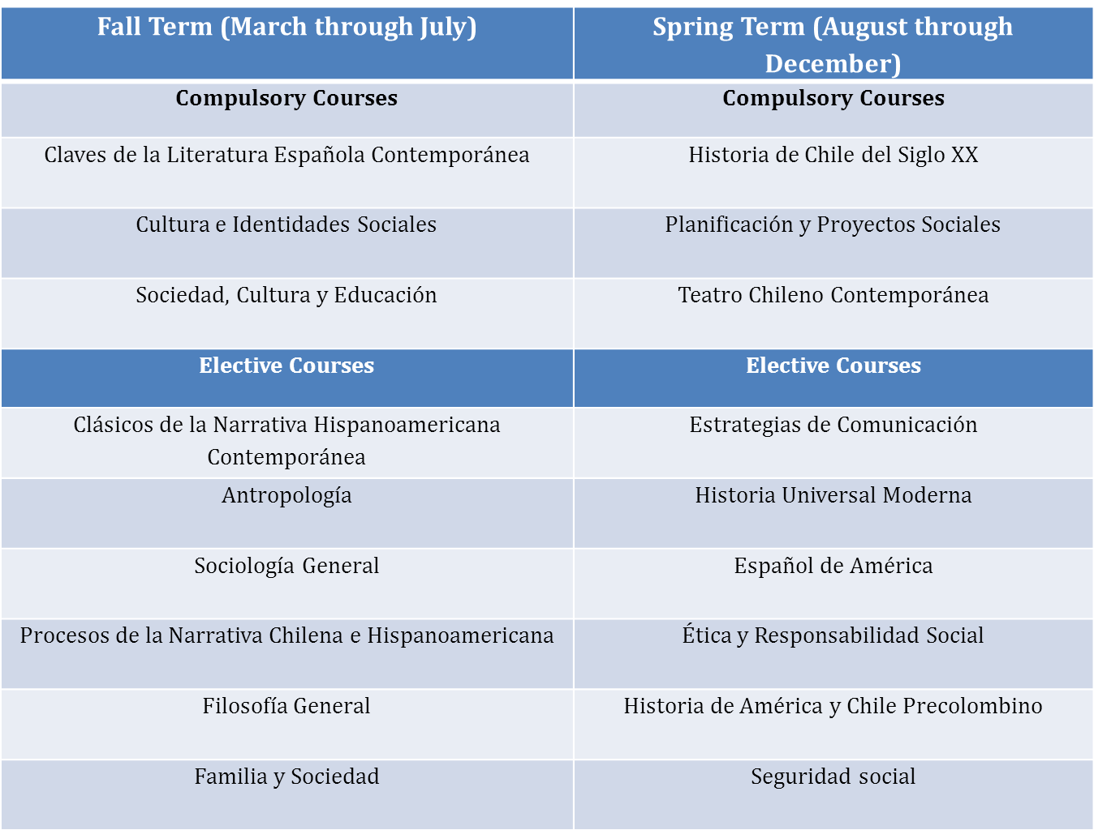

Note:
GVSU students must complete three compulsory courses and two elective courses per term.
It should be kept in mind that course titles offered at UBB are subject to change due to curriculum renovation now underway (Feb. 2014). Changes are not expected to alter key contents of these courses when considered together, but may change the order of presentation of ideas.

Course Descriptions (English translations)

1. Claves de la Literatura Española Contemporánea:
Area of learning oriented to the knowledge and critical interpretation of contemporary Spanish literature from the generation of 98 to late twentieth century primarily in narrative and dramatic genres.

2. Cultura e Identidades Sociales:
The objective of this course is to analyze the elements, processes present in the development of culture and social identities from different theoretical visions.

3. Sociedad, Cultura y Educación:
Subject of theoretical and practical nature, oriented to the understanding of education in society from its purposes, its relationship with the rest of society and social issues within the current educational reality. The course is built around an interdisciplinary look at converging Philosophy and Sociology, in order for students to develop an integrated vision of education, comprising the teaching act in its foundations and perspectives consistent with current challenges.

4. Historia de Chile del Siglo XX:
The course aims to provide a vision about the political, economic, social and cultural aspects of Chile in the twentieth century. Among the topics to be addressed in the course include: parliamentary government, the process of industrialization, the emergence of new social actors in political life (peasants, workers, indigenous people, middle class, women and military), the institutional system Chilean breakups and reinstatement, among others.

5. Planificación y Proyectos Sociales:
The purpose of the course is to develop in students the ability to apply models and methods of social planning in situations of social intervention, through the elaboration of effective social projects.

6. Teatro Chileno Contemporáneo:
Theoretical and practical course oriented to the thematic knowledge, analysis and presentation of Chilean plays, from the surrealist period until the collective creation theater and theater of marginality.

7. Clásicos de la Narrativa Hispanoamericana Contemporánea:
Theoretical and practical course designed to analyze major contemporary narratives of the Chilean and Latin American literature, so that students are able to make critical judgments regarding the political and social environment that the narratives represent.

8. Antropología:
Course contents are intended to introduce students to an integrated view of anthropology as a discipline that studies human groups and communities. With a theoretical and practical perspective, it will deepen the understanding of the fundamentals that explain the existence of the discipline, the configuration of its subject matter, its disciplinary organization majors and fundamental constituent of anthropological concepts and approach. Categories and analysis schemes of this discipline will be applied to national and Latin American cultural contexts, so that they understand the complexity of cultural phenomena, and the diversity that characterizes the contemporary world.

9. Sociología General:
With a theoretical and practical perspective, this course aims to give theoretical and methodological contributions of sociology that are relevant to the development of skills and attitudes necessary for both understanding and analysis of society and for the training of future teachers. The course is conducted through lectures, which will be complemented by discussions of reading, problem analysis and implementation of specific cases and short papers that allow applying the knowledge acquired to the analysis of contemporary society and contextualizing the educational processes.

10. Procesos de la Narrativa Chilena e Hispanoamericana:
Course focused on the area corresponding to the understanding, reflection and insight of pre-Columbian and colonial Spanish American literary discourse and key sources of the Chilean and Latin American narrative learning, including the historical, social and cultural. The study of the materials will be oriented towards the acquisition and student awareness of the Chilean and Latin American cultural identity based on the reading and interpretation of significant literary texts.

11. Filosofía General:
Theoretical and practical course designed to develop the ability to think and understand the complexity of human phenomena, from the analysis of the fundamental concepts of philosophy in its historical development character. This ability will allow students to build processes that will increase its reflectivity intellectual autonomy, providing, also, a strong cultural background.

12. Familia y sociedad:
The purpose of this course is to analyze the different theoretical approaches that facilitate the understanding of the family as a study of the social sciences.

13. Estrategias de la Comunicación:
This theoretical and practical course corresponds to the initial training of teachers and has as main purpose the strengthening of communication skills (speaking, comprehension and production of texts, mainly academics) by applying certain discursive strategies for effective performance in the context of university teaching and professional future.

14. Historia Universal Moderna:
The course will lead students to the knowledge and understanding of political, economic, religious and cultural processes of the sixteenth, seventeenth and eighteenth centuries as manifestation of work of the man in time and space and due to its life in society.

15. Español de América:
Course oriented to a critical and evaluative analysis of linguistic aspects and basic sociolinguistic in the formation and expansion of the Spanish in America.

16. Ética y Responsabilidad Social:
The aim of this course is to recognize the basic notions and concepts of general and professional ethics, as well as its application to situations and / or concrete and real problems that will arise in their future job performance. If you understand social work as a discipline or oriented to promote social change profession, problem solving in human relationships, the empowerment and liberation of people to enhance social welfare, the principles of human rights and social justice are fundamental in practice and professional action as social workers.

17. Historia de América y Chile Precolombino:
Course focused primarily on understanding human existence in Chile and America, from the arrival of the first inhabitants to the present. Therefore, the analysis will be done at specific times of the evolution of peoples, noting the features that have endured over time. In this sense, the course aims to give an overall view of human existence, paying attention to some key moments from the historic role of the aborigines, and especially, understand their problems in the contemporary world.

18. Seguridad Social:
The purpose of this course is to analyze the legal, theoretical and procedural framework of social security system in Chile, with a big emphasis in social protection issues at work, and social security.

