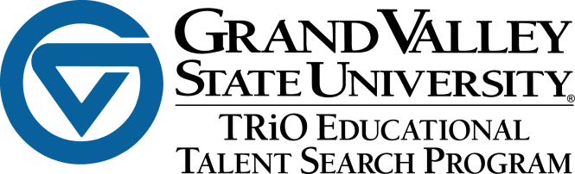

You and your family are invited to the first ever

Family Holiday

Celebration

Join TRiO Educational Talent Search students and families as we celebrate the holidays with food, fun, and volunteering. Lunch will be provided along with a holiday movie in the Loosemore Auditorium.

Where: **Grand Valley’s Pew Campus  
105E DeVos**

When: **December 6, 2014**

Time: **1****2:00pm-4:00pm**

Please call the office at **616-331-7110** by December 1 to reserve your seat.