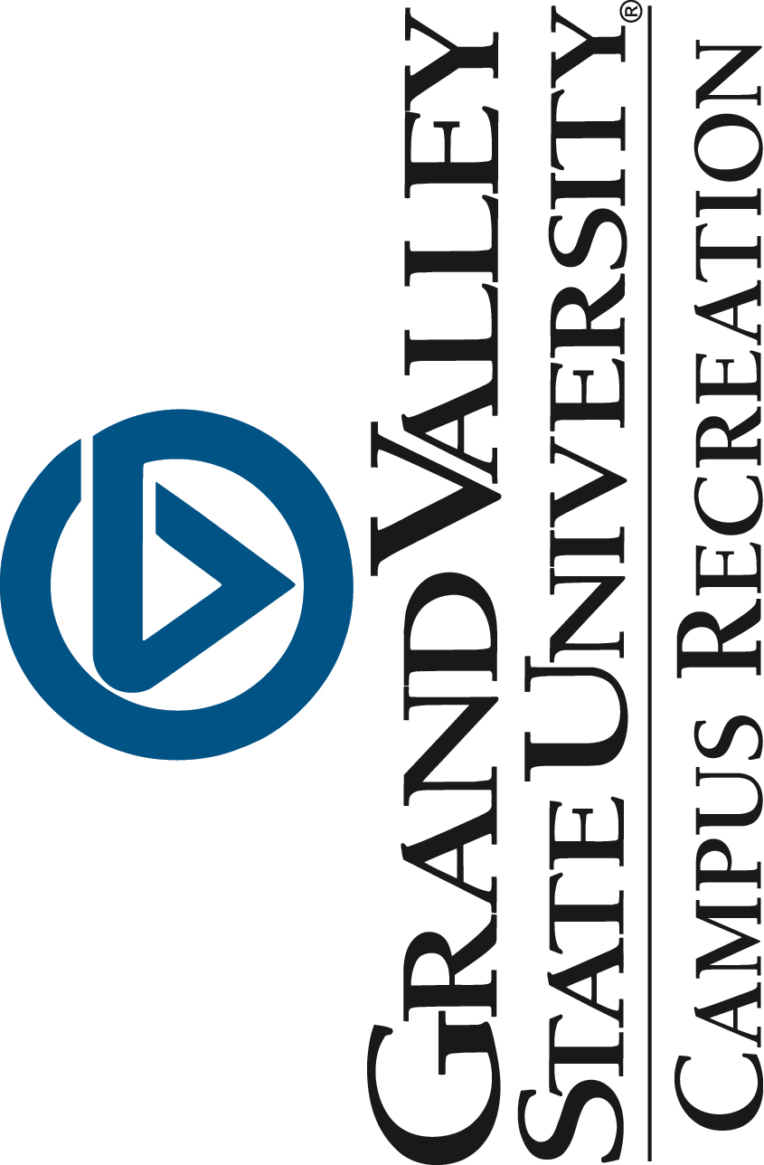

Program Coordinator, Fitness and Wellness

Position Description: The Fitness and Wellness Program Coordinator reports to the Associate Director of Campus Recreation within the division of Student Services. The Program Coordinator has primary responsibilities for overseeing the delivery, operations and evaluation of the Fitness and Wellness programs and services, which includes supporting the mission of Campus Recreation. The department reports to the Student Services Division of the University.

Responsibilities:
- Oversee Fitness and Wellness programs and services including Ufit Plan, Personal Training, Massage, Nutrition, Group Exercise Program, Small Group Trainings, and assist with day-to-day functions
- Assist with staffing, hiring, scheduling, staff training, student staff development, including support for a student based learning environment
- Program planning, and customer service
- Maintain data and assist in end of semester and end of year reports
- Assist with assessment, evaluation and planning of programs and services
- Research and apply best practices
- Facilitate health promotion, education and awareness with campus and community partners
- Scheduling and reservations
- Assist with supervision of the Fitness and Wellness Center
- Payroll
- Assist with programs and events sponsored by Campus Recreation
- Attend regularly scheduled staff meetings and division meetings
- Maintain policies, rules and regulations for programs, services and activities
- Serve on Risk Management Committees and other committee work as assigned
- Work closely with Movement Science, and Athletic and Recreational Facilities and work collaboratively around campus as needed
- Serve as an instructor or personal trainer
- Other duties as assigned

MINIMUM QUALIFICATION: The position of Fitness and Wellness Coordinator requires a bachelor’s degree in Exercise Science, Physical Education or a related field. At least one year of experience in fitness in collegiate recreation is required. It is preferred candidates are certified in at least one of the following: ACSM, NSCA, ACE, NASM, AFAA or related.

Qualified individuals must have excellent written and verbal communication skills, organized, professional, and a passion for working with others. Current CPR/AED and First Aid certifications. At least 2 years of supervising experience. Willingness to work a flexible schedule including some nights and weekends.

DESIREABLE QUALIFICATIONS: A master’s degree in Exercise Science, Physical Education, College Student Affairs or Personnel, or a related field is preferred. Additional specialty fitness certifications or credentialing preferred. NIRSA involvement a plus.

Compensation: based on experience. This is a contracted, one year, full-time (40hours/week) with benefits. The position will be eligible for renewal based on funding and performance.

Anticipated start date: August 2015
Application process: Applications will begin to be reviewed starting June 22, 2015 Applications will be accepted until position is filled.
Please submit cover letter, resume, and three references to:
Amy Campbell
campbamy@gvsu.edu
Associate Director, Campus Recreation
1 Campus Drive – 215 Fieldhouse Allendale, MI 49401

