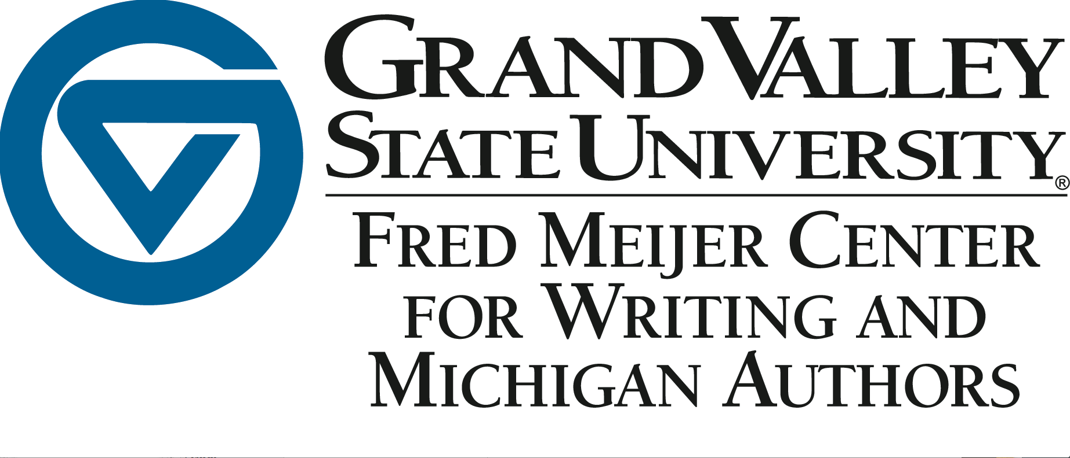

SWS Fellows Application
Fall 2016

If you are teaching capstone, upper division, or SWS courses, you are eligible for the SWS Fellows program which utilizes peer mentors from the Writing Center, Speech Lab, and Research Consultant programs to provide in-class academic support for your classes. These three services form the Knowledge Market, which work collaboratively to guide students towards stronger research, more developed writing, and more effective presentations. In your courses, these three services can provide:
- Multiple in-class workshops with a dedicated group of highly-trained consultants
- Interdisciplinary support where consultants from different programs work one-to-one or in groups on tasks related to research, writing, and/or presentation.
- Planning meetings between consultants and faculty outside of class to discuss upcoming assignments, plan workshops, and share feedback
- Additional in-class workshops available all semester long
- Opportunities to reflect on activities and assignments with consultants, as well as program administrators

Due to the scheduling limitations within the writing center, speech lab, and research consultant programs, the SWS Fellows program is only available in two courses each semester. Interested faculty are encouraged to email Patrick Johnson (johpatri@gvsu.edu), or submit this form to LOH 120.

SWS Fellows Application for Fall 2016

FACULTY NAME: __________________________________
Intended course for Fall 2016: _____________________________________

Please describe your instructional goals related to research, writing, and presentations for the course:

