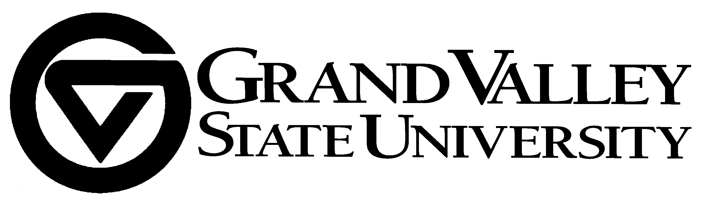
University Academic Senate
Executive Committee of the Senate
Kristine Mullendore, Chair 2008-2000
Lawrence Burns, Vice Chair 2008-2009

Memorandum

TO: University Academic Senate
FROM: Kristine Mullendore, Chair, ECS/UAS
SUBJECT: Meeting of the University Academic Senate
DATE: January 29, 2009
cc: ECS/UAS Distribution

Meeting Date: February 6, 2009
Time: 3:00 p.m. – 5:00 p.m.
Place: 107D DeVos Center

Agenda
- Approval of Agenda
- Approval of Minutes (December 5, 2008) and motion to revise approved minutes from November 7, 2008. (See attached documents)
- Report from the Chair
4. Report from the Provost
5. Report from the Student Senate President
6. Report from Committees/Task Forces
- Graduate Council proposal to revise Faculty Handbook to add policies on Graduate Assistants and Graduate Assistantships – Mark Luttenton (Chair, GC) (See attached documents)
- FPPC proposal to modify Faculty Handbook language to provide for “pausing” the tenure clock - Teresa Beck (Chair FPPC) and Scott Richardson (HRO) (To be distributed later - FPPC final revisions needed after ECS review)

7. New Business
  - Final Plan for CMB to become an academic unit – Mark Staves (CMB faculty) (See attached documents including FSBC memos and UCC Memo)
  - Final Plan for AWRI to become academic unit and companion motion to revise Faculty Handbook language Carl Reutz (AWRI faculty) (See attached documents including FSBC memo – UCC memo will be distributed later)

9. Adjournment

Other Pending Initiatives
  - Final Plans
Chinese Language minor (at CLAS CC)
Environmental Studies minor (at ECS)
College of Education new degree programs (at Grad Council)

  - Prospecti
Philanthropy and Nonprofit Leadership Masters (at UCC/Grad Council)
Supply Chain Management major/waiver to Final Plan request (at UCC)
History Master of Arts (at UCC/Grad Council)
Biomedical Engineering minor (Approved for Final Plan at ECS)
Pharmacology major (Approved for Final Plan at ECS)
Adventure Tourism minor (Approved for Final Plan at ECS)

REMINDERS:
Dr. Vincent Tinto Faculty Workshop and all-campus address at 1:30 on student retention:
Friday, February 20 at the Grand River Room in the Kirkhof Center, Allendale Campus

Academic Integrity Foras
1:00 – 3:00 p.m., 136 E DeVos Center on Thursday, March 19
1:00 – 3:00 p.m., 2263 Kirkhof Center on Friday, March 20

Provost’s Faculty/Staff Conversations in February
“Student’s Changing Futures”
Wednesday, February 4 from 1:30 to 3:00 p.m. at 2263 Kirkhof Center
Friday, February 6 from 10:00 to 11:30 a.m. at 205E DeVos Center

“Curriculum”
Wednesday, February 25 from 9:00 to 10:30 a.m. at 205D DeVos Center
Thursday, February 26 from 9:00 to 10:30 a.m. at 2263 Kirkhof Center

