Academic Policies and Standards Committee
Kristen Vu, Chair 2020-2021

Meeting Minutes
February 11, 2021
9 AM – 11 AM EST
Online: https://gvsu-edu.zoom.us/j/91127849874

Present:

College of Liberal Arts and Sciences
- Carlson, Todd
- Losey, Kay
- Shapiro-Shapin, Carolyn
- Wildey, Mikhila

Seidman College of Business
- Koste, Lori

College of Community and Public Service
- Higbea, Raymond

College of Education

Padnos College of Engineering and Computing
- Corneal, Lindsay

College of Health Professions
- Vu, Kristen (Chair)
Brooks College of Interdisciplinary Studies
- Jae Basiliene

Kirkhof College of Nursing
- Slager, Dianne

University Libraries
- Beasecker, Robert

At Large - Elected by and from UAS
- Vacant

Student Representatives

Ex officio, non-voting
- Benet, Suzeanne - Provost Designee

Visitor
- Schendel, Ellen

The meeting was called to order at 9:00 AM

- Minutes from the January 11, 2021 meeting were approved.
Motion to approve: Carolyn Shapiro-Shapin
Second: Mikhila Wildey
Vote: Unanimous approval

- 2021-22 AY Committee Chair

Raymond Higbea was nominated as Chair for the 2021-22 AY
Nomination: Lori Koste
Second: Lindsay Corneal
Vote: Unanimous approval
- Academic Forgiveness Policy – Academic Integrity Grades
Discussion: Academic dishonesty was not considered when the Academic Forgiveness policy was created. The committee felt courses in which academic dishonesty occurred should not be eligible for forgiveness. The committee did reach out to the group who reviews the academic forgiveness applications and they agreed that it would be possible to implement the policy (particularly in light of the new procedures for academic misconduct through OSCCR). Actions based on this discussion include (1) addition of #8 under Terms of Academic Forgiveness and (2) addition of the phrase “academic dishonesty did not occur in this course” to the Academic Forgiveness application
Motion: Dianne Slager
Second: Kay Losey
Vote: Unanimous approval

- Academic forgiveness cannot be used for courses in which academic dishonesty occurred.
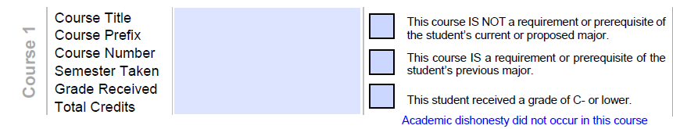
- Temporary (Covid) Academic Policies
Extension of temporary policies Credit / No Credit, Withdrawal, and Attendance policies were discussed at length resulting in a motion to not adapt the Credit / No Credit and Withdrawal policies for the 2021 Spring / Summer sessions and to hold on the Attendance policy until additional information was gathered.
Motion: Todd Carlson
Second: Lindsay Corneal
Vote: Unanimous approval

- Undergraduate Prior Learning

Following extensive discussion, a Prior Learning – Undergraduate draft policy (attached) was developed with need for further discussion and clarification on APSC’s role in the GVSU undergraduate prior learning policy development.

The meeting was adjourned at 10:55 AM.
Minutes recorded by Raymond J. Higbea, PHD.

