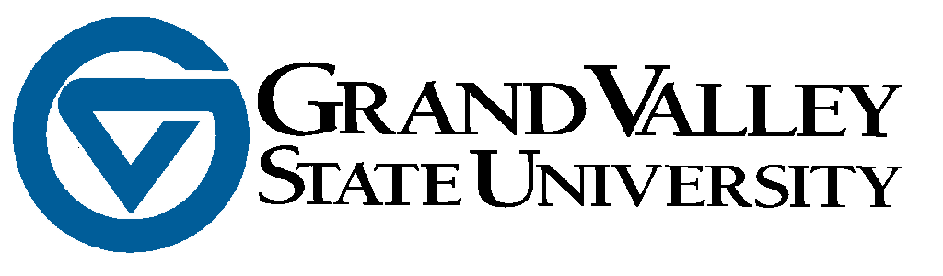

RELEASE FOR USE OF MINOR’S IMAGE and/or VOICE AS A PARTICIPANT IN

___ (Name of Program)__________________

AUDIO VIDEO PHOTOGRAPHY RELEASE

I authorize Grand Valley State University to video-tape and photograph my child’s image and/or voice for use in research, educational, and public service programs. I understand and agree that these audio, video, film and/or print images may be edited, duplicated, distributed, reproduced, reformatted, and translated into other languages in any manner without payment of additional fees, in perpetuity.

Return to: ______________________________________________________
___________________________ Name of Minor Participant
___________________________
___________________________ ______________________________________________________
___________________________ Signature of Parent or Guardian
___________________________

