Task A  Solve  3x + 7 = 5  or  3x + 7 = 5 – 8x | Task B  Mary has 200 feet of fencing. She wants to enclose a garden. How large a garden can she make?
Task D  The Tiling Problem | Task E  Solve  4(2x + 5) = 8x – 19  4(3x +3) = 6 (2x + 2)
Task F  Write an equation that has -7 as a solution. | Task G  An equation has a graph that is a line with a positive slope and a negative y-intercept. Make a table that could belong to this graph.
Task H  Find three consecutive even integers such that four times the third one is twelve more than twice the sum of the first two. | Task I  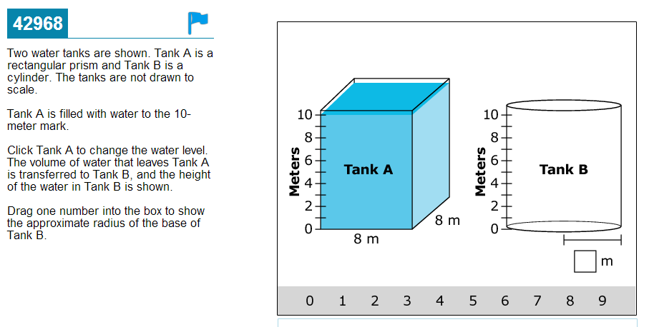  The Water Tank Problem
Task J

d = rt

Find d when r = 50 mph and t = 35 min.
Find r when d = 30 m and t = 5 seconds

Task K  Three consecutive even integers are such that the sum of the smallest and 3 times the second is 38 more than twice the third. Find the integers | Tony is choosing between two used cars.  Car Cost Miles Per Gallon Immediate Repairs  Blue Car $3200 18 $700  Red Car $4700 24 $300  Tony estimates he will drive at least 200 miles per month.  The average cost of gasoline per gallon is $3.70 in his area.  Tony plans to own the car for 4 years.  Calculate and explain which car Tony should buy.

