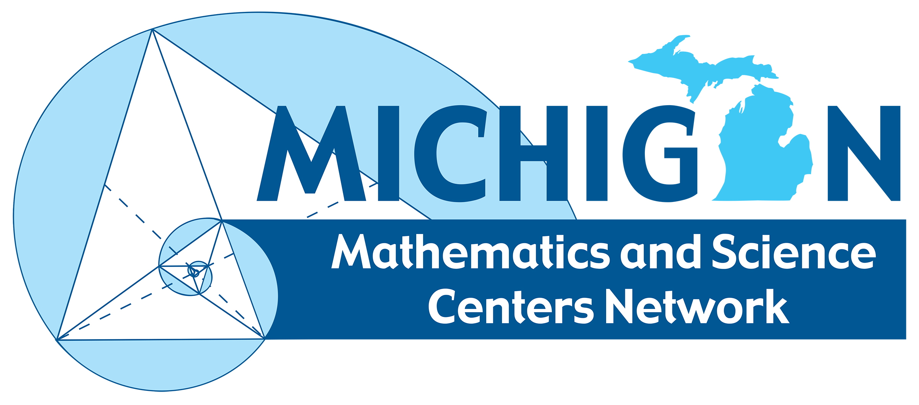

**Note:** *STEM definitions currently vary across the nation. The Michigan Mathematics and Science Centers Network is making strides to develop a common understanding of STEM for educators, legislators, community members, and families.*

**STEM Literacy** **is the ability to identify and apply concepts from science, technology, engineering, and / or mathematics to understand complex problems and to  
innovate to solve them.**

**Students are STEM literate if they are able to apply their understanding of how the world works within and across the four interrelated STEM disciplines to improve social, economic, and environmental conditions.**

**Integrated STEM is a course, program, activity, or experience**

**within STEM education that combines concepts and applications from multiple STEM disciplines.**

**STEM Careers are careers in which concepts from science, technology, engineering, and / or mathematics are applied to solve complex problems.**

**STEM Education is a series of courses, programs, activities and/or experiences that contribute to STEM literacy, including literacy in individual STEM disciplines.**

STEM EDUCATION

*is an acronym for fields of study and careers in the disciplines  
of science, technology, engineering, and mathematics, and  
may include the integration of any and all of the disciplines.*

*STEM Literacy adapted from Washington State Legislation RCW 28A.188.010*

*STEM Schools is adopted language from the US Senate as suggested by NCSSS*

**A STEM School prepares students to be leaders in global innovation by engaging them in rigorous, relevant, and integrated learning experiences, with a science, technology, engineering, and mathematics focus, and specialization that includes authentic research  
school-wide.**

STEM CAREERS

STEM SCHOOLS

STEM LITERACY

Science Technology Engineering Mathematics

**STEM**