Discovering STEM Program  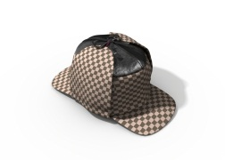  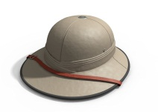  Our Hats are off to you!!!!  We couldn’t do it without our volunteers! | Discovering STEM Program  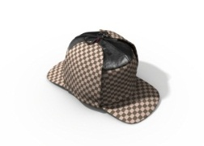  Our Hats are off to you!!!!  We couldn’t do it without our volunteers!
Discovering STEM Program  Our Hats are off to you!!!!  We couldn’t do it without our volunteers! | Discovering STEM Program  Our Hats are off to you!!!!  We couldn’t do it without our volunteers!

