STRATEGIC ENROLLMENT MANAGEMENT PLAN

Executive Summary of Plan
The Strategic Enrollment Management Plan enables distinct learner-ready strategies by harnessing strengths and resources from across Grand Valley State University. This co-created and action-oriented approach for student success upholds our institutional commitments to inclusiveness and community. The strategies and practices presented are intended to articulate and create a strengthened culture for student success.
Active engagement with implementation and accountability phases will drive the institutional goals of having 23,583 undergraduate learners and 3,552 Graduate learners for a total of approximately 27,000 students/learners and increasing the institution’s retention rate to at least 90 percent. Additionally, this plan sets a goal of 50 percent for the institution’s four-year graduation rate. This aim will be met by equitable enrollment, retention, progression, graduation, and overall success for all learners, including:

- First Time In Any College (FTIAC) Learners
- Adult/Nontraditional Learners
- African American or Black Learners
- American Indian or Alaskan Native Learners
- Undocumented/DACA Learners
- First-Generation Learners
- Pell-Eligible Learners
- Food/Housing Insecure Learners
- Graduate Learners
- Hispanic/Latinx Learners
- Nonresidential International Learners
- LGBTQIA+ Learners
- Transfer Learners
- Veteran/Military Learners
- Underrepresented in STEM Learners
- Off-Campus Learners

The attention given to the way learners are organized is motivated by our need to achieve the mission, vision, and guiding principles identified by our community for all students. The plan is iterative and includes diverse partners at all levels of the university to ensure continuous improvement and success. The outlined university-wide goals and objectives, created by change agents and transformation teams across campuses, are enhanced by overarching and shared approaches for university stakeholders. Moreover, Grand Valley State University’s Strategic Enrollment Management Plan serves as a living roadmap for intentional student and institutional growth. Space for innovative thinking is essential at every phase to inspire collaboration in achieving the university’s enrollment and retention goals.

Mission
The Division of Enrollment Development and Educational Outreach values cooperation and interconnectedness with each functional unit at Grand Valley State University. The division contributes to the enrichment of our society by implementing enrollment planning and services that
- value diversity, inclusion, belonging, and accessibility;
- identify, recruit, and enroll capable learners; and
- offer services to support and promote equitable enrollment, retention, progression, graduation, and overall success for all learners.

Vision
The Division of Enrollment Development and Educational Outreach will be recognized as a national model for enrollment management programs, services, and practices. We will be a learner-ready and evidence-based division utilizing an inclusive approach to encourage learners from all backgrounds to become leaders and complete their educational pursuits. Utilizing a coordinated-care approach, we will provide comprehensive services to lifelong learners at every stage of their educational career.

Guiding Principles
- Recruiting, admitting, retaining, and graduating a diverse learner population with equitable outcomes as the goal
- Placing learners’ welfare ahead of other institutional goals by advocating for their needs
- Involving cross-divisional stakeholders from across the institution to think through a lens of transformation to ensure optimal results
- Utilizing asset-based, abundance thinking about our learners and the varied gifts and talents they bring
- Supporting all learners in ways that honor and respect their diverse and multiple social identities
- Delivering intrusive, inclusive, and intentional education and experiences
- Investing in the ongoing learning and development of faculty and staff as they seek to serve learners, recognizing their invaluable influence
- Providing comprehensive and high-quality academic advising and coaching in a supportive learning environment
- Designing course sequencing and course availability within our curriculum to meet the needs of our traditional, nontraditional/adult, and graduate learners

- Using systemically gathered data to inform our decision making
- Seeing the local, state, and global community as valued partners in providing educational opportunities for our learners
- Working to be a learner-ready institution, recognizing and acknowledging our faculty and staff’s role in understanding and supporting our learners

Strategies
Individuals from across the university have come together to form transformation teams focused on the populations mentioned above. These teams, led by change agents, identified numerous strategies to create equitable pathways for access to and participation in higher education. In addition, each college created their own strategies that aim to do the same. Similar themes emerged from the recruitment and retention efforts of the transformation teams as well as the colleges, such as:

- Financial Aid and General Support
- New Student Programming
- Marketing
- Student Mentoring and Advising
- New Staff/Office
- New Web App Development and Data Analytics
- Curriculum Development
- Faculty/Staff Training and Development
- Registration and Credit Equivalency
- Childcare
- Relationship Building
- Admissions and Recruitment Practices
- Pipeline and Articulation
- K-12 Engagement

The graphics below illustrate these common themes.

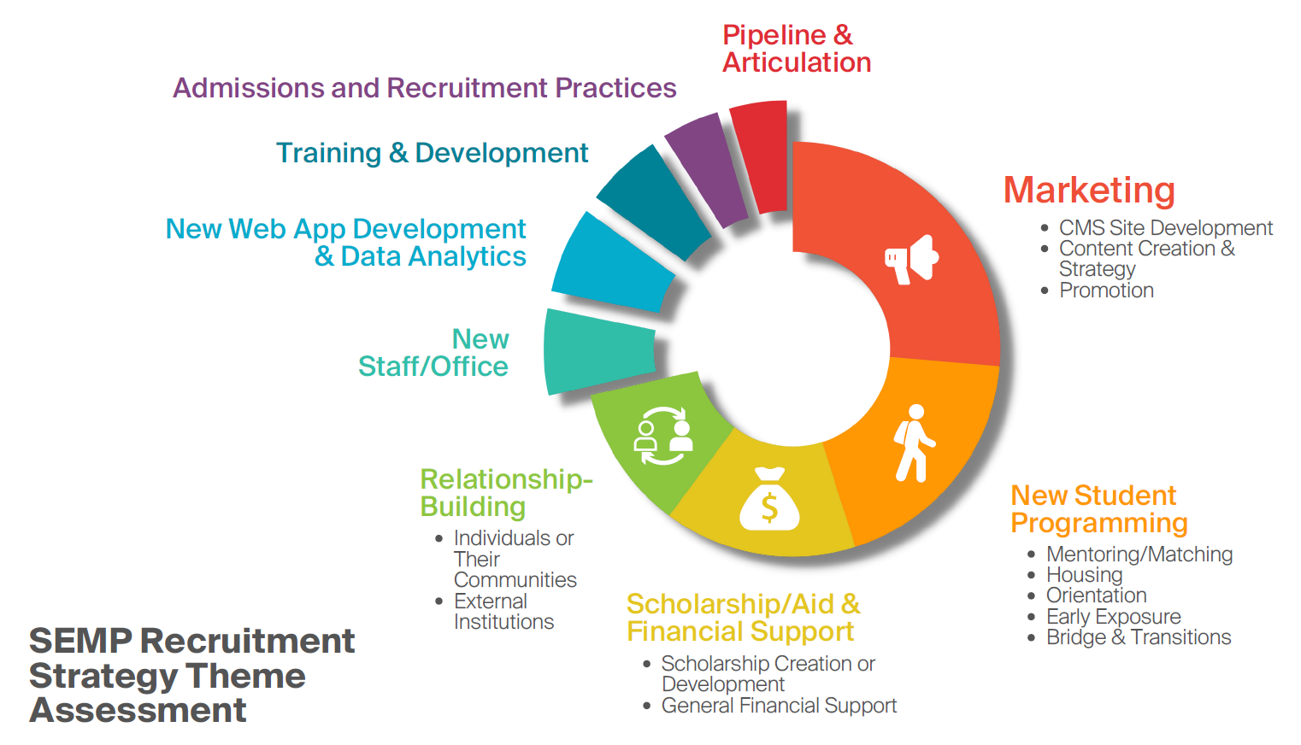

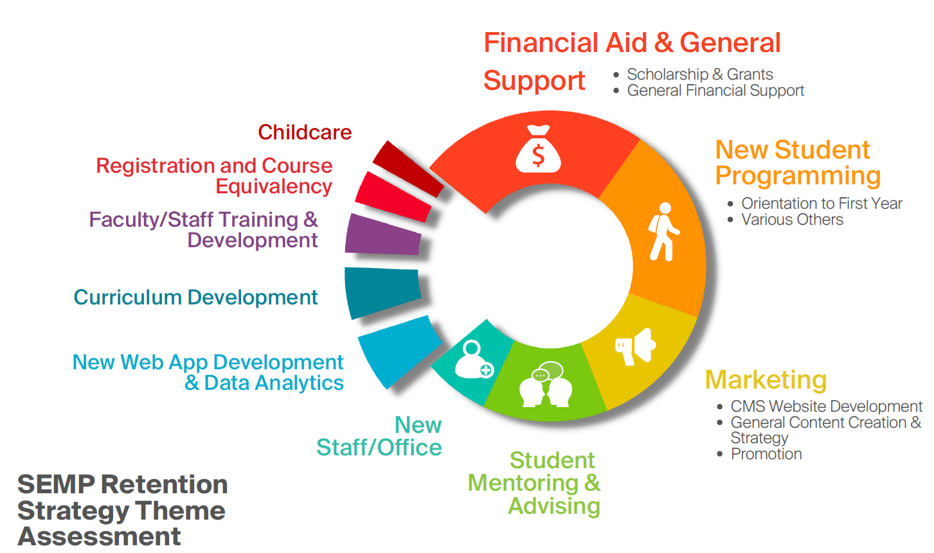
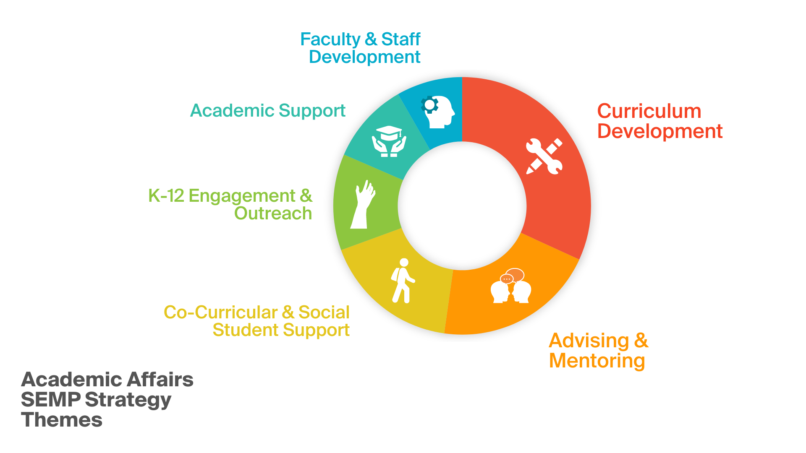

Examples
There are many examples that demonstrate how the Strategic Enrollment Management Plan has been used to create real change at Grand Valley. Here are several initiatives to show the meaningful work that is being done across the university.
The Grand Valley Pledge, established in 2021, provides free tuition for Michigan students who are admitted to Grand Valley and have a family income of less than $50,000. The Grand Valley Pledge is strategically focused on providing access to education for low-income students. These students are likely first-generation students as well. Overall, the Grand Valley Pledge helps to recruit students who identify in several of the populations mentioned above.
A partnership with the David D. Hunting YMCA will help recruit and retain adult and nontraditional learners as well as graduate learners. This partnership creates access for these learners to affordable nighttime childcare, allowing them to attend classes, while knowing their children are being adequately cared for by YMCA staff.
Simple marketing strategies like translating collateral into Spanish and hiring a recruiter specifically for the Detroit area is helping to recruit Hispanic/Latinx learners, first-generation learners, African American or Black learners, and FTIAC learners. This is done by meeting students where they are at. Having materials in Spanish lets learners read the information in a language most comfortable to them and their families, who play an important role in their decision-making. In addition, placing a recruiter in Detroit provides a greater ease of access to information about Grand Valley for learners in that city.

Similarly, the creation of a website to house resources for DACA and undocumented learners focuses on increasing recruitment and retention of this population. The university’s position related to immigration and DACA is clearly articulated, and the website lists the many campus, community, and legal resources available to DACA and undocumented learners. In addition, there are ally resources and trainings for students, faculty, and staff who are committed to creating a welcoming and supportive environment.
Another recruitment initiative is the Pathways to GVSU Program, which provides students as early as the 8th-grade with the foundational support to be successful for entrance at Grand Valley. Participants will be required to attend academic coaching and tutoring sessions, SAT workshops, career readiness sessions, financial aid and literacy education seminars, alumni speaker events, campus visits and stays, and other developed programs.
The Summer Student Success Program, is a comprehensive six-week program designed to transition students in the Oliver Wilson Scholars program from high school to college. This is done by developing the knowledge, skills, and abilities needed for success, using academic coursework, educational workshops, and co-curricular programs designed to foster a strong sense of belonging through relationships with faculty, staff, and other students. This enhanced summer bridge program is a retention effort focused on a diverse population of students, who likely identify as FTIAC, African American or Black, Hispanic/Latinx, first-generation, and more.
The HBCU/HSI Pipeline Consortium is an initiative focused on both recruitment and retention. Students from HBCUs and HSIs enroll in Grand Valley to earn a master's degree that is not offered at the HBCU nor HSI. This unique program helps recruit both African American / Black learners and graduate learners. The industry sponsored graduate fellowships and additional interactions with community and business leaders helps retain these students.
Be a Laker, Bring a Laker is a recruitment initiative that involves the entire Laker family. Every Grand Valley alumnus, parent, student, and faculty member knows someone who would benefit from a Grand Valley education, and this program provides resources to these individuals to help them recruit future Lakers. Informational sessions and trainings are available for alumni, parents, students, and faculty to learn how to better connect prospective students to Grand Valley.
A new academic advising model, created for the 2022-2023 academic year, seeks to address retention. All students new to Grand Valley will be required to meet with their advisor. First year students do not have experience with program planning, class selection, nor advising beyond summer advising and registration sessions. They may also have changed their majors, developed new interests, or struggled academically. The required advising ensures these new students understand the requirements of their major, their progress toward earning a degree, and the resources and opportunities available to them prior to registering for the upcoming academic year. The changes related to advising address retention problems among FTIAC learners.

