The **POWER** Study Hour

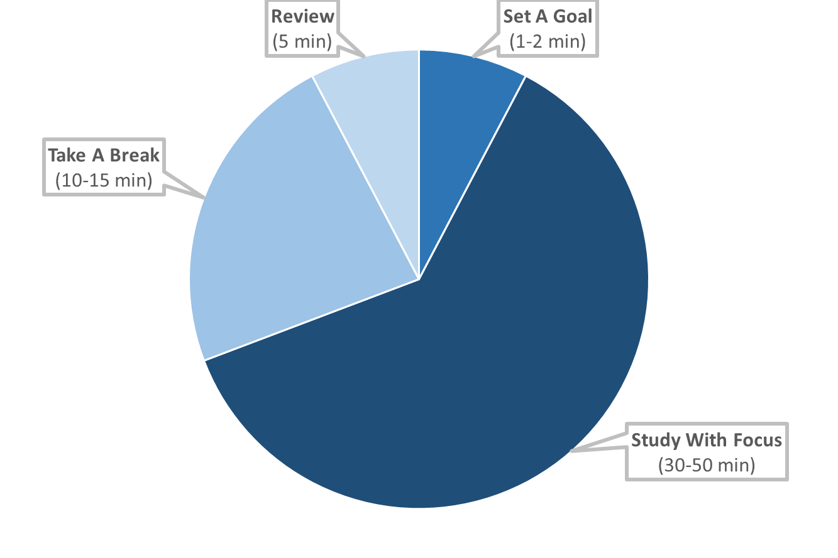

1. **SET A GOAL** ( 1-2 minutes )

Decide what you want to accomplish during your study session.

2. **STUDY WITH FOCUS** ( 30-50 minutes )

Set a timer for 30-50 minutes. Work on your goal without distractions for the set time.

3. **TAKE A BREAK/REWARD YOURSELF** ( 10-15 minutes )

Reward yourself for your hard work with a timed break. Set a timer for 10-15 minutes and enjoy yourself by taking a walk, having a snack, playing a short game, chatting with a friend, etc.

4. **REVIEW MATERIAL** ( 5 minutes )

Review what you previously studied.