Webinar using Zoom- Before

Setting Up the Zoom Meeting for the Webinar – Regular/ In-class webinar
Setting up a Zoom Webinar is nearly identical to setting up a Zoom Meeting.
- Open Zoom on the browser by clicking on the mentioned link: https://zoom.us/web/sso/login?en=signin
- Enter SSO: gvsu-edu
- Login to Zoom with credentials – seidmanwebinars

1. Select the “Webinars” option on the left and select “Schedule a Webinar”
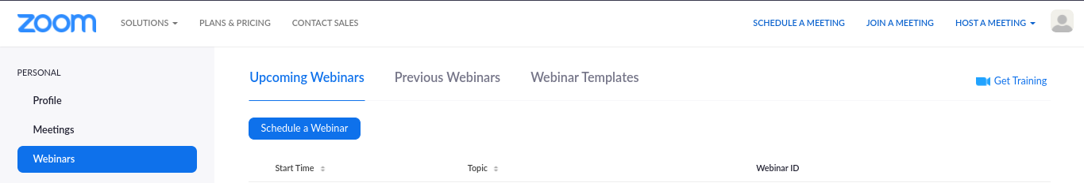
- Enter the “Topic” name
- Set the “date” and “time” to start
- Set “Duration” of the webinar
- Enable/Disable “Registration” if required
2. Next to Webinar Options (the only options unavailable in Zoom Meetings), make sure “Q&A” is disabled or enabled as requested by the person responsible, select “Require Authentication”, “Enable Practice Session” and Automatically “Record Webinar” is selected. Click “Schedule Meeting.”
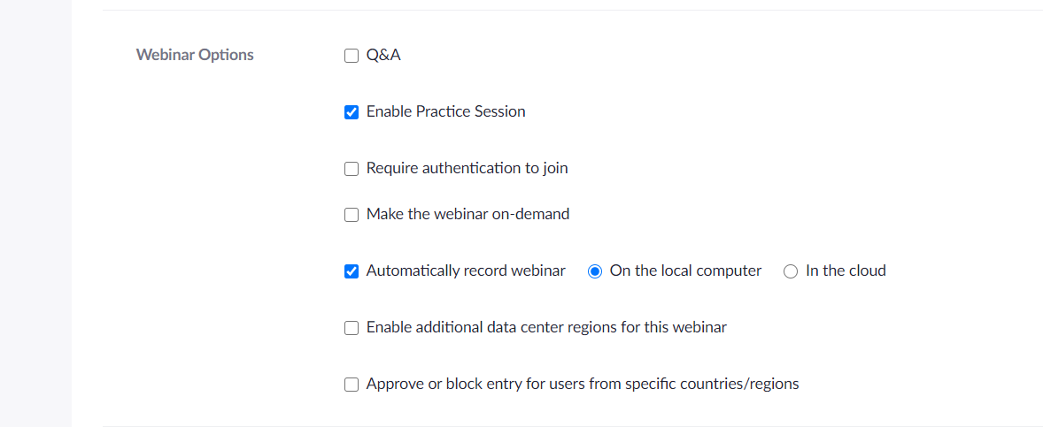

3. Once the Webinar is scheduled, scroll down to Invitations, and to the right of “Invite Panelists”, select “Edit”.
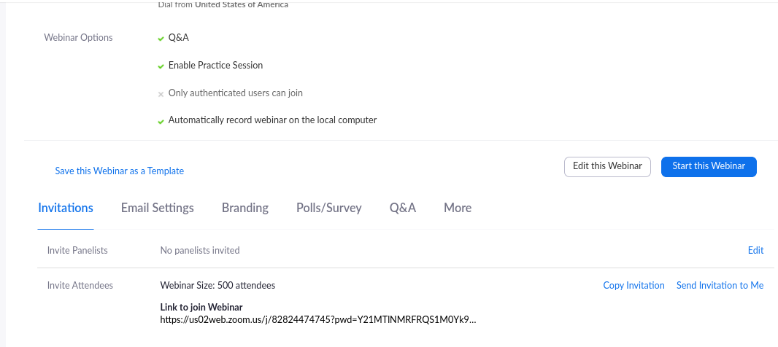

4. Add the names and emails of the Panelists in the popup and ensure that the “Send Invitations to all newly added panelists immediately” is selected and click “Save”.

In-class webinar: The panelists will be present in class, therefore there will be no panelist link unless anyone is joining via an online medium.
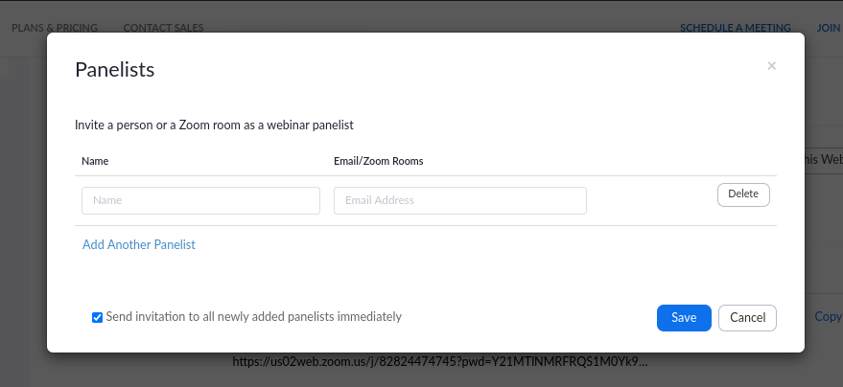

5. In the Invite Attendees column, select the “Registration link”, hover the cursor to the right of the link, copy and send it to the person responsible for distributing the registration link to the webinar.

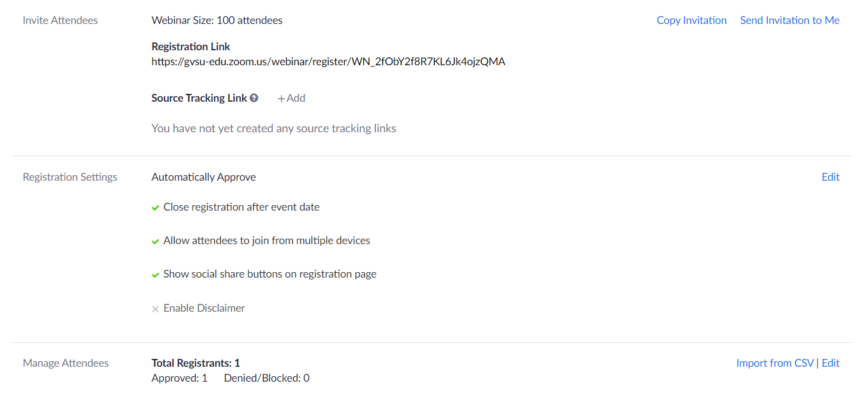

6. Click on the “Edit” for “Registration settings”. Make the following selection under the ”Registration” Questions are by default selected.
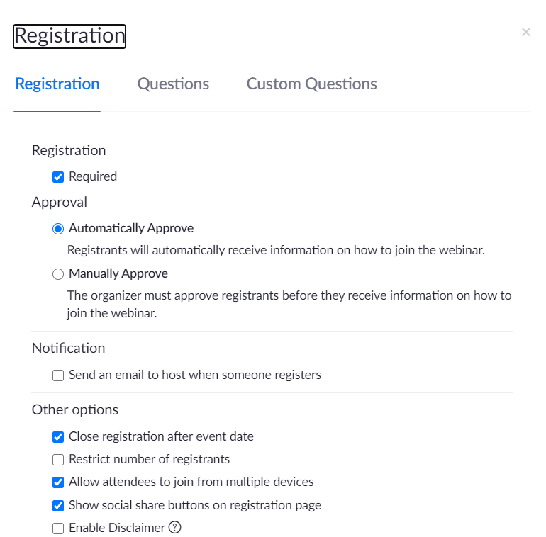
7. A “custom question” can be added. Select/De-select “Required” depending upon the requirement of the responsible person.

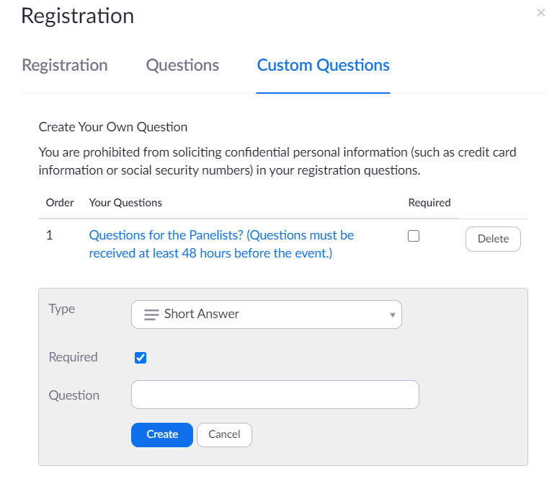
8. There is no way to disable chat settings prior to the Webinar, so if you want to block attendees from putting messages in the chat remember to open the chat once the Webinar is started. Click the three dots in the chat section and under who can chat with who and select “no one”.

Registration Report:
Select “Reports” from the left of the zoom page. Click on “Webinar”. Follow the rest steps mentioned in the image. (Note: Send out the report one week and one day before the webinar)
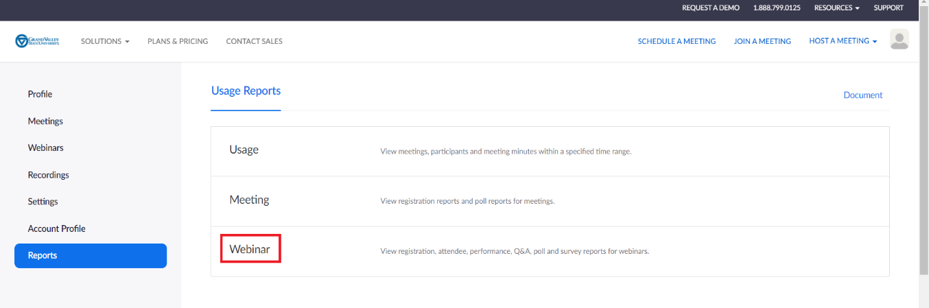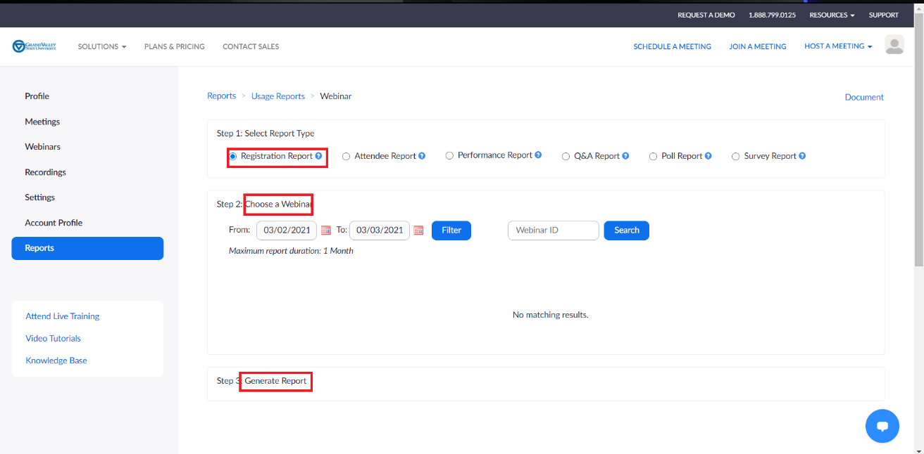

Email Settings: If the email settings need to be changed, from our end we can edit the language and if we can send or not. If there are further changes, the admin needs to be contacted. (Note: Set the email reminder to “1 day before webinar”)

In-Class webinar: There will be no reminder emails for the panelists, as they will be present in person.
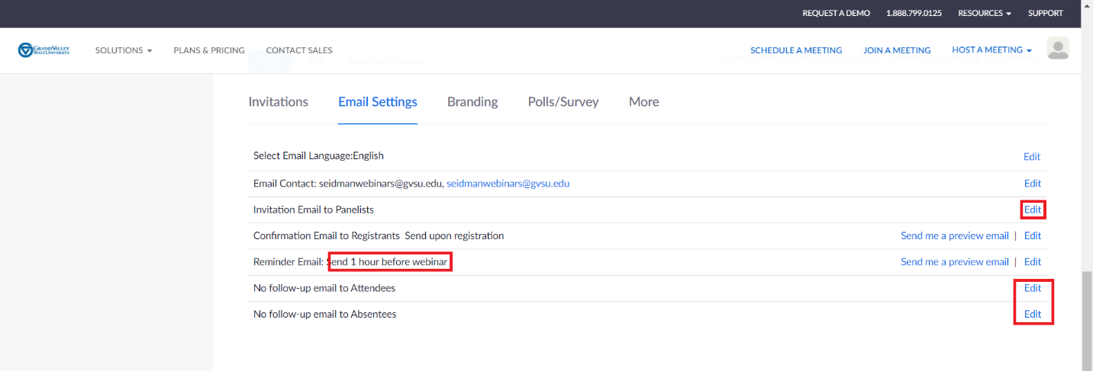

Branding:
After you schedule the meeting, click the Branding tab to customize branding options for your registration page:
- Banner: Click Upload to add an image that appears at the top of your registration page.
- Logo: Click Upload to add an image that appears to the right of the meeting topic on your registration page. The logo also appears in the email invitation

Before Webinar - Setting Up the Zoom App for the Webinar

- Log into the Zoom app, “Settings” Select the camera quality to “HD” and deselect “Mirror my video” and then click “Advanced” on the bottom.

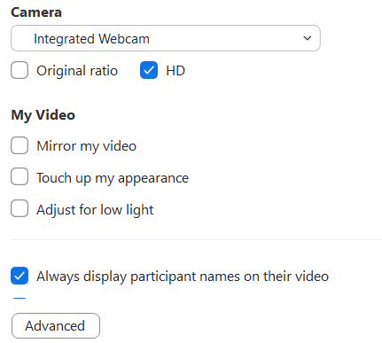

- In the “Advanced” option – deselect the “Optimize de-noise” and “Hardware Acceleration”
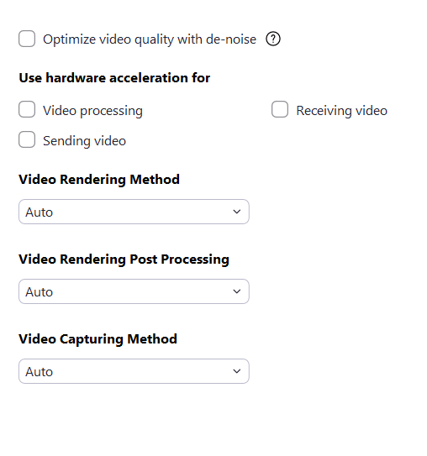
- Powerpoint Presentation:
Start the practice session in webinar 30 minutes before and ensure all the settings are in place and Powerpoint presentation have rehearsed timings of 15 seconds on them.
Powerpoint Transition Advance Slide Select “After” – 00.15.00
Or
Powerpoint Slide Show Rehearse Timings
- Talk to the panelist when they join and ensure the video and audio quality. Ask them to turn off their camera and mics before beginning to share the PowerPoint presentation.

